Basic Mug Design in Cricut Design Space
(** In bold are things you need to do, non-bold type gives explanations)
- Double-click on the Cricut shortcut on the desktop to open Cricut Design Space.
(You usually have to be connected to the internet for the program to open.)
- If a login screen appears, type in the required e-mail and password.
- Click on to maximize your screen and then click on New Project (see pic below).
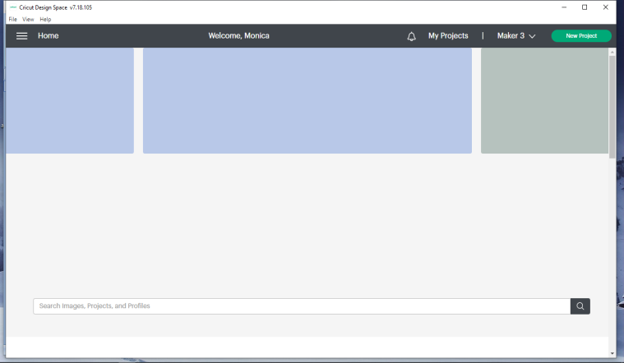

- Click on Upload.

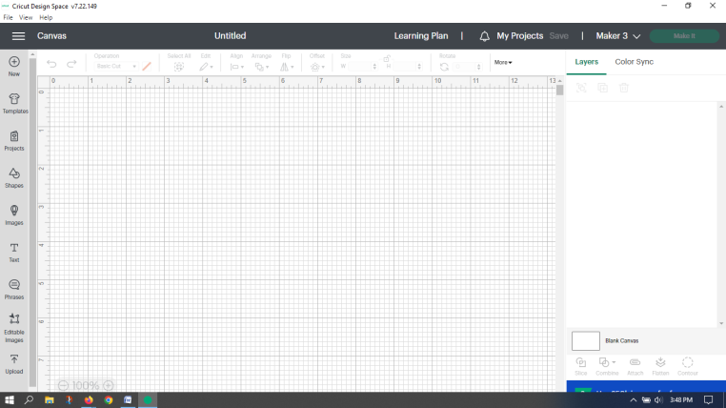

- Click on the template you want to use (from the options available-were free from JenniferMaker). You may have to scroll down. Click Add to Canvas.

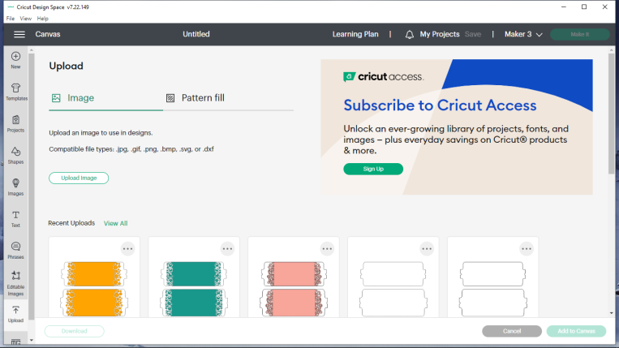

- Click on the Ungroup/Group icon to ungroup. The ungroup/group icon has two small overlapping squares as indicated by the yellow arrow. We will only be working with the top wrap (for a 12 oz mug) not the bottom wrap which is made for 15 oz mug. If you look at the picture below, in the red box you will see a Mug wrap label that has a picture of the two mug wraps that you just imported. Below that label, it shows each wrap separately. Because the top heading shows two wraps, it indicates they are grouped together – whatever you do to one, you do to the other. If you add something to the canvas that has more than one part, you will have to ungroup them to work with each separately (unless keeping things proportional is important). Most designs with multiple parts come grouped.

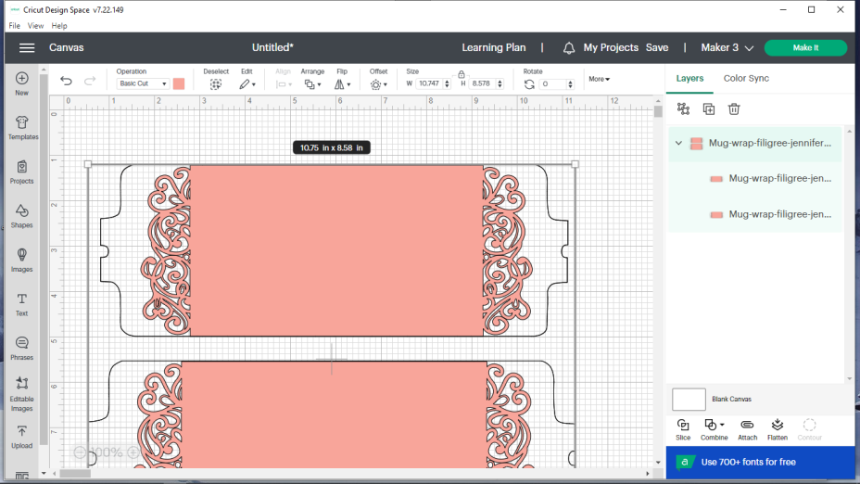

- Go over to the right side of the second mug wrap layer (which is the wrap for the 15 oz mug). An eye should appear when you hover over the area indicated by the yellow arrow. Click on the eye. The 2nd wrap is now hidden and won’t be affected by what we do. It also won’t be made. Make sure the larger wrap was hidden; if not, hit undo and hide the other one.

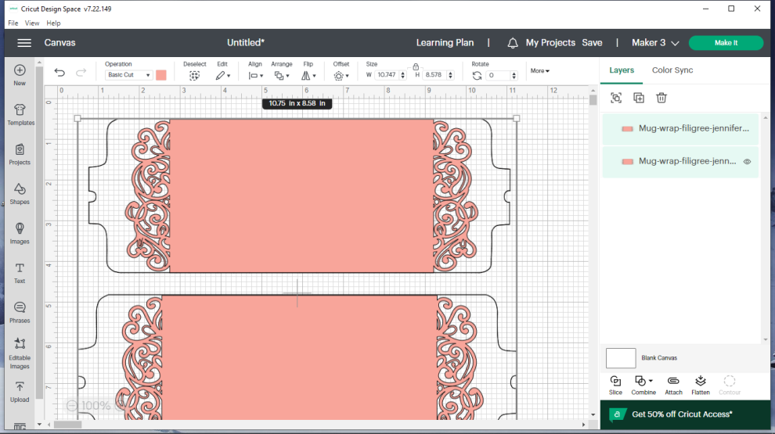

- DO NOT CLICK ON ANYTHING! JUST READ WHAT FOLLOWS! Next, if you want an image cut out of your wrap that isn’t already in the mug wrap design, you will have to pick an image. (If you don’t want to add an image, you can insert/edit words if you want to (go to step #21) or leave it as it is.) Before you choose an image, look at the picture below. This is important! When you choose an image, it will come into the program fairly large. In the picture, the images you see that are not cut out of the mug wrap are the original images – before they were resized to fit on the mug wrap and before they were cut (subtracted) from the mug wrap. Note how the firefly that is on the mug wrap will be too small to cut out the details. If it had been left quite large, it would have been okay. The before and after are shown to help you decide what kind of drawing you want to use. Note, too, that if you pick a picture with a lot of colors, it might just make the outline as seen by the person in the coveralls, or sometimes, it will cut differently than expected or won’t cut out right. If you cut a shape out and you don’t like the cutout, click undo (curved arrow just under Canvas toward the top left hand side of the screen) until your image is gone and then pick a different one. The areas on the mug wrap that are white will be white on your actual mug. The areas shown in pink in the picture below would all be pink on the actual mug (unless you used an infusible ink sheet that wasn’t pink – then they’d be whatever the color of infusible ink sheet you chose). Be careful if you pick an image with small details (whether original size or reduced in size), like the dragonfly and the more intricate butterfly….they are harder to cut with the Cricut and require more experience to weed out the correct parts.
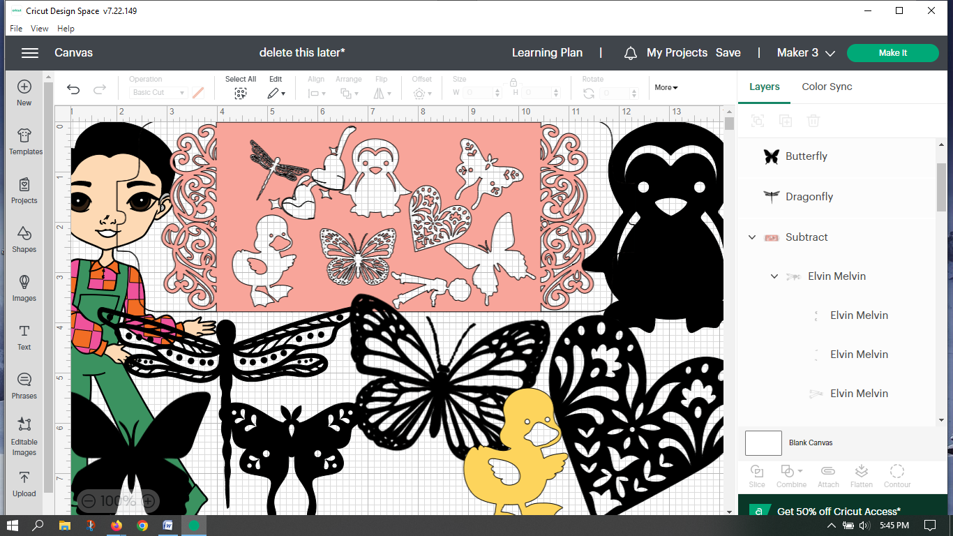
Another important thing to know about images is that when you click on Images (see arrow on the 1st picture below), you will be taken to images that are provided by Cricut. You can use these images, but beware…many cost money. Even when you click free as seen in the 2nd picture, they may not be free. As you see in the 3rd picture, there is an “A” in a green box just above and to the left of the dragonfly. That means it is only free if you’ve paid to subscribe to Cricut Access (~$100/yr). The images are only free if the free box is checked and there is NO “A” in a green box above and to the left of the image you like. My suggestion is to go to getdrawings.com or a similar website and search their drawing, coloring, or clipart sections for the picture that you want and then download it. Look for “free for personal use”.
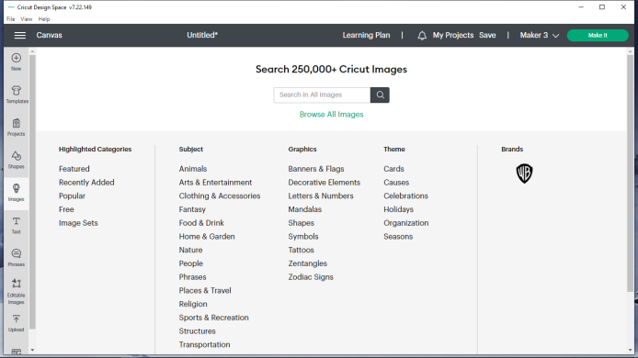
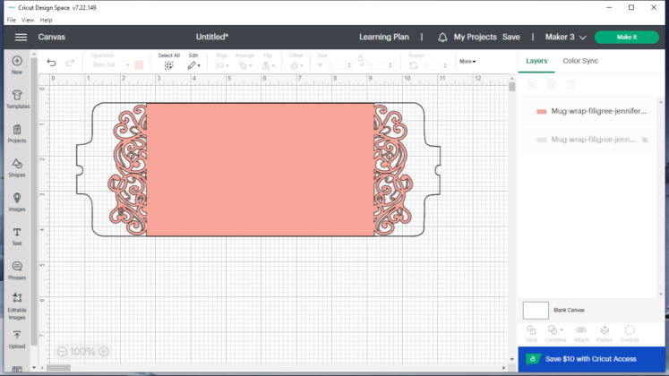
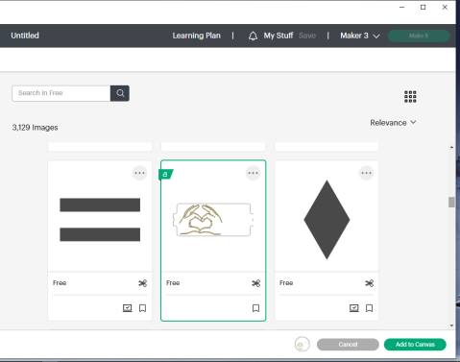

- On the internet, go to getdrawings.com, and in the search box type the word in for whatever you are looking for (example = dragonfly). As seen in the picture below, I am searching clipart for vector dragonfly. You can change the words to whatever you want. Click on the magnifying glass to search. The best images to pick are black and white and fairly simple. Small details will be hard for the Cricut to cut out once we reduce the size.
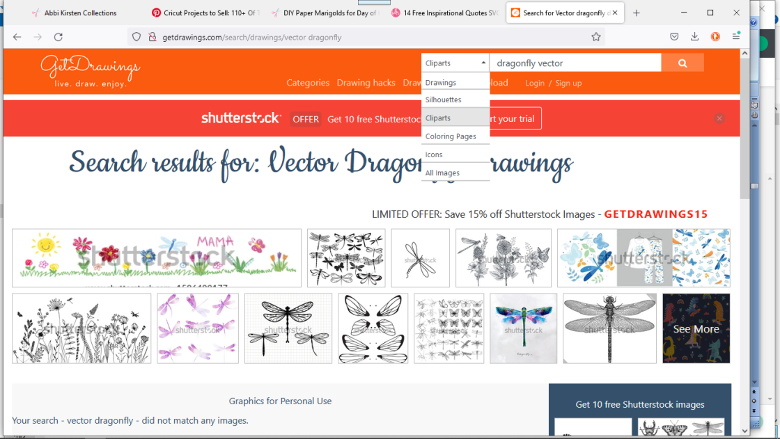

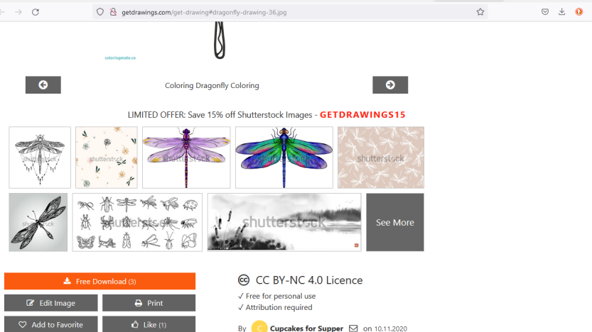
- Once you find the picture you like, scroll down the page farther and you will find the download button. Download the image.

- Click on Download again and you should see the download complete at the top of the screen.
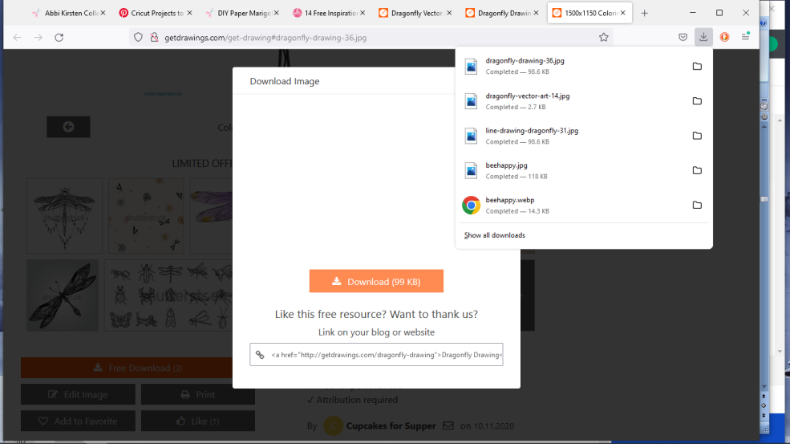
Close the internet window and go back to Cricut Design Space.

- Click Upload the same way you did on #4 earlier. Now click Upload Image.

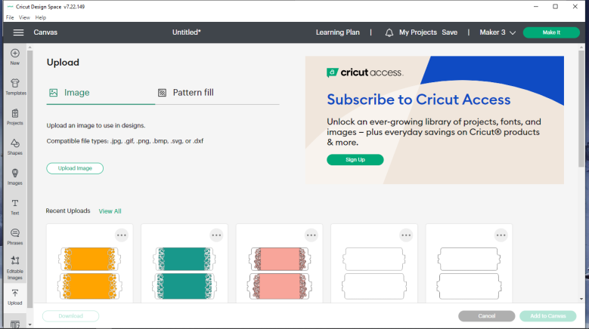
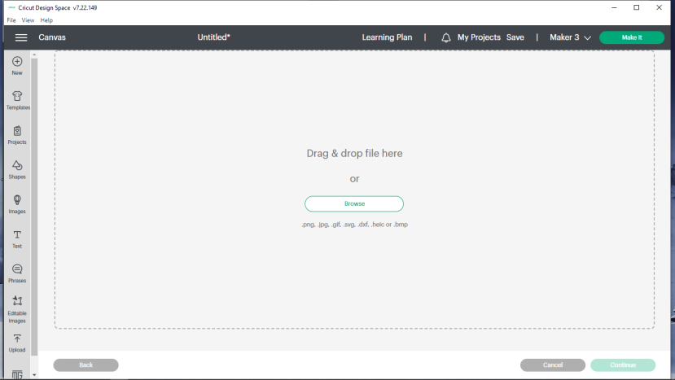
- Click on Browse.

- Click on the Downloads folder and find your saved file and click on it (mine has a yellow arrow pointing at it – yours should be at the top of the list, but will probably have a different name). Click Open.

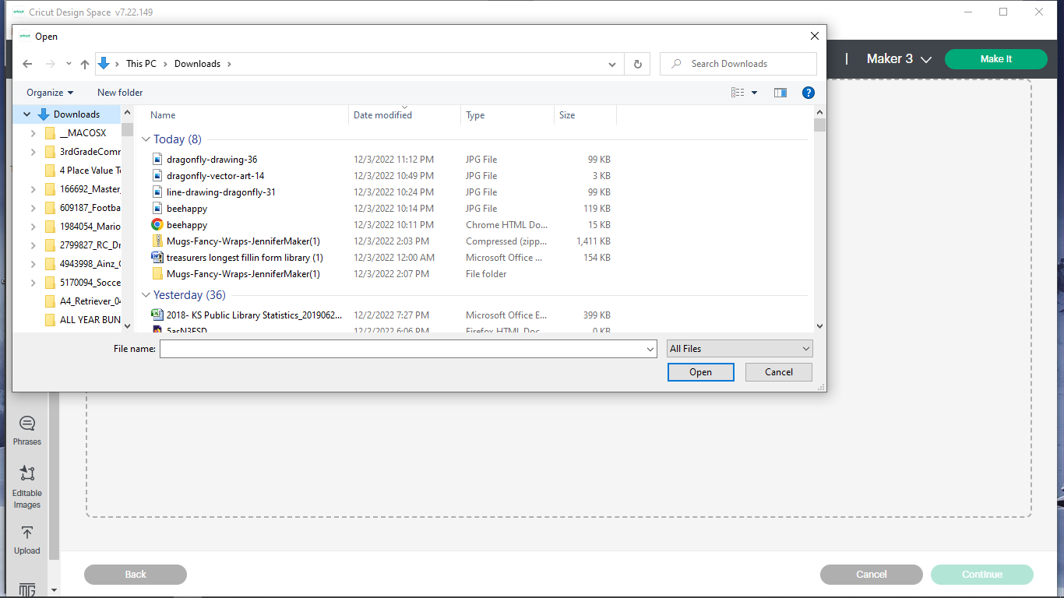

- Choose Simple and click continue.

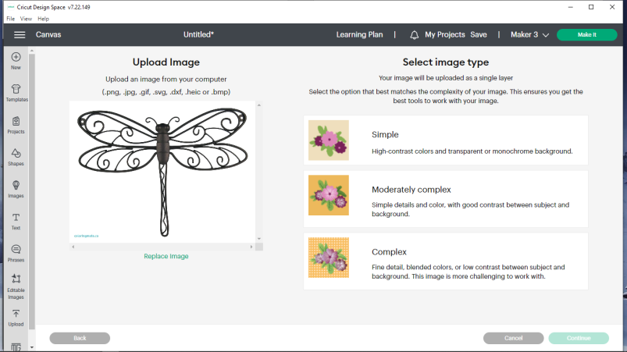

- On this screen, you will have to remove the background – everything that isn’t black. I have already clicked in the area near the lower arrow. When I clicked there, it turned the area to a blue gridded pattern from the grey color it was. You need to make all the grey areas (like where the upper arrow is pointing) turn to the blue grid pattern. Click on those area to change them. If you miss a grey area it will not cut out the detail. Don’t miss the little spots!
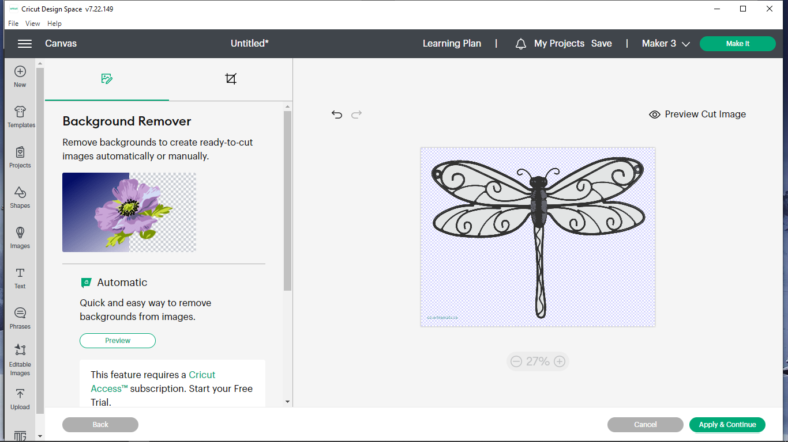
Finished it looks like this. If you make a mistake, click the undo button (top left arrow). Zoom in and out to see the smaller areas you need to remove! Click Apply and Continue.
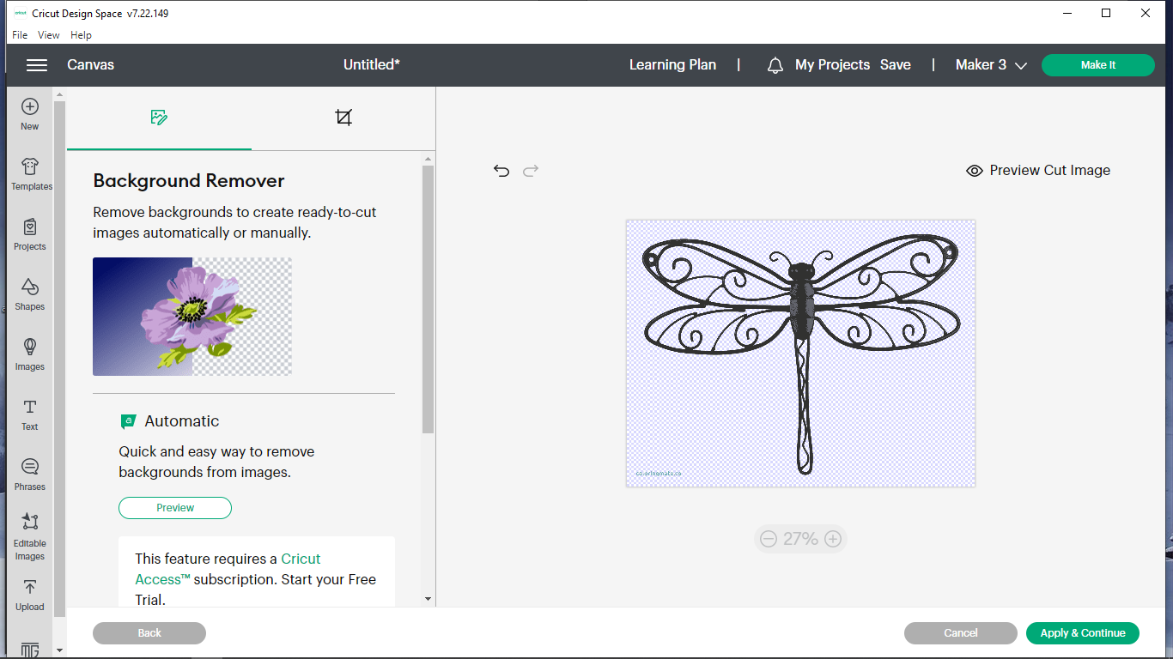
Make sure you clicked on all the gray areas – even the small areas like the ones on this part of the dragonfly’s body. Zoom in to make it easier!
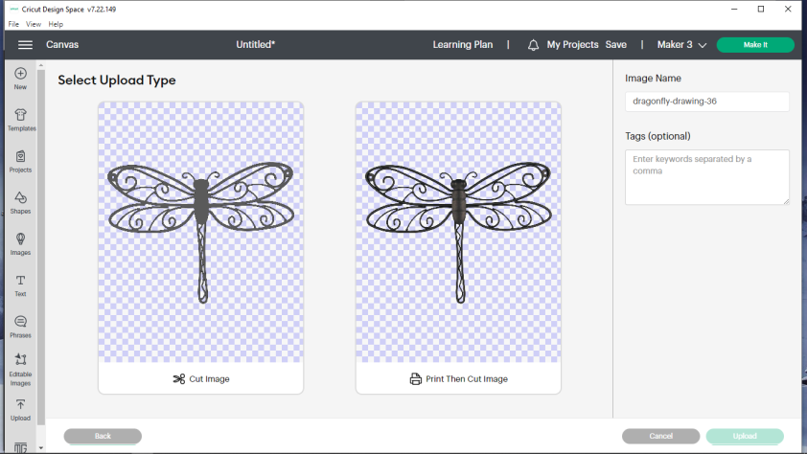
- Click on Cut Image and click Upload. (You can change the image name if you want.)

- Now select the image you chose and click Add to Canvas.
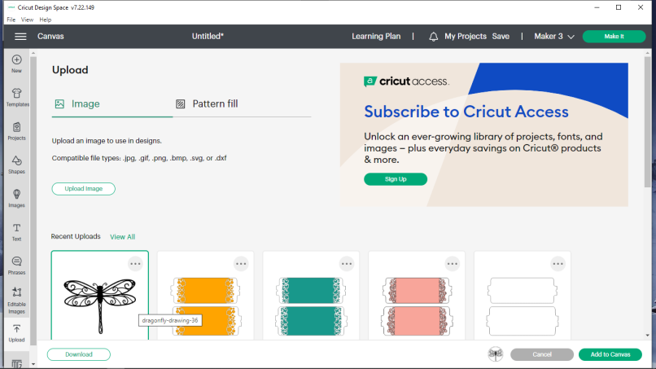

- You image may come in huge. If it is, lock the padlock (if it’s unlocked) by clicking on it and then reduce the image’s size. To resize, go to the left top corner of the image and double click on the white square and drag inward. It will shrink in size. If image is now off to the side, double click on it and drag it to the mug wrap. Repeat until it is the right size.
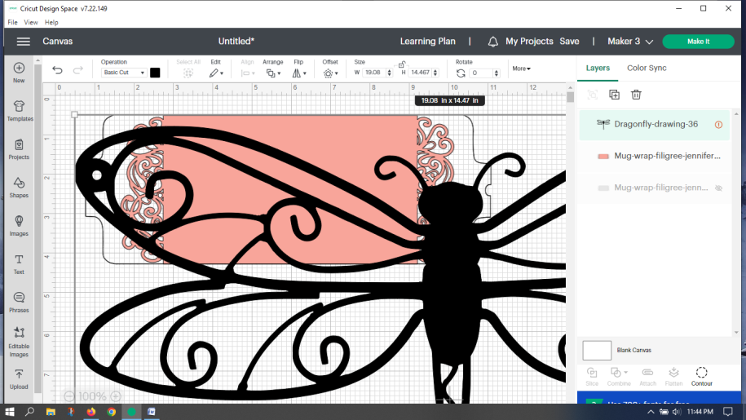
- If you would like to rotate an image, follow the next steps. If you don’t, just place your image wherever you think you want it on your mug wrap. To rotate it, move your cursor to a point about the same distance from the image to where the tip of the yellow arrow is below – your cursor should turn into a curved line with arrows on both ends. When it does, double click and drag it the direction you want it to turn. You can turn from any of the image’s four corners this way. Drag it to where you want it on the mug wrap.
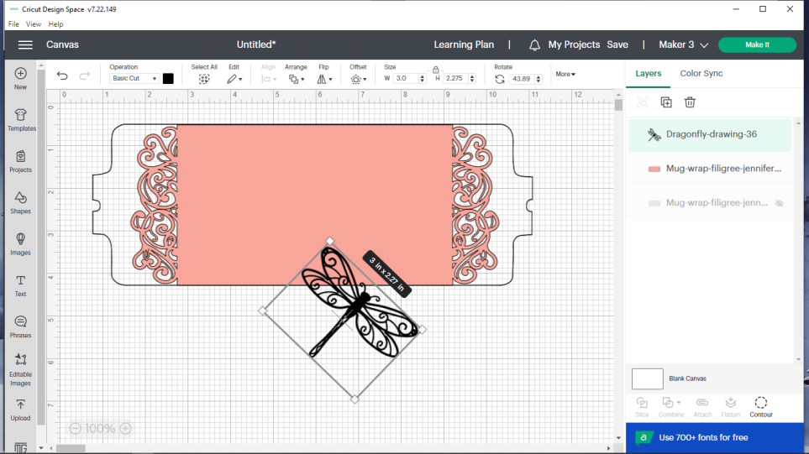
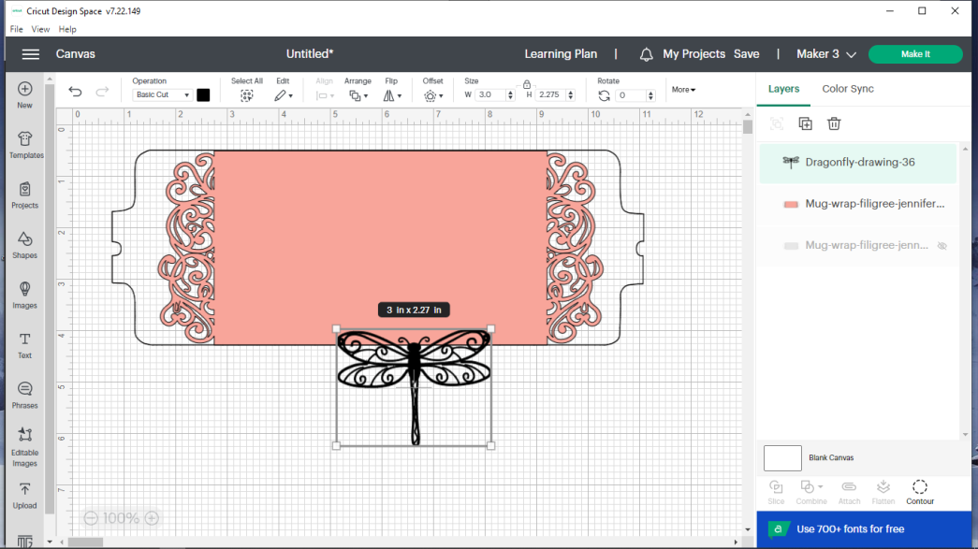

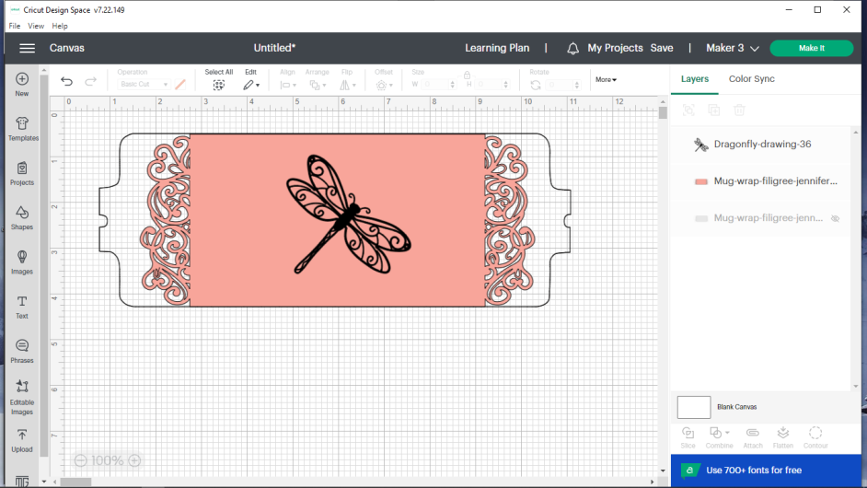

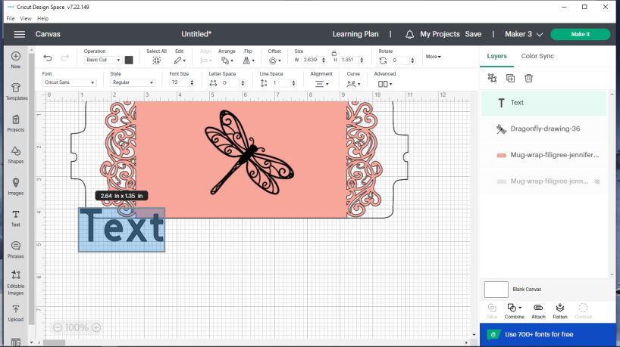
- Go over to left side and click on Text. A text box should appear as shown. Do not click on the text box, just type what you want. Because it was highlighted in blue, it will replace the word “Text” with whatever you type.

- At this time, I want to point something out. ANYTHING you put onto your Design Space canvas defaults to cut (at least at this time). So far, my pink mug wrap will be cut, the dragonfly will be cut, and my words will be cut (my text is selected and it indicates basic cut next to the yellow arrow on the pic below). You want the words to be cut out of the mug wrap – they will be white since the mug’s color will show where the letters are cut out. Now we will resize our text, rotate it (if desired) and then place it where we want it. This process is exactly the same as it is for an image. To resize your words, go a white corner square (one of them is indicated by the 2nd yellow arrow, double click on it and without letting go, drag inward. To rotate your text, go out away from one of the corner squares (distance shown by the 3rd arrow’s tip) to the spot where your pointer turns into a curved double headed arrow. Double click and move the direction you want it to turn. Finally, double click somewhere on top of your words and drag the words to the location you want them.

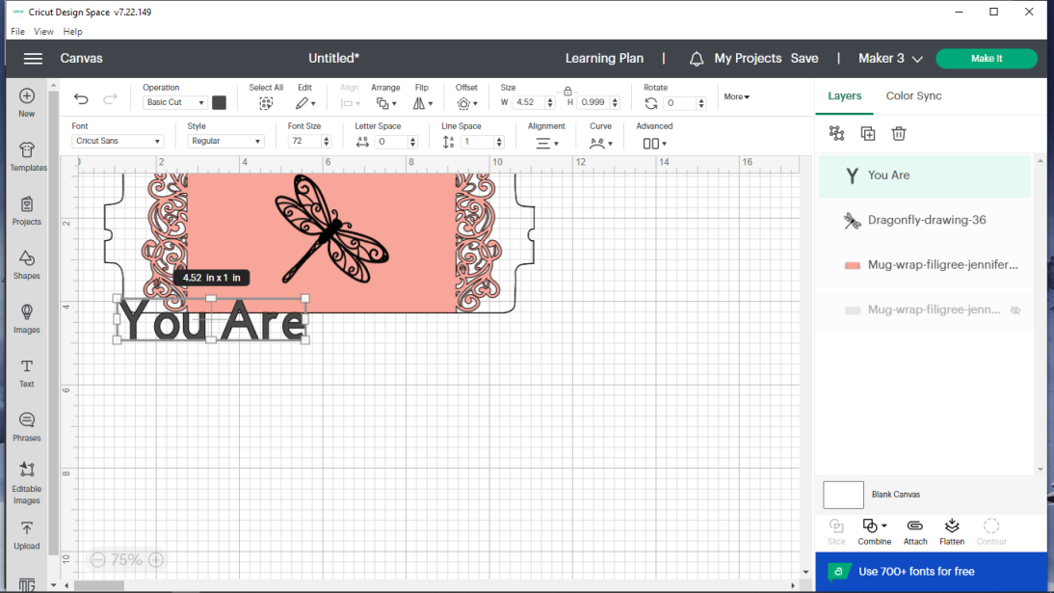
- To change the text font (appearance of your words), make sure your words are still selected (surrounded by the box that has little white squares at the corner), then go up to box under Font and click on it (see 1st pic). After you click on it, your screen will look like the 2nd picture.
Click on System . The reason we choose system is because those are the fonts already on our computer and they don’t cost money like most of those under the Cricut tab.
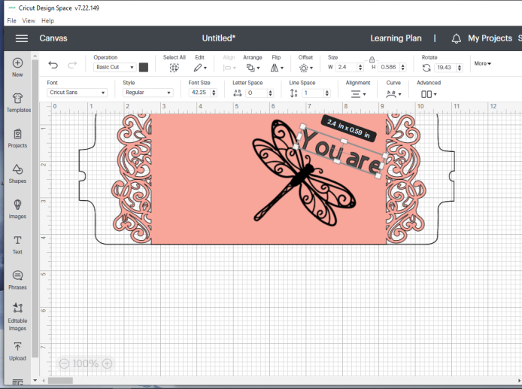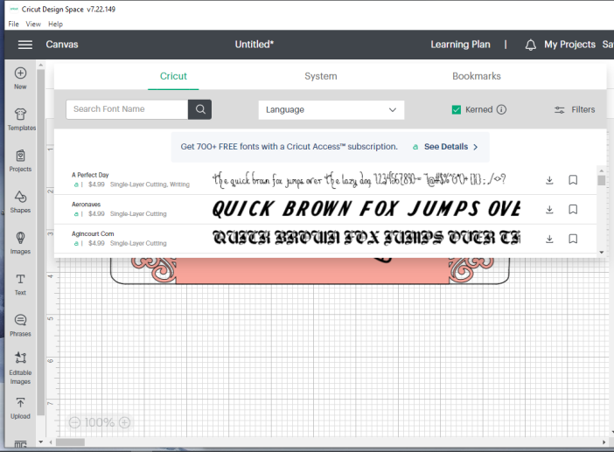.
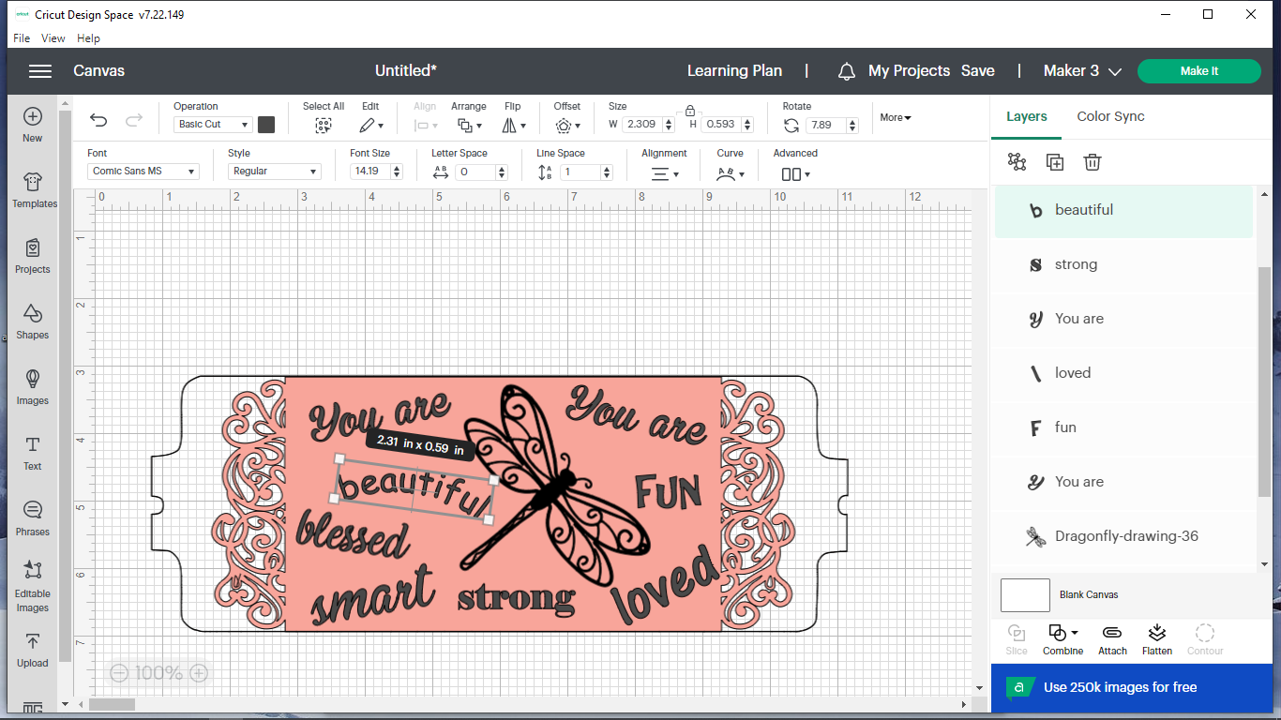
- Scroll through the list for a text style you like. Click on it and then click somewhere in the gridded area. If you’d like to add more text, just repeat steps #21-24 for each text box you want to add. I added 7 more text boxes to get the picture below. To curve text, as you see the word “beautiful”, go up to the down arrow just under Curve, and click on it. Move the slider until it looks how you want it.

- To have it cut everything out in the right spot (as you see it on your mug wrap), we must attach everything together. Double click somewhere above and to the left of your mug wrap. Without letting go, drag down and toward the opposite corner of the mug wrap making sure that as you drag, the mug wrap and all your words and images end up at least partially highlighted in gray. When you let go, it will show a rectangular box like the second picture. Note: As long as some gray is on an image or word, it will select it. Click Attach.
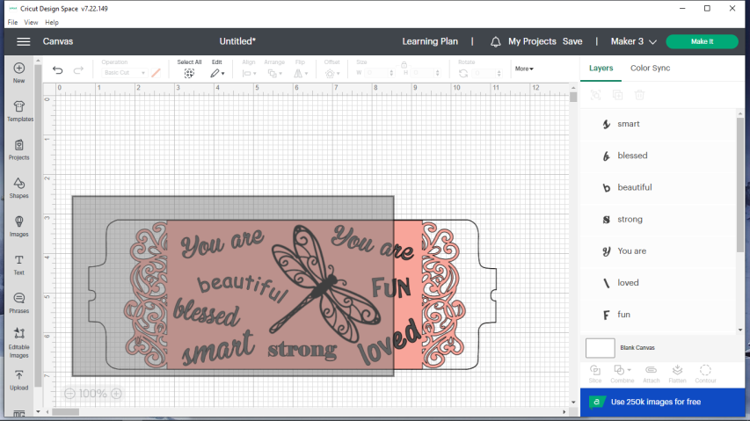
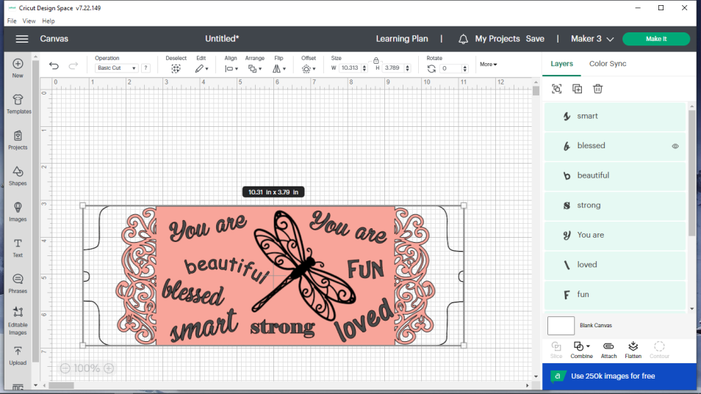
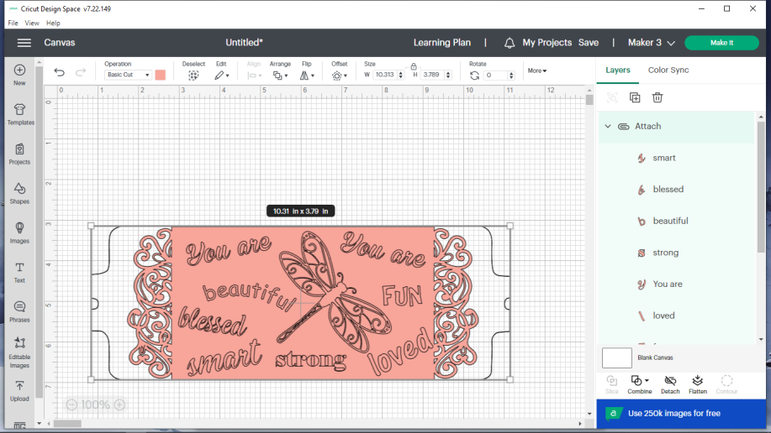
- Check to see if the machine listed is the one you will be using. If it isn’t, click the down arrow and change it. Click on Make It.

- Choose On Mat and then click Confirm.

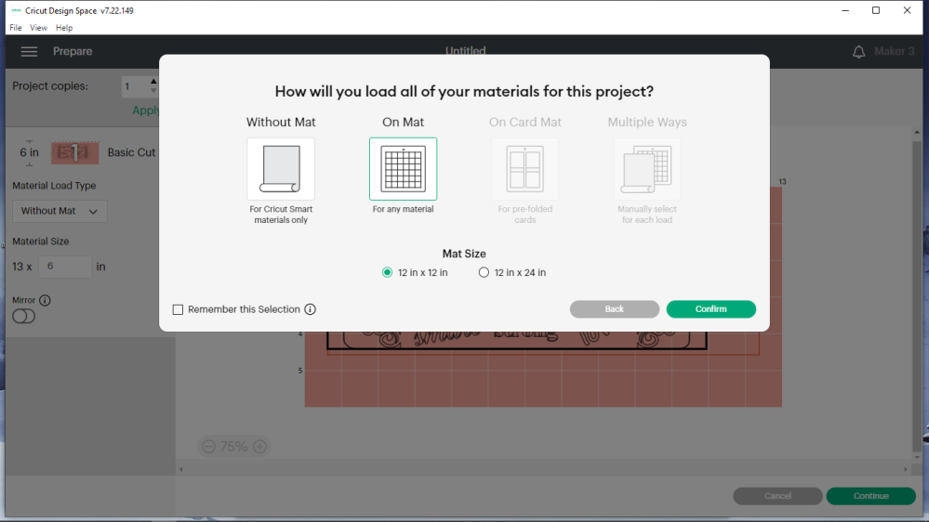

- Your next screen should show all your images and words on the mug wrap. Choose mirror (MUST DO!). All your words and images should be mirror-image now. Click Continue.
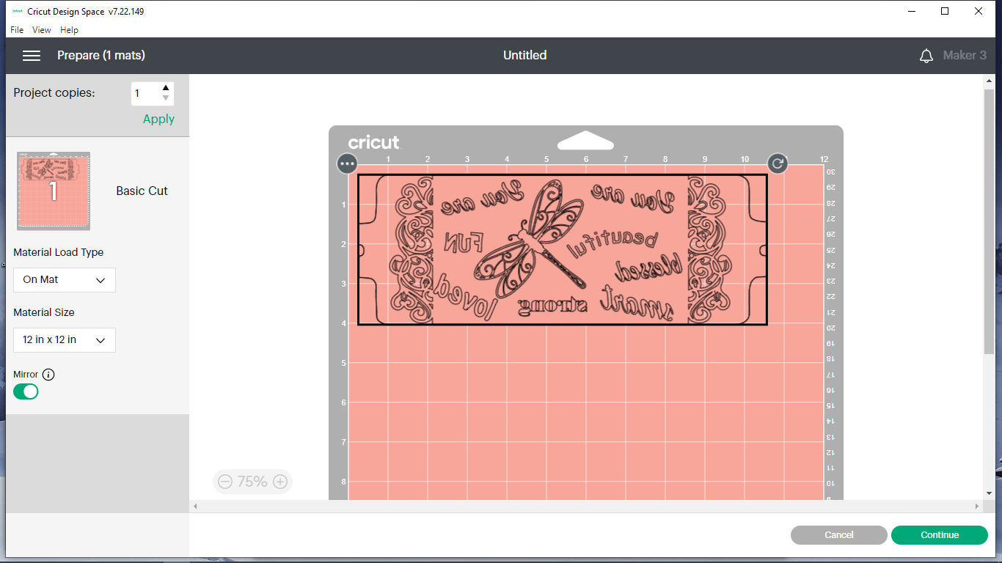

- Select Infusible Ink Transfer Sheet. If you don’t see infusible ink transfer sheet, click on Browse all materials.
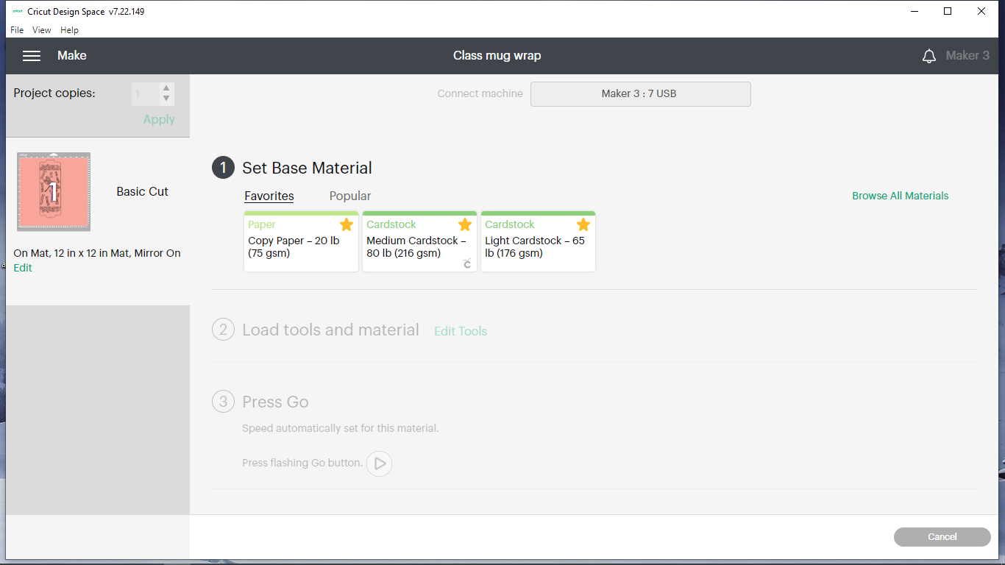
- Type in infusible where it says “search all materials” and click on the magnifying glass.
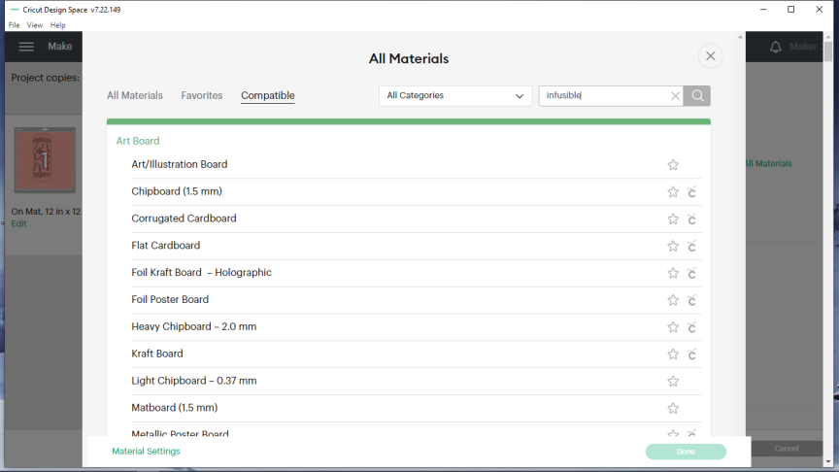

- Click on Infusible Ink Transfer Sheet and choose Done.
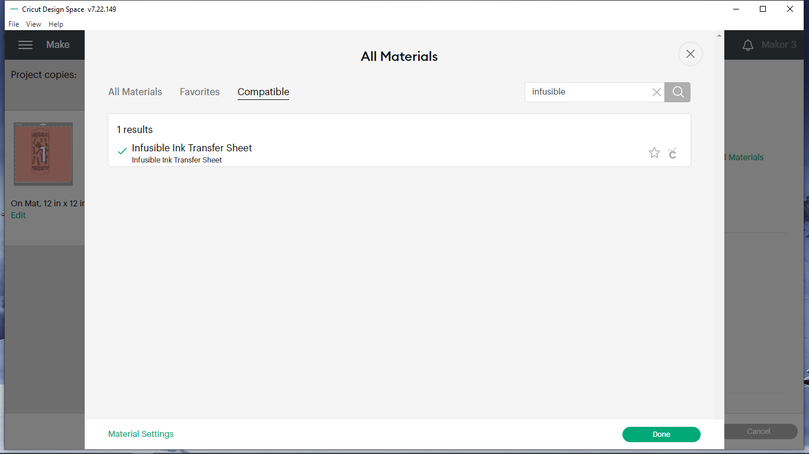

- Click on the down arrow to the right side of the box below Pressure. Choose More (super important! - will not cut deep enough unless it is on more). The screen below shows that “More” has been selected. Also note that the other arrow shows that mirror is on which is absolutely necessary if you have any wording – if it is not mirrored, your words will be backward on your cup. Make sure the fine point blade is clean (can poke into an aluminum foil ball, carefully, many times) and in clamp B. Now put the infusible ink sheet you chose (dull colored side up) on a clean, standard grip mat. Press it down carefully (with clean, dry hands or you could get fingerprints on your mug) and make sure there are no bubbles under it. Press the blinking double headed arrow on the Cricut to load the sheet.
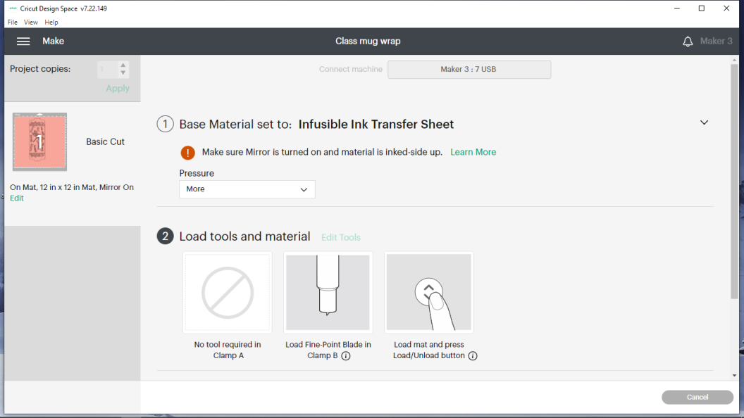

- After double checking everything, press the triangular shaped “go” (play) button on the Cricut (will be blinking). It will start cutting out your design.

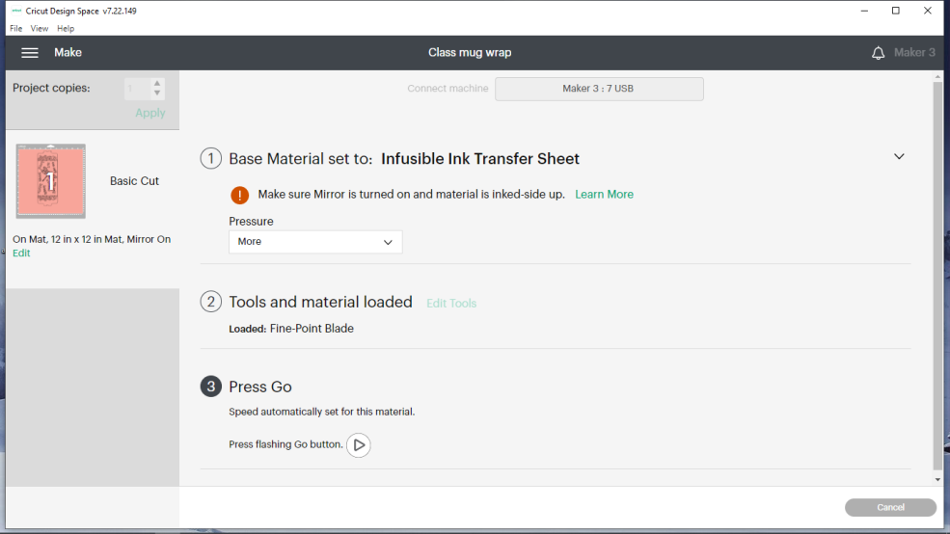

- Make sure the cut goes completely through the infusible ink layer. (I will show you how to check.) If it didn’t, don’t unload the mat; just press the button with the triangle shape on it again. It will re-cut. However, if you did have it on more pressure it should have cut fine.
- Choose Done on the screen. Unload the mat if the Cricut doesn’t. To do this, press the button with the double-headed arrow on it. Carefully peel the mat away from the infusible ink sheet. Don’t let it touch the sticky part of the mat! Use scissors to cut just outside the border cut by the machine if you used a large (12x12) sheet of infusible ink. It is easier to work with a smaller area.
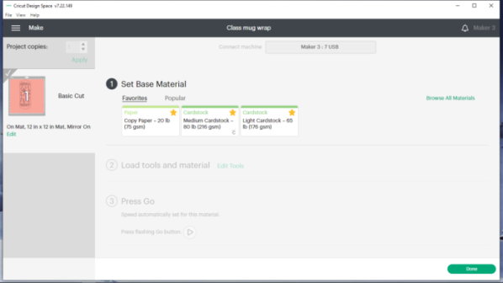
- Make sure your hands are clean and dry. If they aren’t, it can smear or leave fingerprints in the ink. Use a weeding tool and your fingers to weed the parts that are to be white (mug’s color). The words should be weeded as well as some parts of the image. If you need help, ask! Looking at the Cricut Design space canvas screen, where your design is, may make weeding easier.

- Important!! Only sublimation mugs will work! They have a special coating that allows the ink to move into it. Clean a mug designed for sublimation by wiping it with isopropyl alcohol wherever the design will go or use a lint roller on it if a lint-free cloth isn’t available. (I have used mugs straight out of sealed packaging without cleaning them, making sure I didn’t touch anything, and had good results.)

- Turn the mug’s handle toward you with the mug upright. Centering the middle of the mug wrap on the side opposite the handle, wrap the mug wrap around the mug keeping the top and bottom edges lined up with the mug’s edge. Check the distance between the mug wrap ends and the handle. The distance away from the handle on each side should be the same. If it isn’t, carefully adjust it. Using your hands, make sure the mug wrap is tightly attached to the mug and air bubbles are smoothed out. Secure the edges underneath the handle using heat resistant tape. Secure the top and bottom edges of the wrap to the mug all of the way around. If there are any cuts in the protective film that the design is on, tape over them. (Gaps at the top or bottom edges of the wrap or air bubbles can cause smeared or blurry looking transfers. If the infusible ink transfer design goes too close to the handle, it will not transfer right and you will end up with a blurry look (NOT PRETTY!).
- Plug in the mug press. When it is hot, it will beep and have a green light. Once it is up to temperature (green light), place the mug in it so that the handle is slightly right of the center of the opening. (The handle in the picture below is NOT positioned to the right enough. The handle should be about where the arrow is pointing.) Push down on the raised levered handle (see rightmost arrow) until it locks in place. If you notice that the mug is not centered, lift up the levered handle and move mug carefully. If it’s not moved carefully or it has gotten too hot prior to moving, the ink may smear. If any part of your design is not touching the heated plates, it will not transfer - or if it does, it will look faded and fuzzy/blurry.

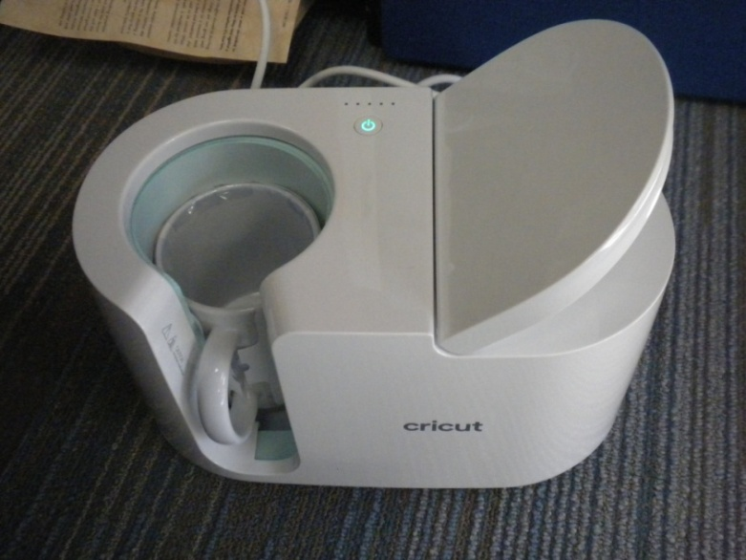

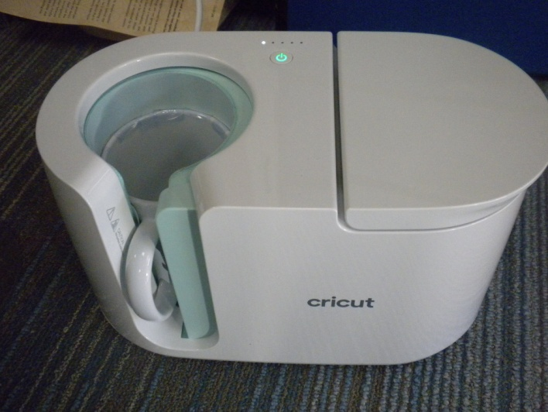
- As seen in the picture, once the mug is locked in place, the small lights will begin to light up. When it is done heating the mug, all the lights will have lit up and it will beep.
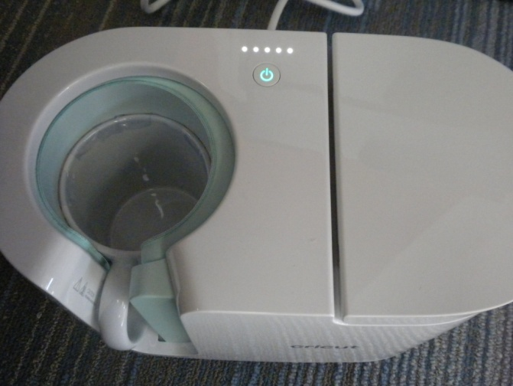
- Release the mug by lifting the handle and carefully remove it. Place it on a potholder, EasyPress mat (yellow arrow), or other heat-resistant material to cool. When cool, remove the wrap. You’re done! The cup is dishwasher and microwave safe since the ink has sublimated (transferred in gas form) into the coating on the cup.
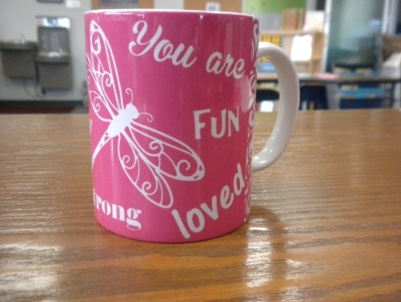
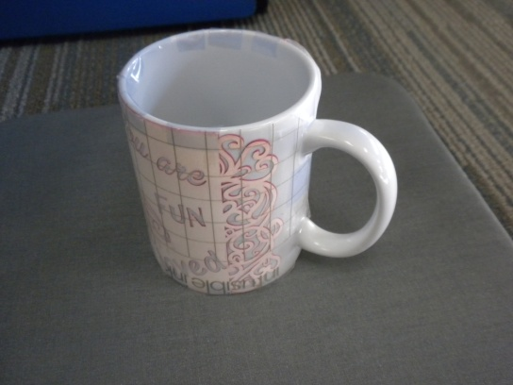

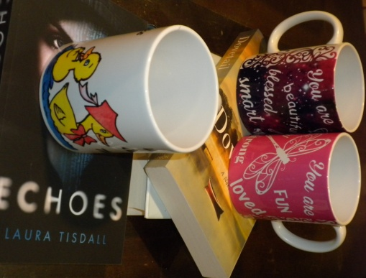
This class from the Discovering How Art Can Affect Our Lives program was made possible in part by a Peggy Barber Tribute Grant from the American Library Association’s Public Programs Office.

