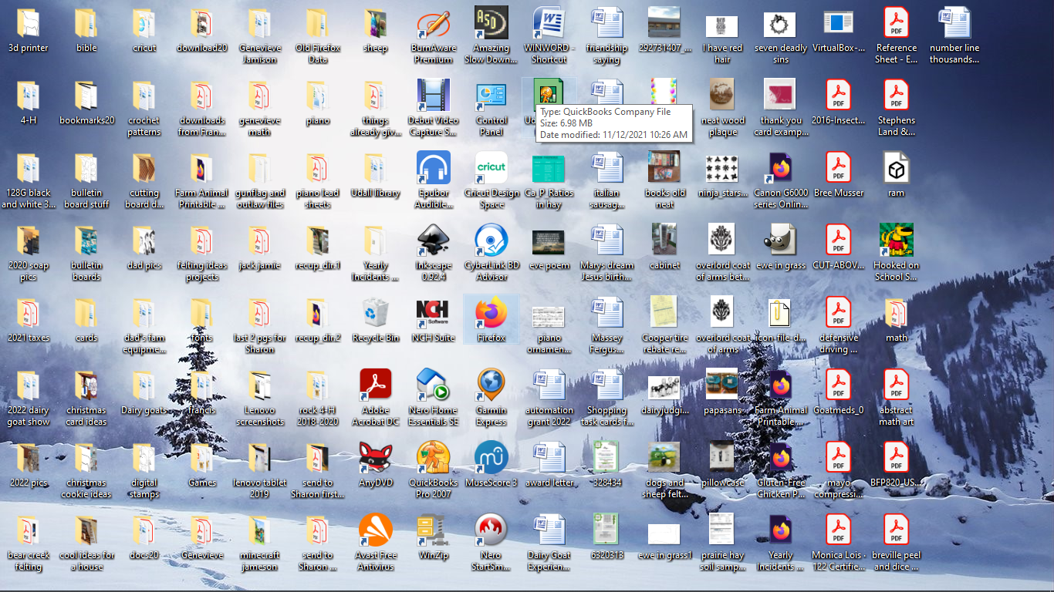**Basic Card Design in Cricut Design Space**

1. Double-click on the Cricut shortcut on the desktop to open Cricut Design Space.
2. If a login screen appears type in the e-mail and password on your computer.
3. **Click on to maximize your screen and then click on New Project (see pic below).**

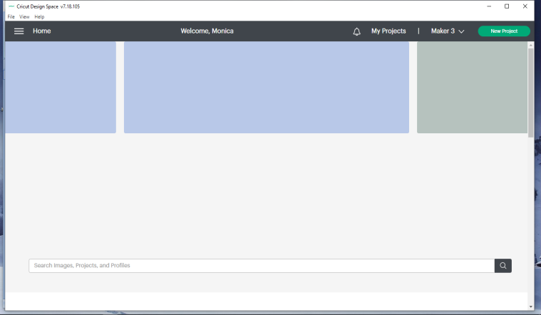

1. **Click on Shapes**

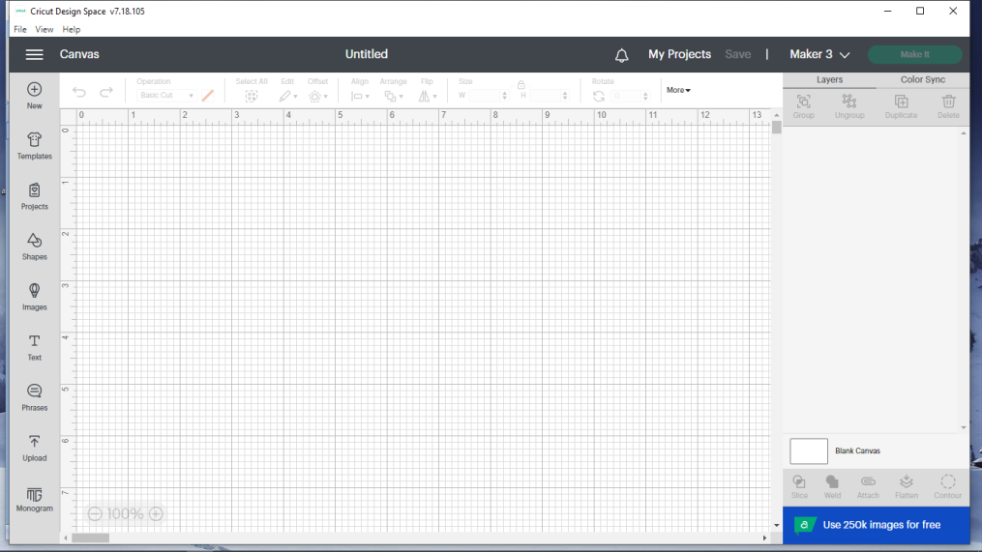

1. **Click on the square shape**

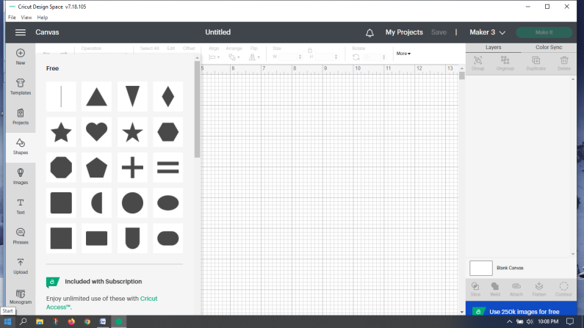

1. **Click on the padlock symbol to unlock**. Clicking on the padlock allows you to toggle between locked and unlocked. If it is locked, proportions will stay the same if you increase either the height or the width (won’t distort the shape you already have). If it is unlocked, you can change both the height and width. This allows you to make a rectangle out of a square (or an oval out of a circle). We want unlock since we want a rectangular shape to make our card.

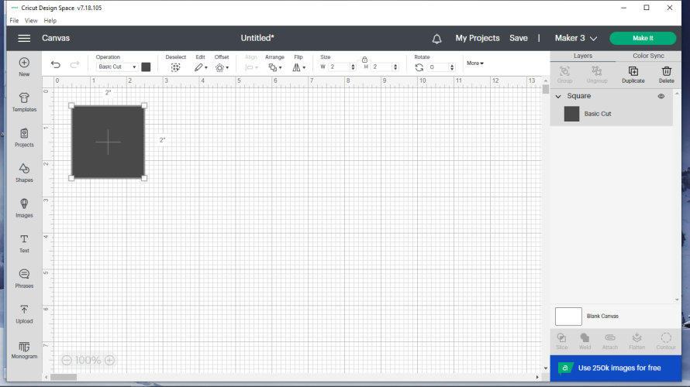

1. **Change the W (width) to 6 and the H (height) to 8 and press enter.** This change will make a card 6” wide by 4” tall when folded in half horizontally.

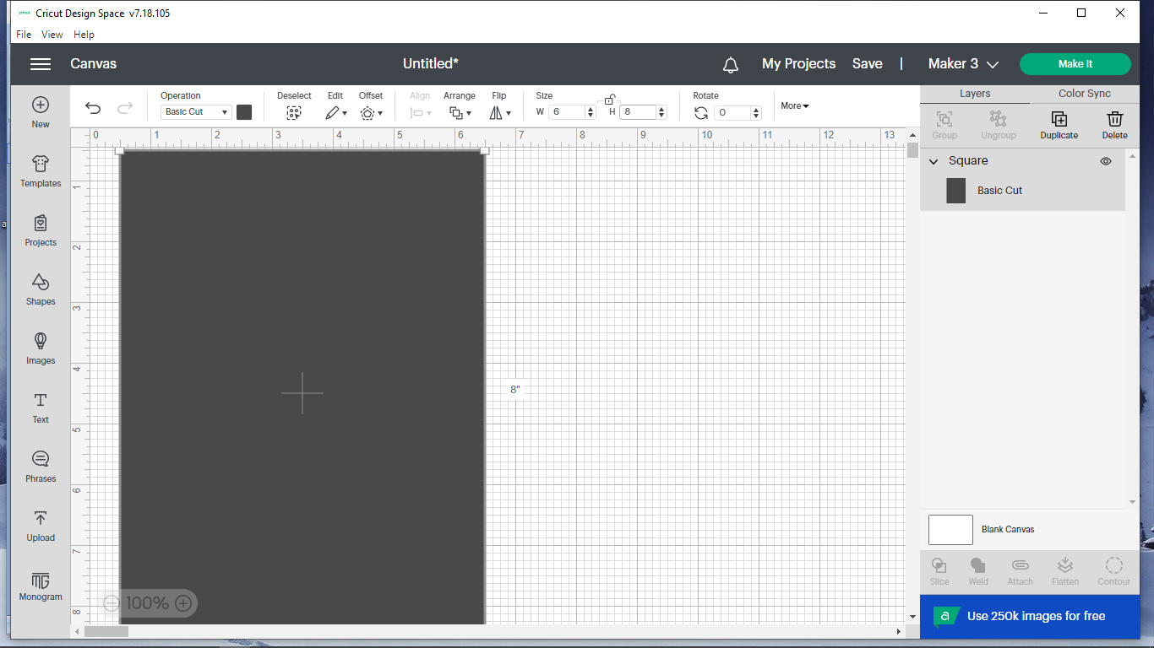

1. 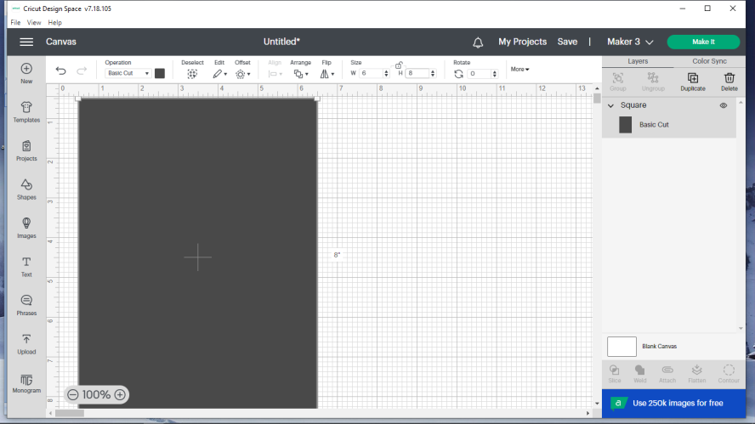 **Click on the ( – ) sign to shrink everything down to 75% instead of 100%**. This will make it easier for you to see exactly what is being done in the next steps.
2. 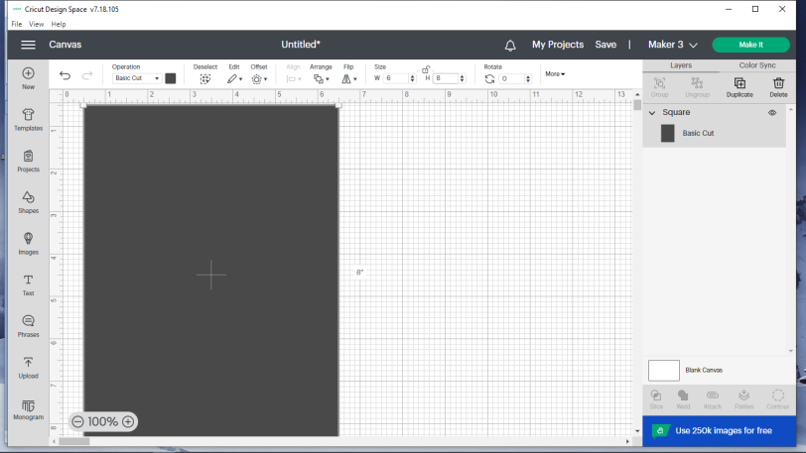 **Click on the black square.**
3. **Choose the color that resembles the color of the card you want to make** (the color that you will see on the front and back of the card). It’s not important that it matches, it just needs to remind you which color the sheet of paper you need when it prompts you to load paper.

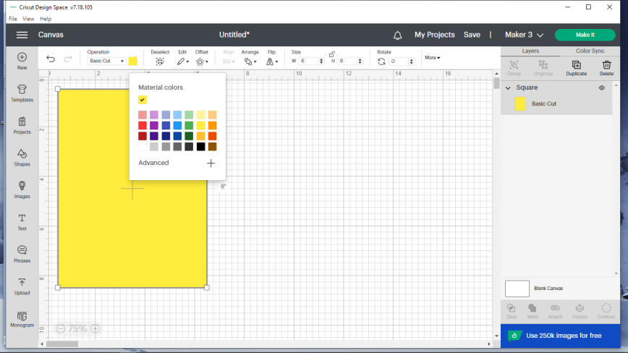

1. **Click anywhere on the gridded area to exit the color selection box** (clicking in the gridded area de-selects whatever you were working on)**.**
2. **Click on Shapes and choose the heart.**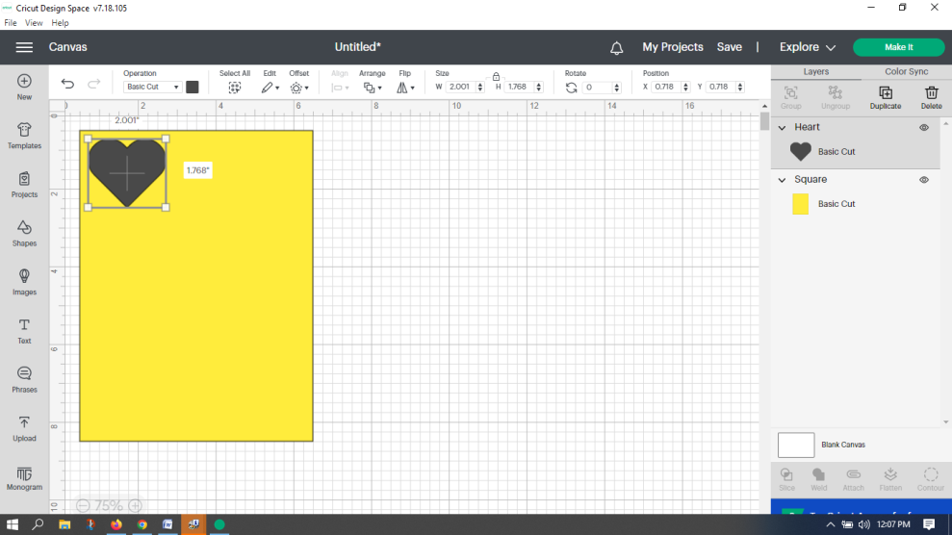
3. **Go up to rotate, type in 180, and press enter on the computer keyboard.** Your heart should now be upside down. We will use the heart shape to make a cut out in our card.

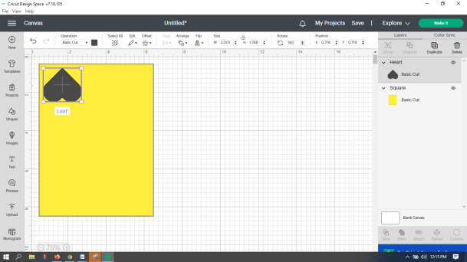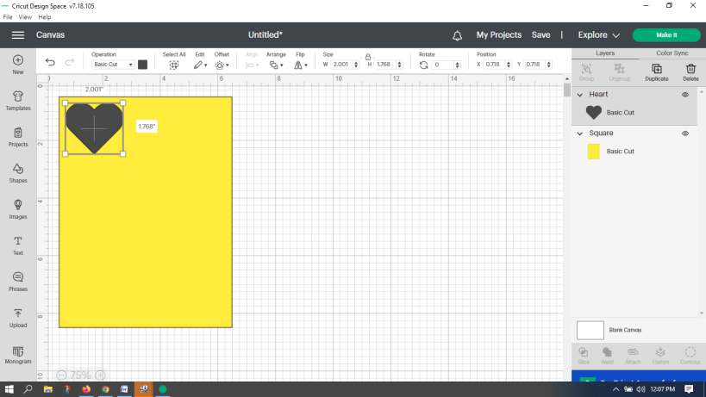

1. **Go up and click on the padlock above the W and H to make it unlock. Then go to W and enter 4.30 and enter 5.06 for H and press enter on the computer.** This will make our heart the right size to make the cutout like the example card. Your screen should now look somewhat like this.

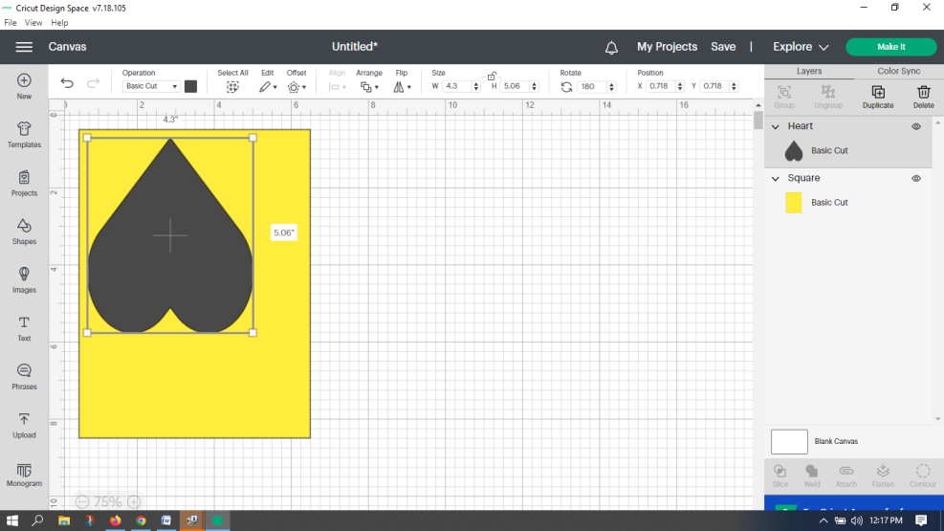

1. **Move your selection arrow/cursor to somewhere toward the top right of your rectangle** (make sure you’re in the colored area surrounding your heart/shape). **Tap twice on the touchpad and without letting go, drag your finger to the right some and then let up on your finger**. This should have moved your rectangle to the right (for a heart to cut out right, the rectangle needs moved over). It should now look like this (DOES NOT have to be in the same spot as my picture – just moved over some).

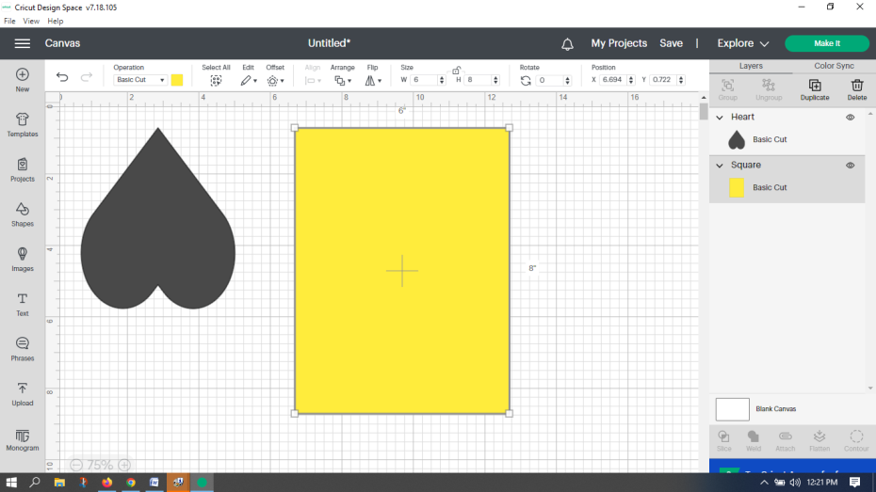

1. **Click on Shapes**. See #4 earlier if you have forgotten where it is.
2. **Click on the shape that looks like a line located at the top left (may say score line when you are above it).** The line we are making now will be a score line that will allow the card to be folded easily and it will be placed in the right place so we don’t have to guess or measure.
3. **Go up to rotate and change the 0 to 90 and press the enter key on the computer**. This will make your line go from vertical to horizontal (see #13 for where rotate is).
4. 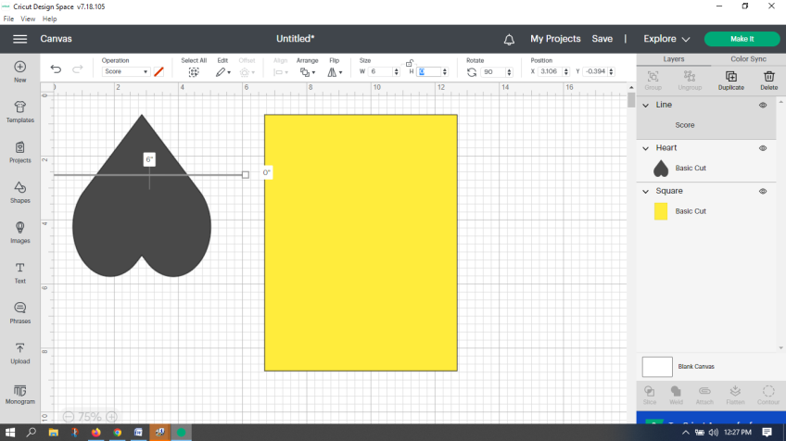**Click on the padlock and then change W to 6 (width of line will be 6”) and H to 0 if the computer didn’t already do it (minimal height).** See #6 for padlock and #7 if you have forgotten where W and H are. Your screen should now look similar to this.
5. **A) Look at the picture below. If your Line layer is already grey, go to C. B) If the Line layer isn’t grey, click on it.**  **C)** **Hold down the shift key on the computer** (which allows you to pick an item right next to the previous one) **and click on the Square layer – making that area gray, too.** You will now see that your rectangle and horizontal line are enclosed by a box. (Note: A grey layer means you are working with it.) 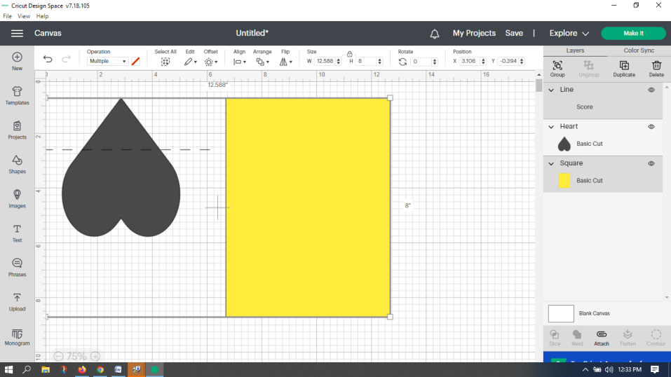
6. **Just under align, click on the downward pointing triangle and choose center (last option).** This will center your horizontal line horizontally and vertically over your card which makes your score where it should be to fold the card in half. To align anything, the parts you want to align together, MUST BOTH be selected.

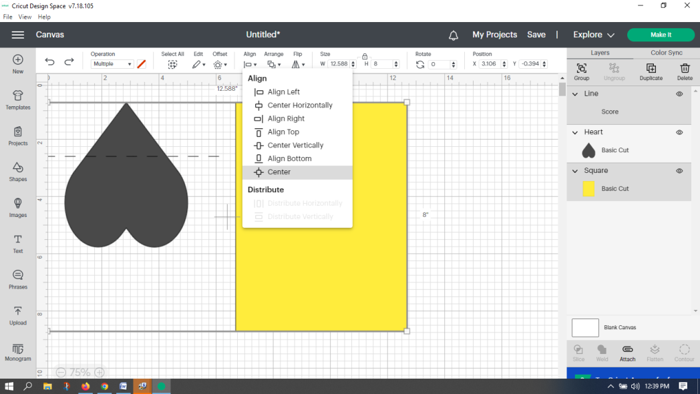

1. **Go over to the bottom right corner of the screen and click on Attach just above the blue highlighted rectangle (see above pic).** (The Line and Square layers straight above the attach button should still be gray when you click attach –and will be gray after they are attached.) By attaching the line to the rectangle, you can move the rectangle around if necessary and your line will stay in the proper place. If you do not attach them, and you move either the line or the 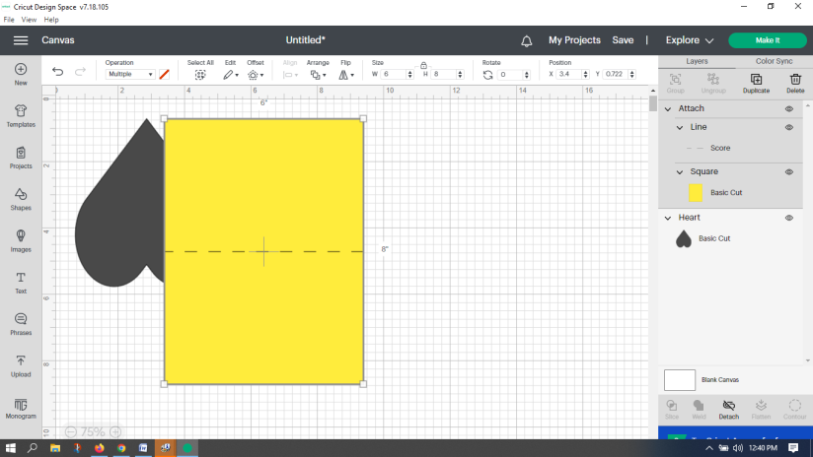rectangle, you will have to realign them to get your score line for folding in the right spot.
2. 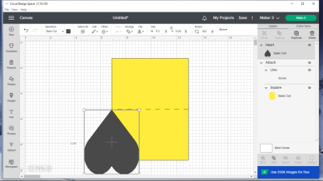**Move the heart over to where its tip is just below the score line and where the side of the card splits the heart in half.** It should look like the picture below. **If your heart is behind the rectangle, click on Arrange and choose Bring to Front.**

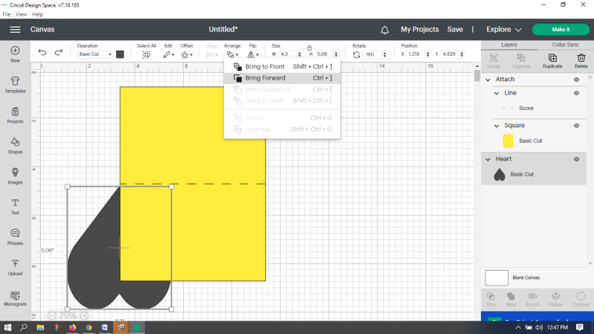

1. 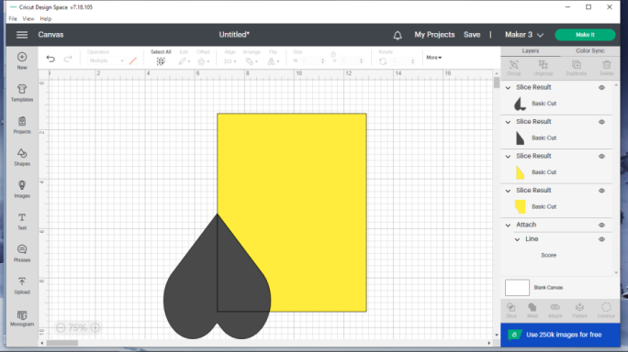 **Hold down the Shift key on the keyboard and click on the Heart layer and the Square layer** which are located on the right side of the screen (see blue arrows on picture below). **Click on slice.** Slice cuts the shape on top out of the shape below. It now looks like the 2nd pic.

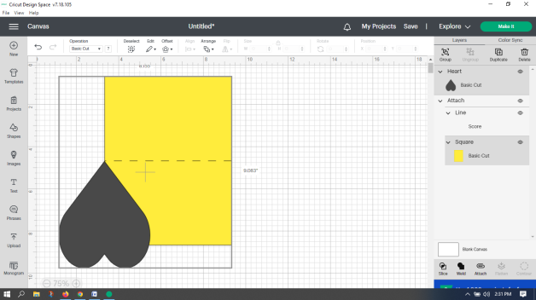

1. We no longer need the heart since it has made our curved cutout. **To delete it, click on the heart and press delete on your computer.** You will still have a gray area on your rectangle (see below). **Click on the gray area and press delete again.** Now you have an odd lower left corner that is outlined (see below). This is showing where it has cut the overlapping part of the heart out of your rectangle. **Click on it and press delete one more time.**

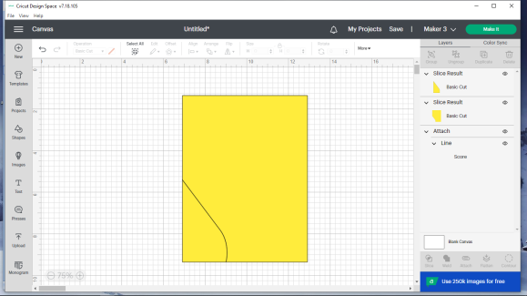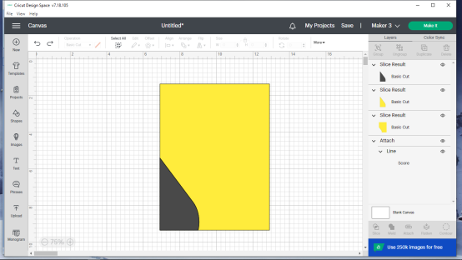

1. 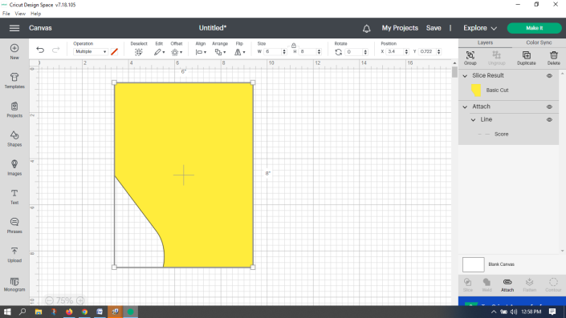**Click on the Slice Result layer and then click on Arrange and choose Send to Back. Go to the right side of the screen and select the Slice Result layer and the Line layer and click on Attach.**
2. **Click on shapes, and choose the square. Click on the padlock** above W and H (so it unlocks). **Change the W to 5.75 and H to 3.5 and press enter on the keyboard.** This will give us a smaller rectangular piece of paper (in a color or design) to glue to the inside of our card. (The slightly smaller dimensions will give us a border of the original card color around the glued in smaller piece.) **Right click on the black rectangular shape you just created and choose Send Backward (or go up to Arrange and choose Send Backward ).** It should now look like this.

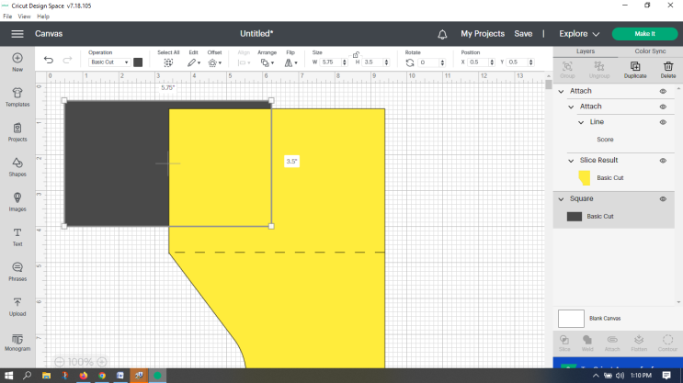

1. **Go up to small black square toward the top left of the screen and choose a color similar to what you want glued to the inside of your card.** (Done just like #10 earlier). **Change the percentage in the lower left hand corner of the screen to 50%.** (like #8) It should look similar to this (your new rectangle may be a little more to the left).

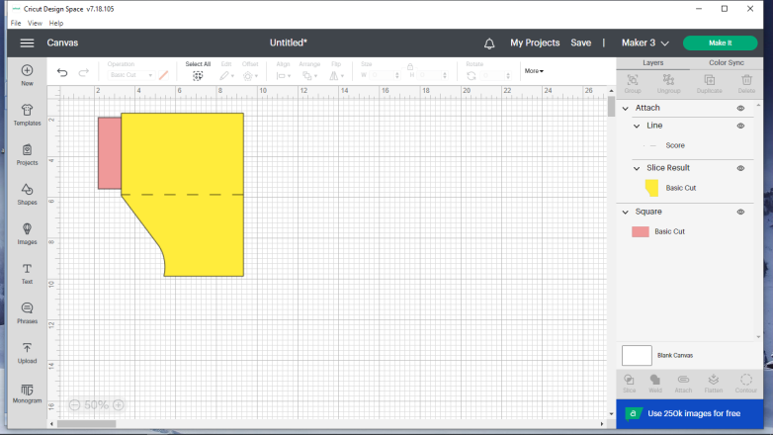

1. 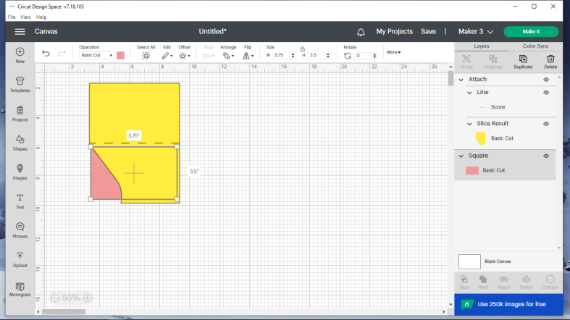 Drag the pink rectangle down until it is centered on the lower half of the card (doesn’t have to be exact).
2. **Now click on text** (on the left side of the screen about halfway down).  **Double click inside the box that was just made. Delete the letters that are there** (by pressing backspace or delete on the computer) **and type To:. Then press enter on your computer and type the name of the person you want to give the card to. Change the font size to 17 and press enter. Rotate to 340 and press enter. Double click on the text box and drag it down to where you see it below.**

**Click on the gridded area of the screen.**

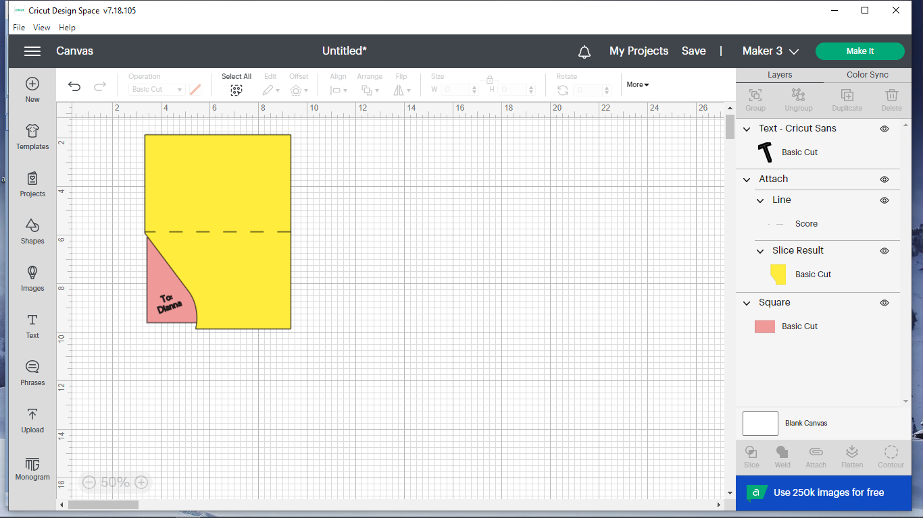

1. **Click on the To: text box**. **Now double click on it and go up to the box right under Operation** (toward the left side just under the horizontal black stripe that goes across the top of the screen). **Click on the triangle next to it and go down and choose pen. Click on the square next to the triangle. Choose .8 gel pen and a color similar to the color of the gel pen/marker you will use and then click on the gridded area to get out of that menu.** It now looks similar to this. (I chose blue.)

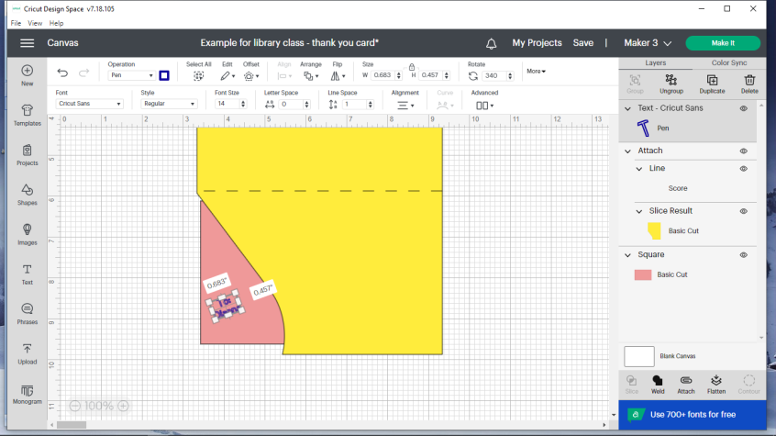

1. 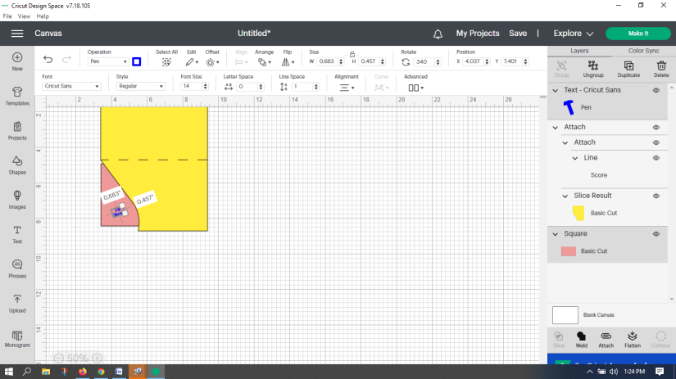**Re-click on your text box. Click on the box below font.**

1. It will now look like what’s below. **Click on System.** This will take you to the fonts found on your computer instead of giving you Cricut’s limited “free” selection. **Important: If you still see prices under the font names, click on System again. Scroll down until you find Milton 1 and click on it.**

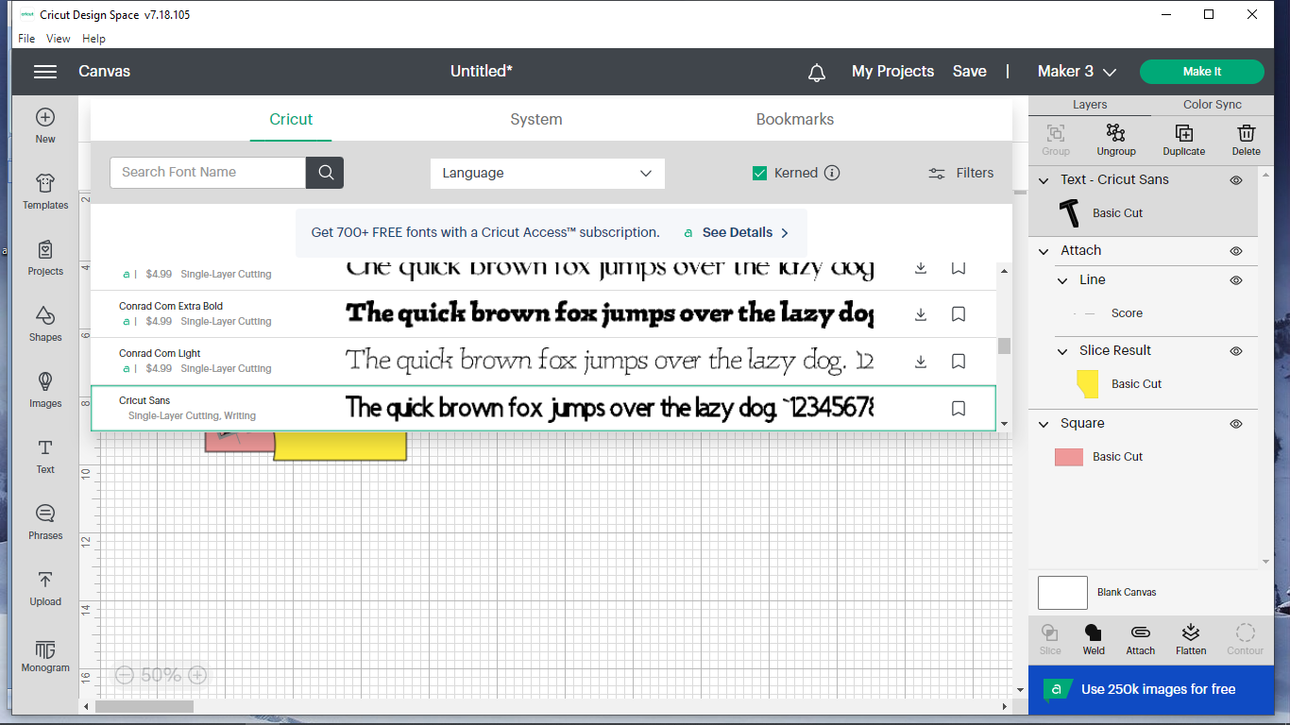f

**Click on the gridded area. If you are happy with where your To:/name text is, you’re ready for the next step. If not, double-click and drag it to where you want it. Next, click on the Square layer found about 2/3rd of the way down on the right side of the screen. Click on the triangle just below Arrange and choose bring forward** (brings your pink layer forward, but not over your text layer – we will use this to make sure the inside text isn’t seen where we have the To: text**. Go over to the left side and click on Text again.** It now should look similar to the pictures on the next page (not necessarily exactly the same as):

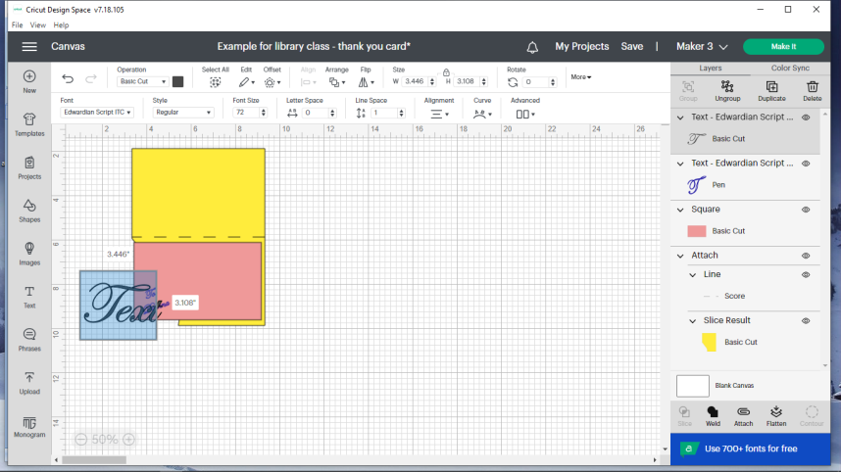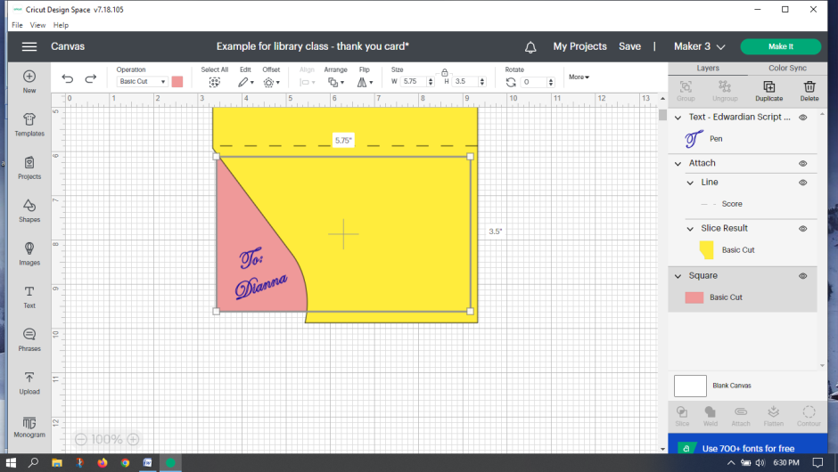

1. **Go up to the triangle just under Operation (see #31) and select pen from the list shown. Next click on the black square just to the right of the triangle you just clicked and choose .8 gel pen and the color for your text** (You can match the To: text color if you want or go with another color.)**. Click the box under font, go to system, and choose Milton 1. Click on the gridded area to exit color palette. Click on the text again. Go up to font, change the size to 30, and then press enter on the computer.** This will allow you to be able to read your text when writing it. It will be too big for the card, but we will fix that later. **Double click inside the box that says “Text”.** It will turn blue. **Type whatever you want to tell the person you will be giving the thank you card to. Click on the gridded area of the screen. Double click on the middle dot on the right side of the text box (see picture below) and while keeping your finger down, move your finger straight to the left.** This will square up your text (and look similar to the picture on the next page).

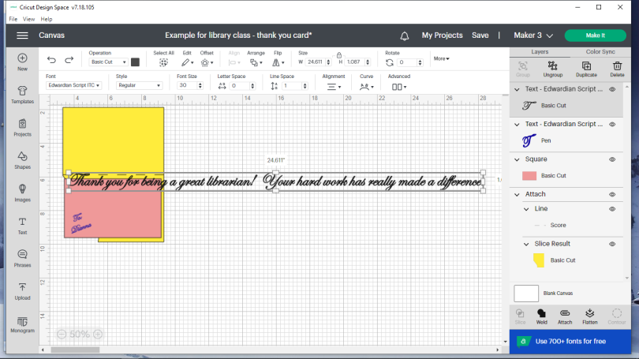

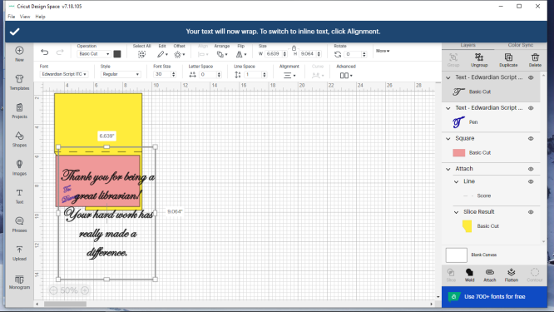35. **Change the font size to 20 (remember to press enter). Now by double clicking on the middle dots on each side of the box that has your text and dragging, change the size and shape of the box until it fits on the right half of the card that has the To: on it.** It should look similar to that below. Around 3” wide is a good size to try for (see just above the text in the white area and you will see the width).

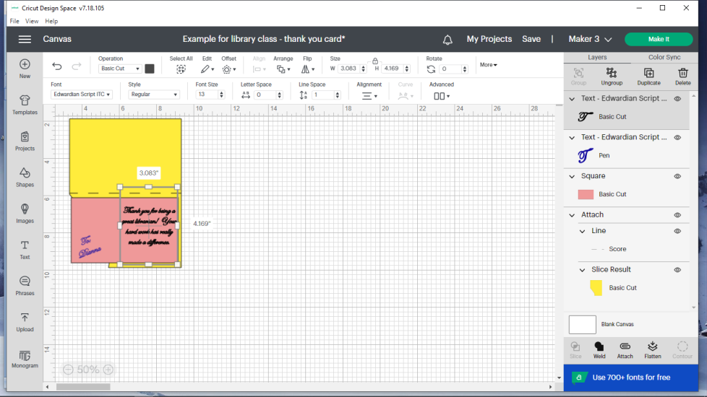

1. **Hold down shift on the computer and then go to the right side of the screen and click on the two text layers and the Square layer** (without letting go of the shift). They will be gray if they are selected. **Let go of the shift and click on attach** (just above blue bar at lower right).

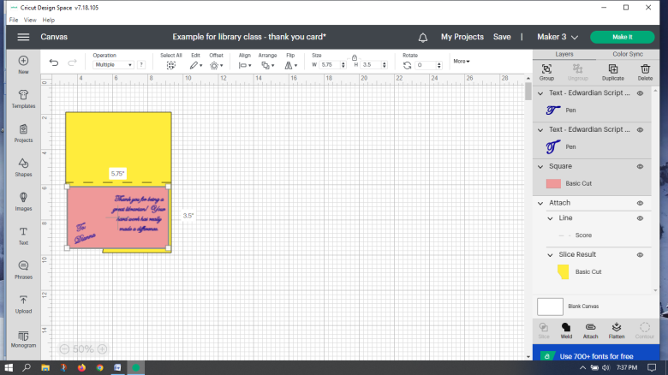

**Now double click on the part that has all your writing (my example is pink) and move it to the right so that it is off of the yellow card.**

1. **Click on text again. Change the font size to 31 and press enter on the computer. Double click the box that says “Text”** (it will turn blue)**, then type in Thank, press enter on the computer and type You! Click in the gridded area. Click on the Thank You, go up to the triangle just under Operation at the top, click on it and choose pen. Click on the black square box next to the triangle you just selected and choose what color the pen will be that writes “Thank You”. Click on the grid area.** In my example below, I chose a brown color to represent a gold metallic pen. **Double click on “Thank You!” and drag it down to where you want it. See picture below.**

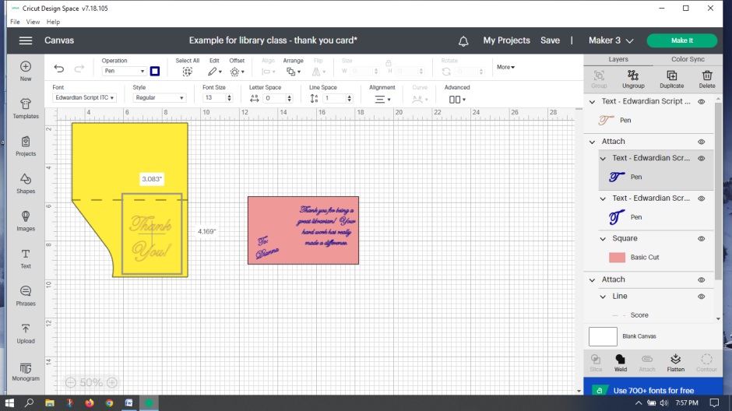

1. 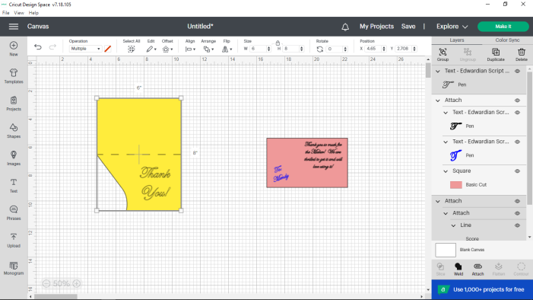**Click on your Thank You! Hold down shift and then click on the Attach layer that is indicated by the yellow arrow (SEE PIC BELOW!). Do not pick the attach layer circled since that is what is attached to the pink rectangle!** This will attach the Thank You to the previously attached score line/card combo front of the card. The heading Attach just lets you know that the parts listed below it are already attached. **Click Attach just above the blue bar at the bottom right.**  Now everything is attached and the yellow area below could be moved and the score line and text would move with it.
2. To the left of the green Make It button found at the top right of the screen, make sure it shows the machine you will be using. It should say Maker 3 if you are using the blue machine and Maker if you are using the white machine. If it isn’t right, click on the triangle and choose the right one.
3. **Click on the green Make It at the top right side of the screen. Click on the 2nd option “On Mat”. Click on the green Confirm button.** If everything is right, your mat should look like below. If things aren’t right, you will see text next to the pieces of paper. To see all of #2’s information just click on the mat that has the 2 on it. Both should show that a pen will be used with a basic cut. The main card will also say that it will be scored.

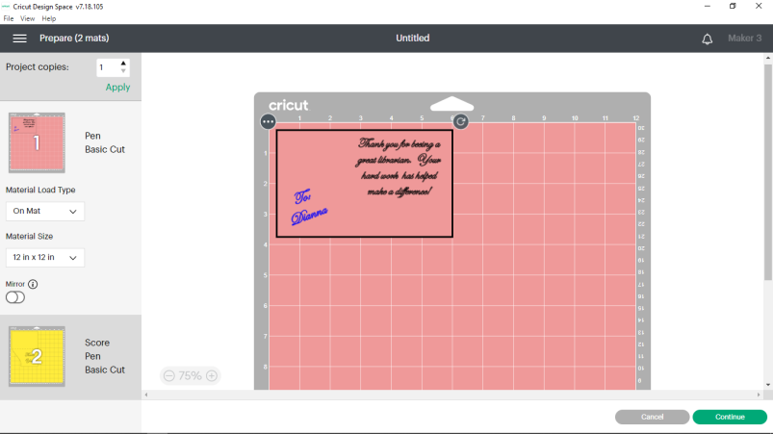

1. **Choose the green continue at the bottom right. (Note: if you see a message saying that the wrong machine is hooked up (Maker instead of a Maker 3, etc.), just tell it to change it to the settings of the machine that you are using and then you will probably have to go back to the start of this paragraph (#37).**
2. **On Set Base Material, choose medium cardstock – 80 lb. Put the color of paper you chose that is similar to what color is shown in box one on a 12x12 standard grip mat. Put the mat within the guides on the Cricut. Push the button on the Cricut that has up/down arrows. Click Make It on the computer. Read the instructions on the screen and follow them! When it is finished, it will tell you to press the up/down arrow button on the Cricut to unload the mat/paper. Peel the mat off the paper (not the other way around or it will curl the paper). Put your second color of paper as shown on the Cricut onto the mat and repeat the process. Now that everything has been done by the Cricut, fold the main card body in half using the score line.** (Note: If using cardstock that is not solid core, you may end up seeing white after you fold it.) **Next, put glue on the back side of the smaller piece of paper and center it vertically and horizontally on the inside of the card. Press down. Congratulations! You are done!**

This class from the Discovering How Art Can Affect Our Lives program was made possible in part by a Peggy Barber Tribute Grant from the American Library Association’s Public Programs Office.