References for the Cricut Christmas Card
Possible sayings for the inside of your card (from FTD.com):
- “Maybe Christmas, he thought, doesn’t come from a store. Maybe Christmas… perhaps… means a little bit more!” – Dr. Seuss
- “Christmas is not as much about opening our presents as opening our hearts.” – Janice Maeditere
- “I will honor Christmas in my heart, and try to keep it all the year.” – Charles Dickens
- “Peace on earth will come to stay, when we live Christmas every day.” – Helen Steiner Rice
- “It is Christmas in the heart that puts Christmas in the air.” – W.T. Ellis
- “A little smile, a word of cheer, A bit of love from someone near, A little gift from one held dear, Best wishes for the coming year… These make a Merry Christmas!” – John Greenleaf Whittier
- “At Christmas, all roads lead home.” – Marjorie Holmes
- Praying you have a Christmas filled with miracles and memorable moments you’ll cherish forever.
- May your life be filled with warmth and good cheer this holiday season and throughout the New Year.
- May Jesus Christ’s love surround you and your family especially during this holiday season. Merry Christmas!
- Wishing you peace and joy!
- May Jesus Christ’s love surround you and your family especially during this holiday season. Merry Christmas!
Helpful Suggestions
- If something happens in Design Space that shouldn’t while you are following the instructions, just click on the Undo button (curved arrow to the right of New located near the top left corner of the canvas).
- Graphics that will be foiled should be made of lines (monoline, coloring book pages, etc.). If they are solid, it will only foil the outline. If it is a picture, it will also only do the outline.
- Bold foiling shows up the best, but medium will work fine (and is necessary on fine details).
- Push rollers to side BEFORE putting your paper in! Rollers can press on the foil and leave tracks.
- Do not let foil overhang your paper. If it touches the sticky part of your mat, it will come off and stay stuck to your mat (wasting foil and making mat not as sticky).
- Foil should be at least an inch wider than the area you are foiling so that tape will not be in the way of the foiling tip. Tape will prevent foil from adhering properly.
- To make sure that the tape you will be using to hold down your foil will not tear/damage your cardstock, test a small area before starting. If tape damages the cardstock, use different tape or apply it to fabric first. After removing the tape from fabric, it should be less sticky. Tape can be re-used for other cards. Cricut foil tape and painter’s tape usually work well (textured cardstock is usually the exception).
Basic Card Design in Cricut Design Space
- Double-click on the Cricut shortcut on the desktop to open Cricut Design Space.
- If a login screen appears type in the e-mail and password on your computer.
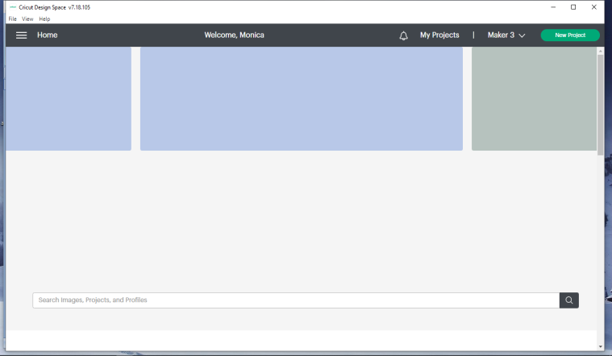
- Click on to maximize your screen and then click on New Project (see pic below).

- Click on Shapes
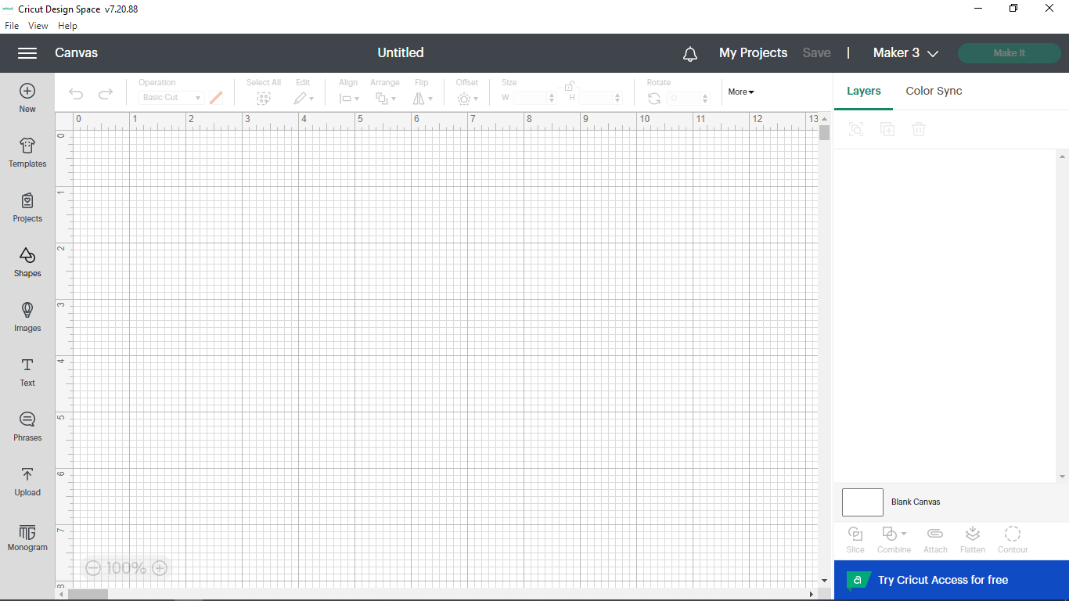

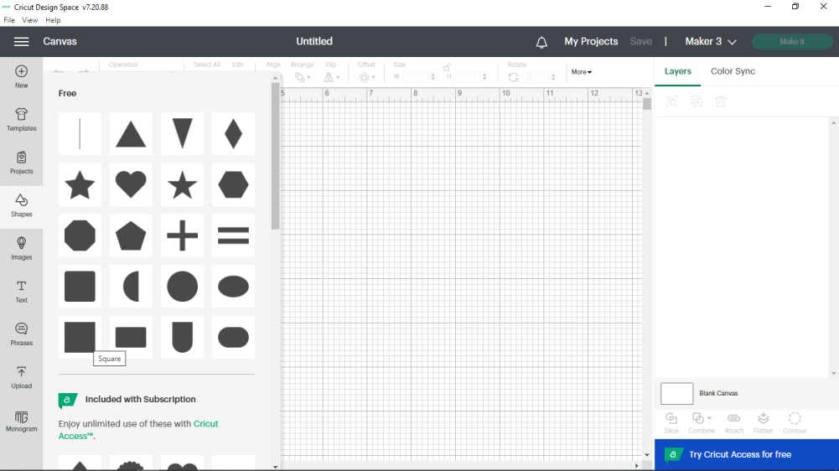
- Click on the square shape

- Click on the padlock symbol to unlock. Clicking on the padlock allows you to toggle between locked and unlocked. If it is locked, proportions will stay the same if you increase either the height or the width (won’t distort the shape you already have). If it is unlocked, you can change both the height and width. This allows you to make a rectangle out of a square (or an oval out of a circle). We want unlock since we want a rectangular shape to make our card.
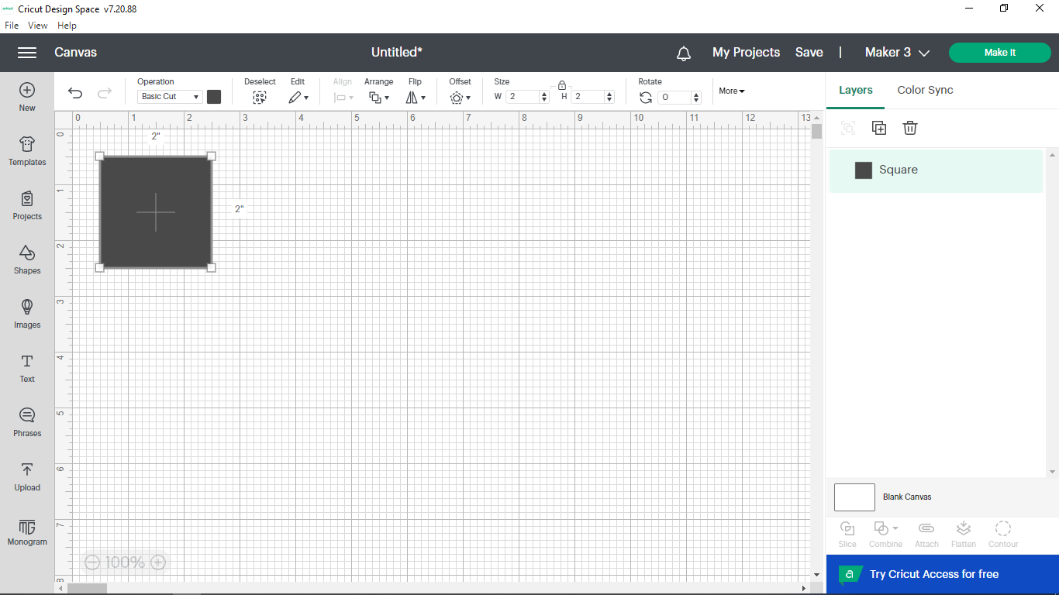

- Change the W (width) to 7 and the H (height) to 10 and press enter. Go back to the lock symbol and click on it to re-lock it. This change will make a card 7” wide by 5” tall when folded in half horizontally.
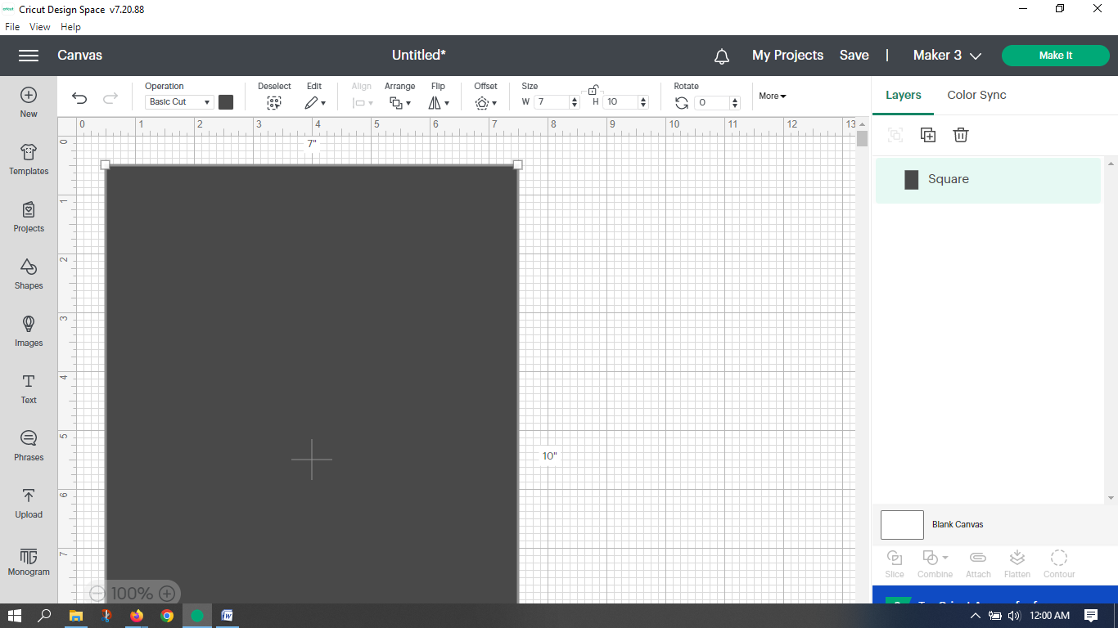

- Click on the ( – ) sign to shrink everything down to 75% instead of 100%. This will make it easier for you to see exactly what is being done in the next steps. Drag your black rectangle all the way to the top so you can see all of it.
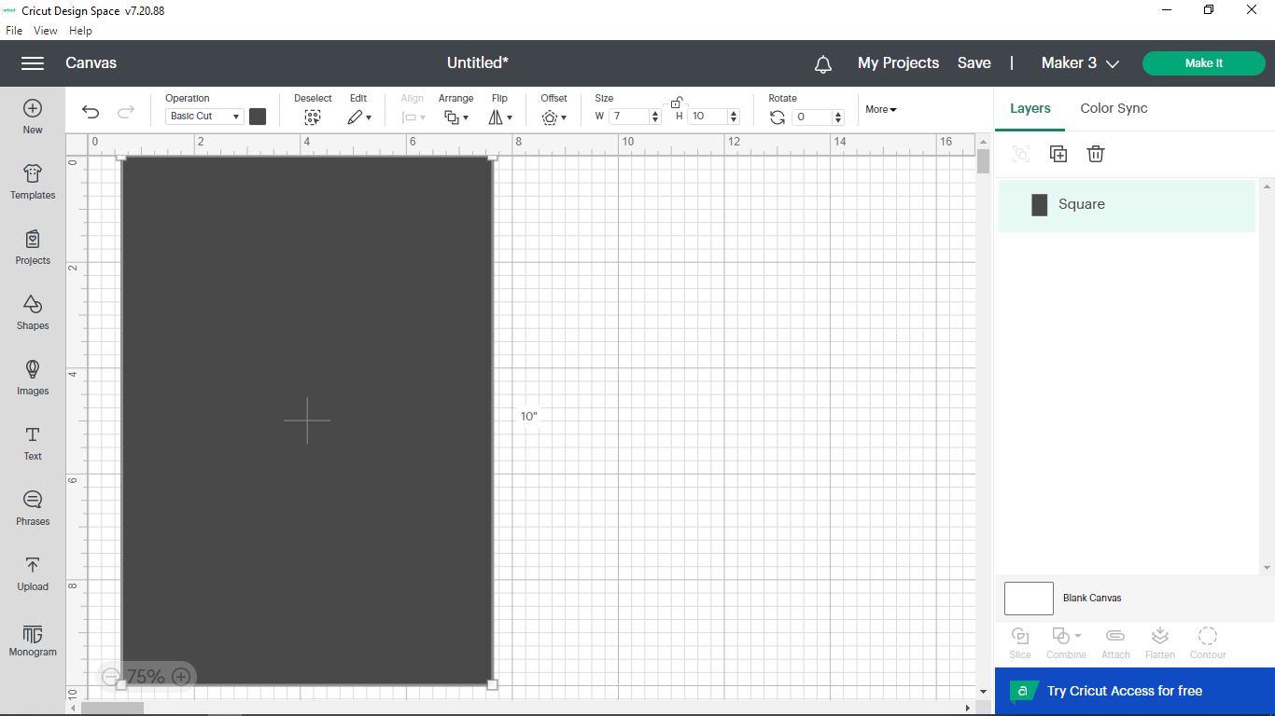

- Click on the black square.
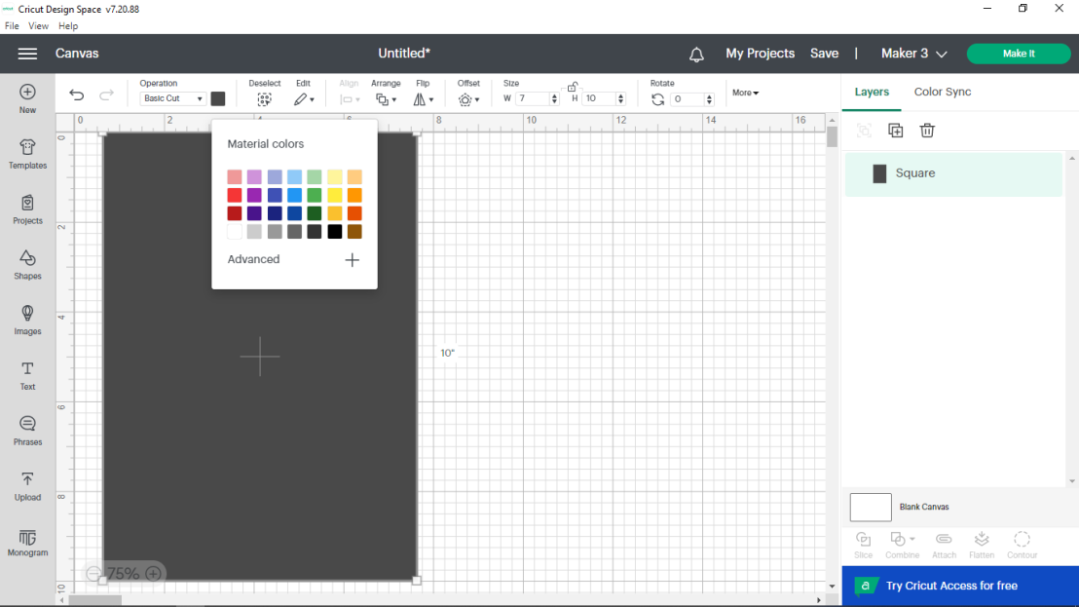
- Choose the color that resembles the color of the card you want to make. It’s not important that it matches, it just needs to remind you which color the sheet of paper you need when it prompts you to load paper.

- Click anywhere on the gridded area to exit the color selection box (clicking in the gridded area de-selects whatever you were working on). Your screen now looks similar to this.

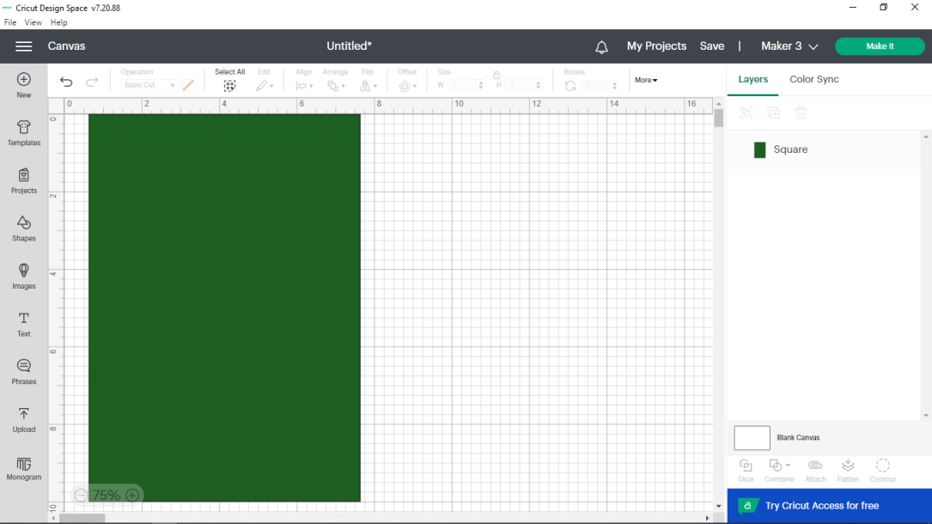

- Click on Shapes again and choose the line.

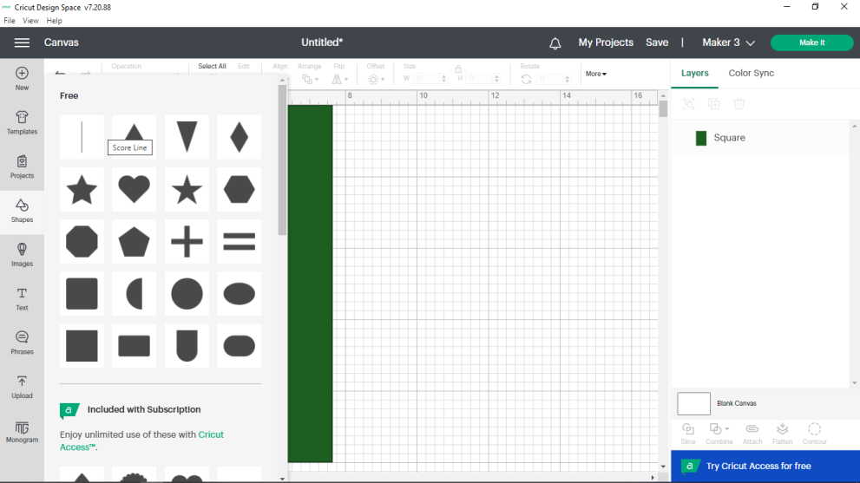

- Go up the height (H) and change it to 7 and then to rotate, type in 90, and press enter. Your line should now be horizontal now. This line will mark the fold in our card and will be scored.
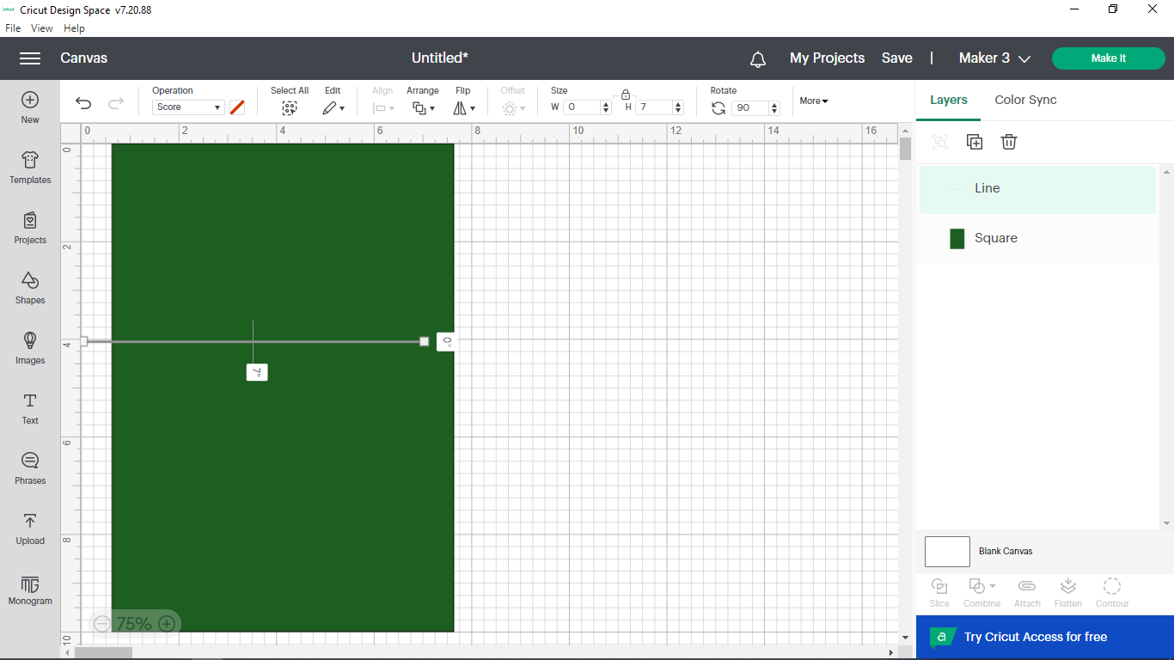

- Go over to the right, click on LINE layer, press down shift on the computer and without letting go click on SQUARE layer. This will make both highlighted.
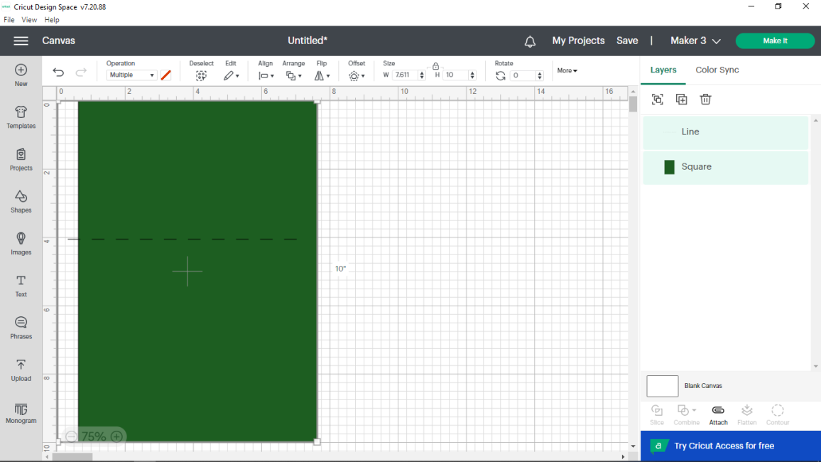

- Now go up to the top to just under align, click the triangle, and choose center. Now your line shows where your fold will be for your card

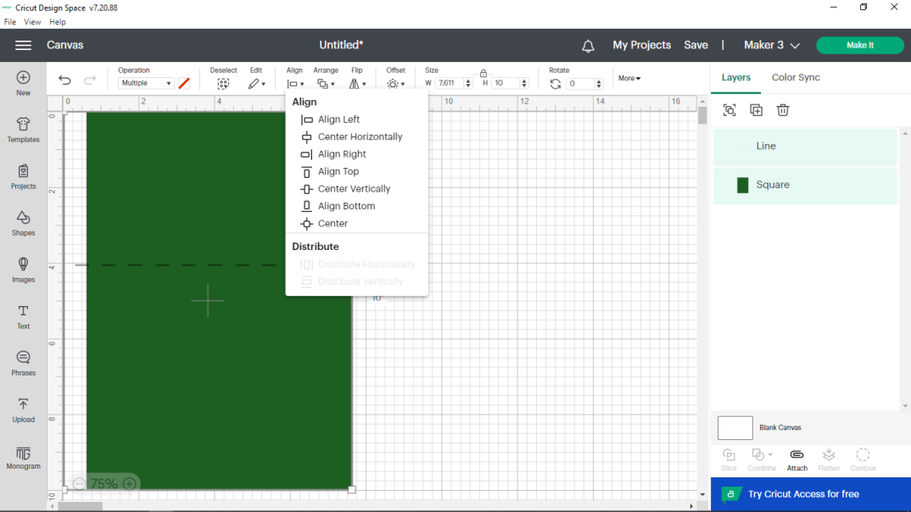

- Go back over to the right and select the Line layer, hold down the shift key on the computer, and then click on the Square layer. This will select both parts again (the score line and the card shape. Go up to just under Edit and click on the triangle next to the pencil. Choose Duplicate. Drag the second card shape to the right of the first one. Now it looks like you have two cards. We will end up with only one card, but we will use the second one to design the inside of the card
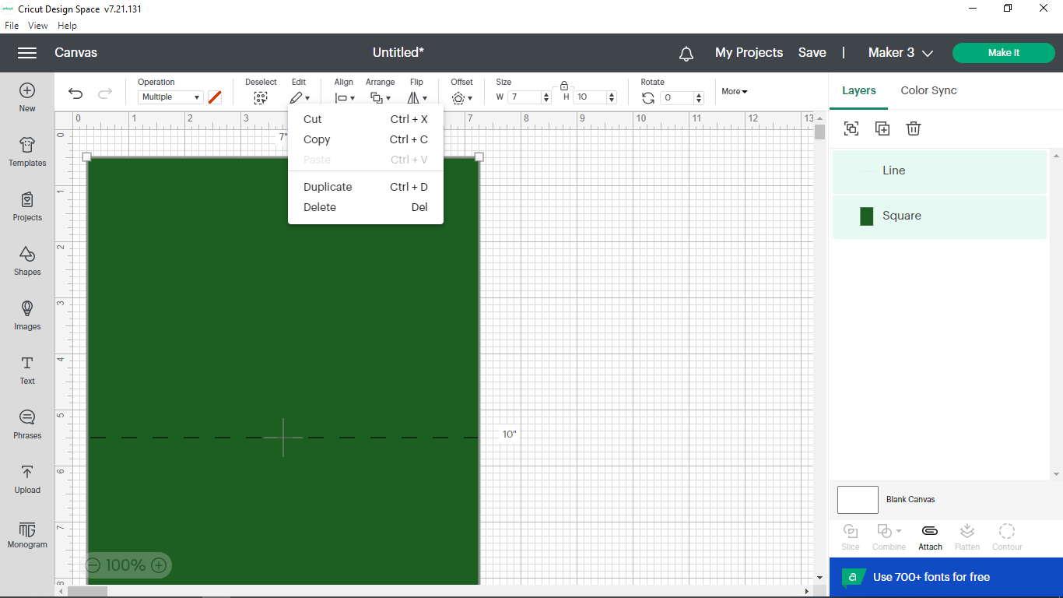.

- Click on upload.

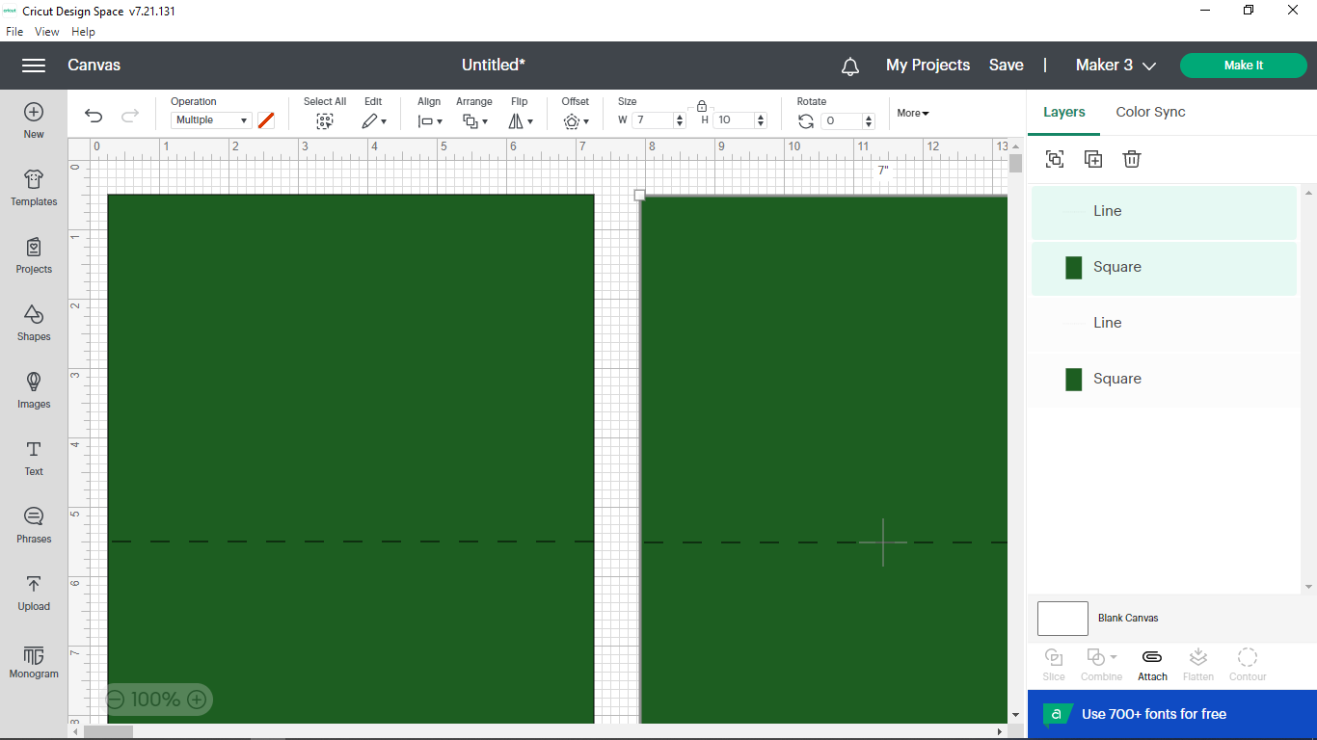

- Click on the snowman image (or the tree if you want that – I will continue with the snowman) and then click on the green button that says “Add to Canvas”.
If you choose the tree, just place and size it like I do the snowman.
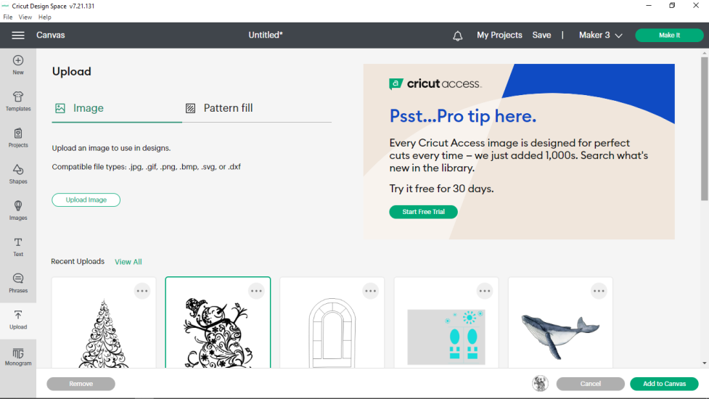
- Resize your canvas again to 75%, if desired (see #8). If it hops down to 50% (Design Space can be unpredictable sometimes), just click on the plus sign (+) and it should go to 75%. You may have to move the scroll bars to the top and to the left to get to where you can see things.
- Click the padlock to make it lock. For the snowman, change the W (width) to 3.25 and press Enter on the computer. The H (height) should change to around 3.6. For the Christmas tree, change the H (height) to 3.6 and press Enter on the computer. The width should be around 2.3.

- It now should look like the picture below. Drag the snowman down to the lower left portion of this card.

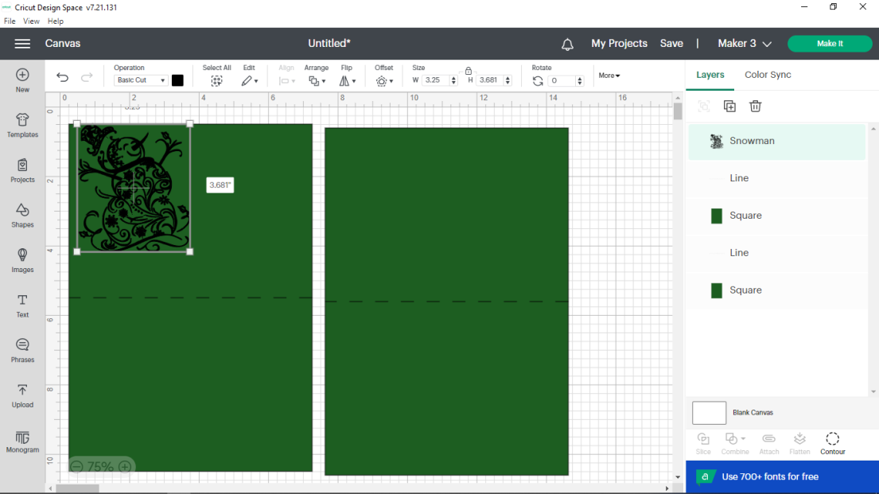

- Click on the triangle just under Operation. Go down to Foil and the over to Bold and click on it. Now instead of cutting your snowman, it will foil it.
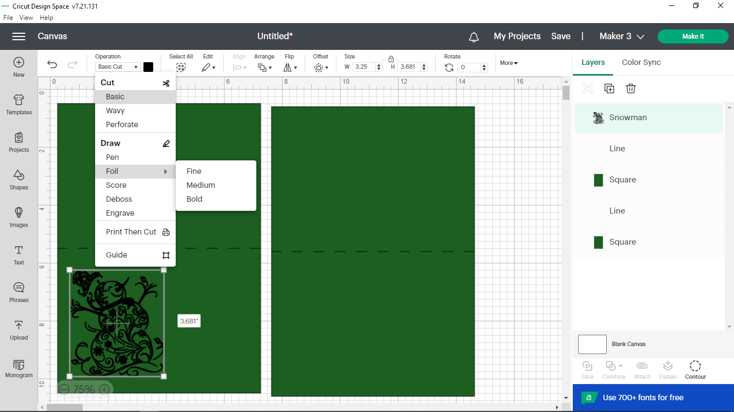

- You can change the color of the foil by clicking on the square to the right of the spot that now says “Bold Foil”. (We are only using gold and silver today.) Click somewhere on your card when you have chosen your color.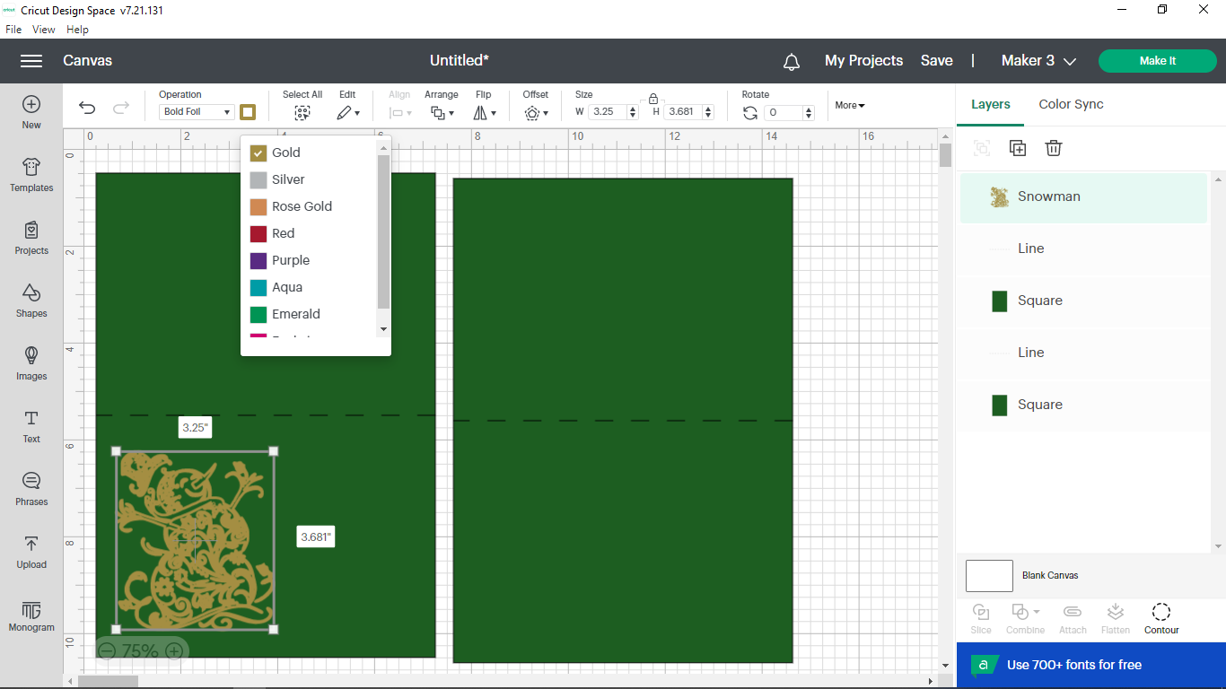
- Click on Text.
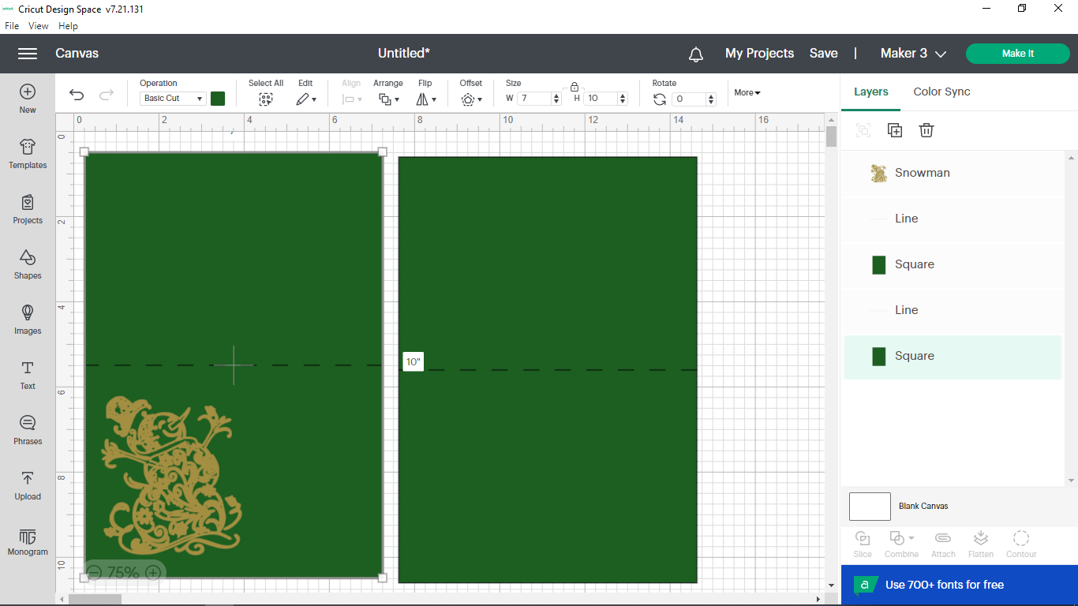

- You will see a highlighted box that says “Text”. Do not click anywhere…. Just type “Merry” press Enter on the computer and the type “Christmas”. It should look like this. Just under Operation, click the triangle, go down to foil and then over to Bold. Click on the colored box beneath operation (and a little to the right) to change your foil color. Finally, click on the arrow next to the box under Font.
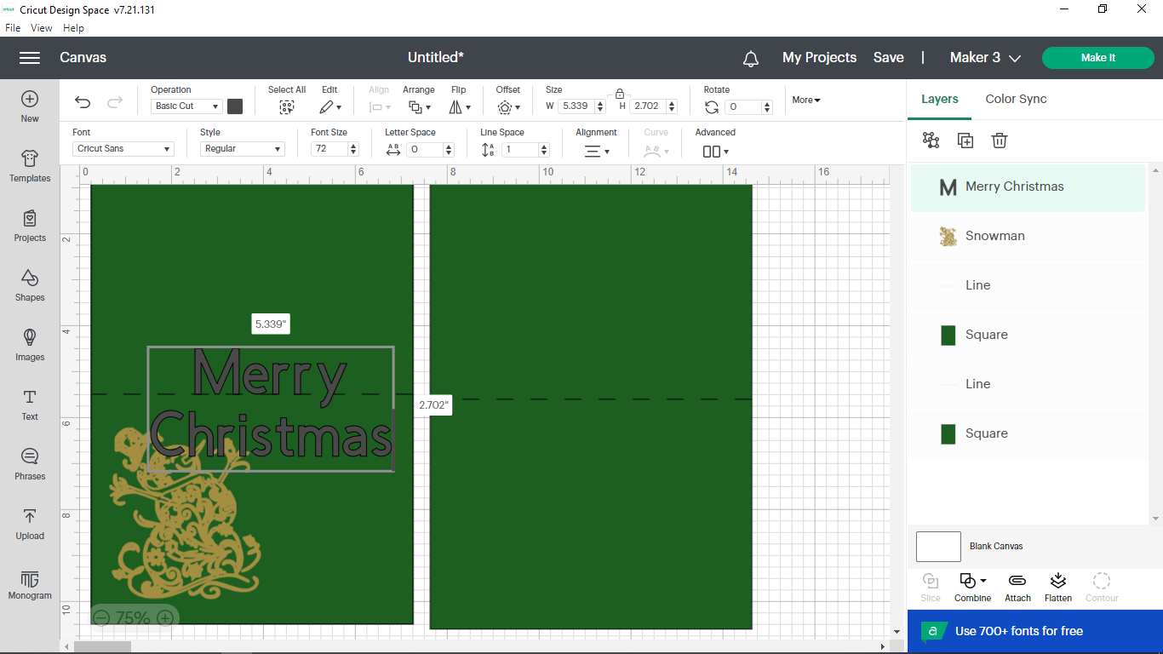

- Now the screen looks something like below. Click on System. In the box that says “Search Font Name”, type in Milton and press enter, if needed.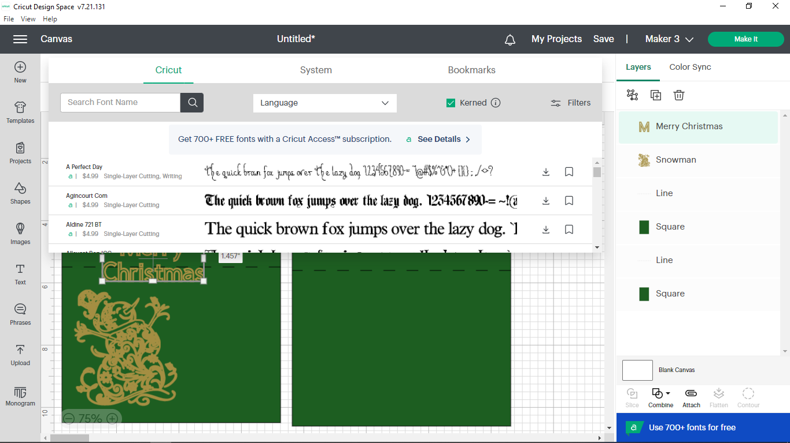

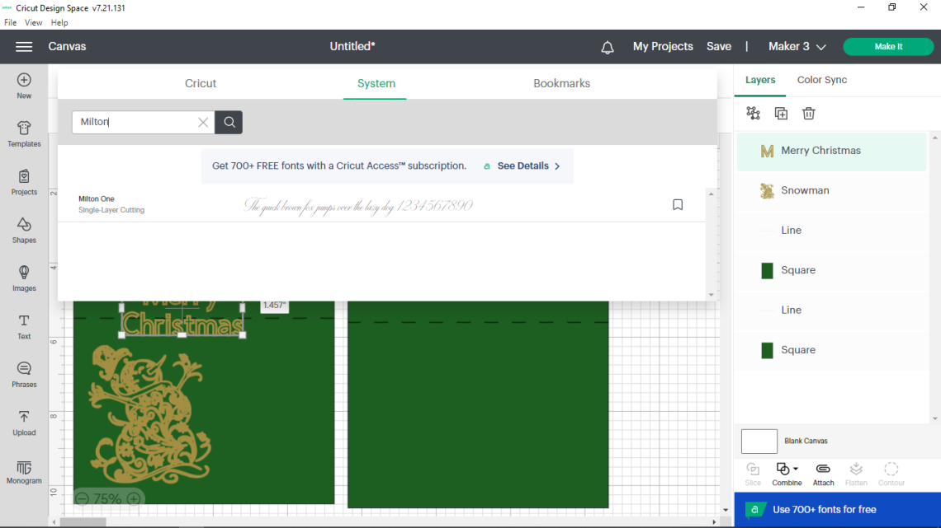

- Go to the box under Font Size , enter 48, and press enter. Drag the box with “Merry Christmas” over to the right of your snowman.

- Press down ctrl (lower left side) on the keyboard and while holding it press “C” on the keyboard. This will copy your “Merry Christmas” box but you won’t see the copy yet. While holding down ctrl again, press “V” on your keyboard instead. This will paste the copy onto your card. Drag it over to the bottom half of your other card.

- It will now look like below. Go up and click on the triangle under Operation, go down to foil and over to Medium. Double click on the words “Merry Christmas” (it should now be highlighted).
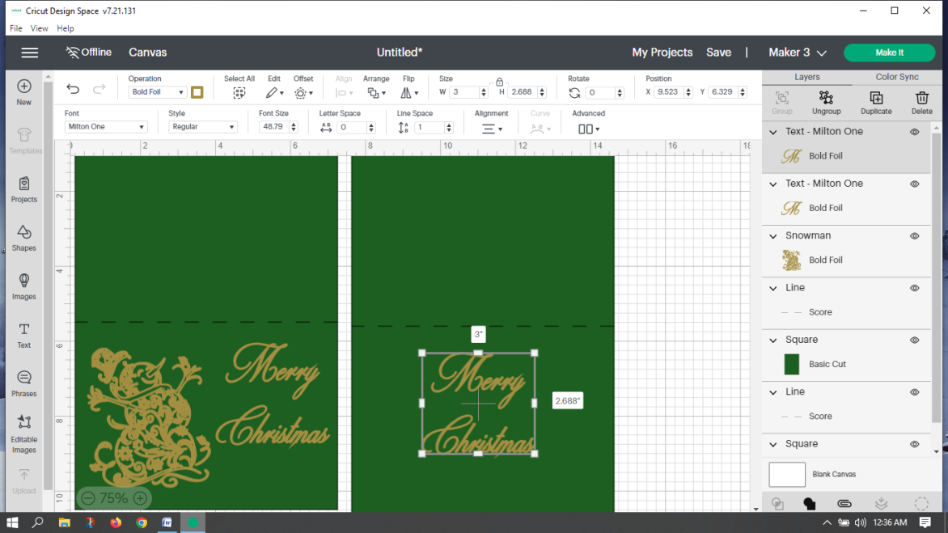

- Go up to the box under font size. Type in 30 and press enter. Double click on the text box and type whatever you want the inside of your card to say. Press Enter on the keyboard when you want it to go to the next line. There are some sayings on a separate page, if you need some help. You can copy and paste into a text box if you find something on the computer. Below is an example of what it might look like now. Notice how the greeting is off center. 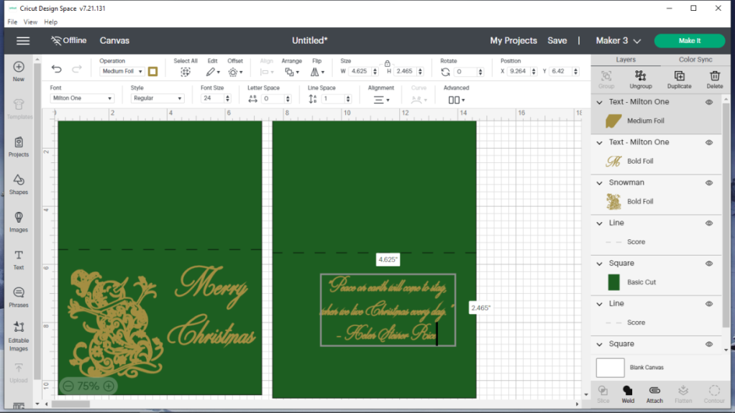

- To fix this, push down the shift key on the computer (lower left side) and while holding, click somewhere in the green area on the top half of the card. Click on the triangle under Align, and choose Center Horizontally. (Note: two areas on the right side of the screen should be highlighted when you do this: the medium foil script and the rectangular basic cut shape. If they aren’t you will need to select one of them, hold down ctrl on the keyboard and then choose the other one.)

- It should now look similar to below. Now we will attach everything. Attaching keeps everything where you now see it on the card when the Cricut cuts it out, scores it, and foils it. This step is IMPORTANT!! For the card on the left, click on the snowman, press and hold shift on the keyboard, click on the “Merry” area, click on the score line (dotted line), and then click in the green on the top half of the card. You should see 4 areas highlighted on the right side as seen below. Let go of shift on the computer. Click on Attach.
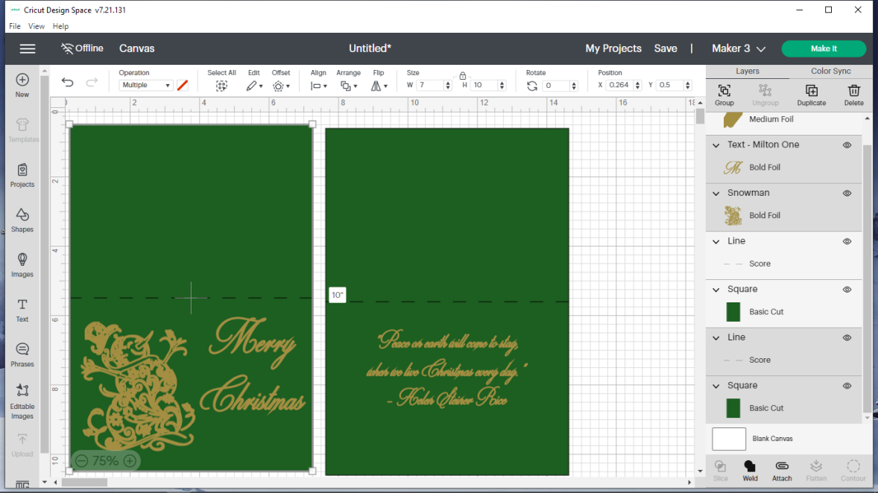

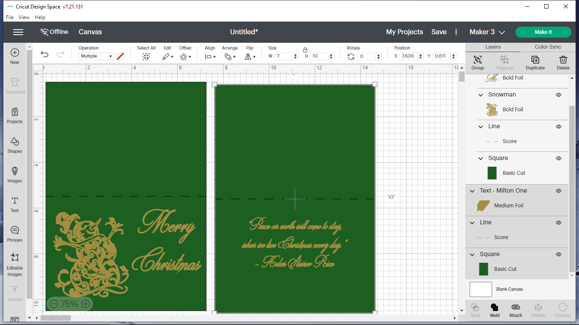
- Now attach the parts of the card on the right. Click on the greeting, press down shift (and hold), click on the score line, and then click in the green on the upper half of the card. Let go of shift. Click on Attach again. (We needed to attach 3 things this time.)

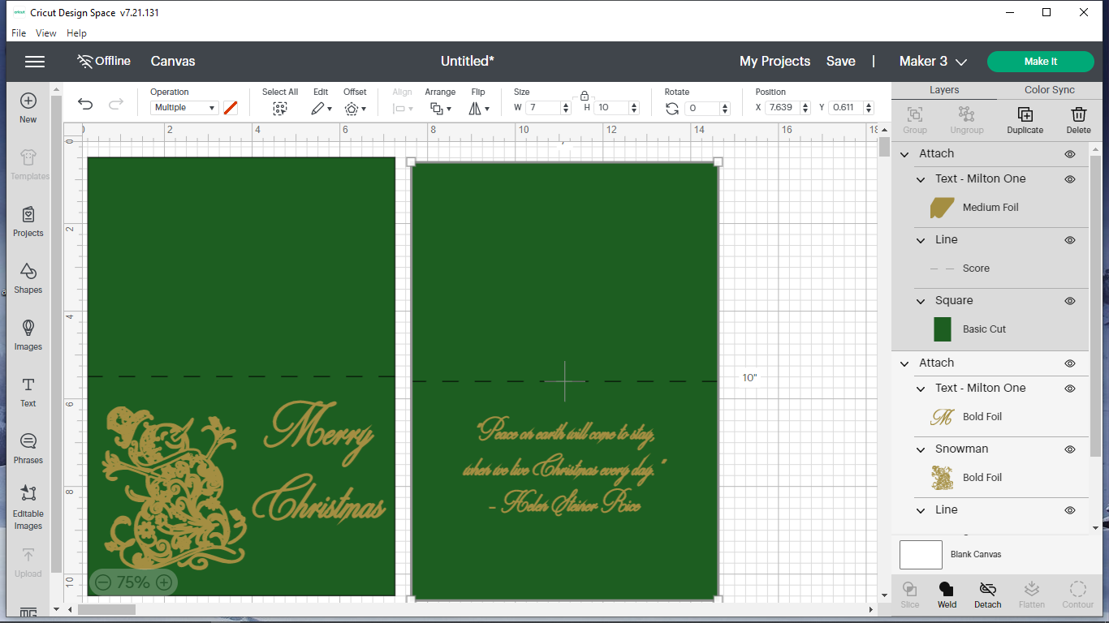
- Now we need to make sure the right machine is selected. Go up to the top right. Make sure it says the machine you will be using. We will have them labeled. If it is wrong, click the v to the right of the name (Maker 3) and choose the right one. Click the green Make It button.

- If everything was attached properly, the next screen should look like this. Notice the light area around the mat labeled #1. If you click the #2 mat, your screen should look like the second example. Notice how the area is light around the #2 mat. The light area surrounding a number lets you know you are looking at that mat. Your cards should look just like the ones below. Go back and click on mat #1.
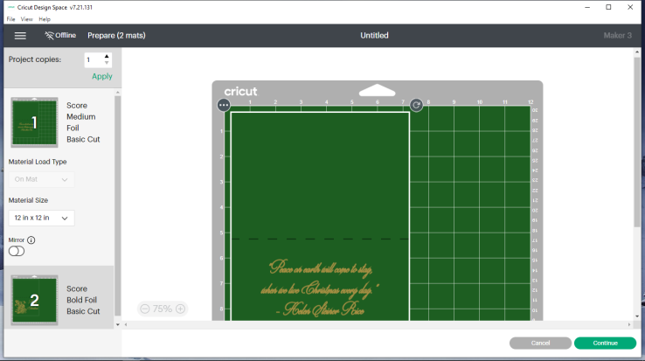
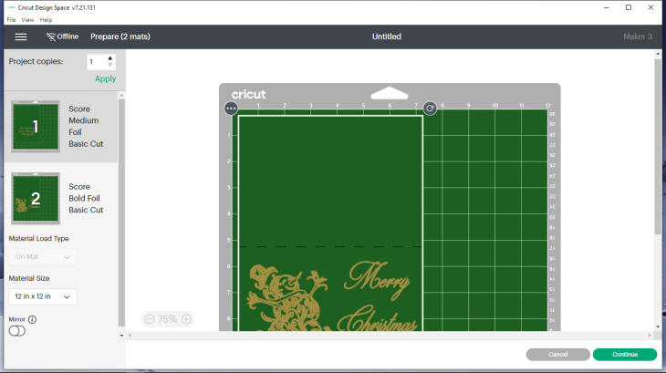

- Now we start the REALLY IMPORTANT STEPS! These steps will allow you to foil both sides of the card in the right spots. Even though the Cricut thinks we will cut 2 cards, we will only cut 1!

Double click the card and drag it to where the top left corner is at 1 over and 1 down (see the picture below). Your dotted score line should at 6. For this card, placing it carefully is important as you will see later! NOTICE THAT YOU WILL TAPE YOUR PIECE OF FOIL FROM 6 DOWN TO 11 and from 1 OVER TO 8!! (just under the score line and almost all the way across the card) Remember this when placing foil. Click on Continue.
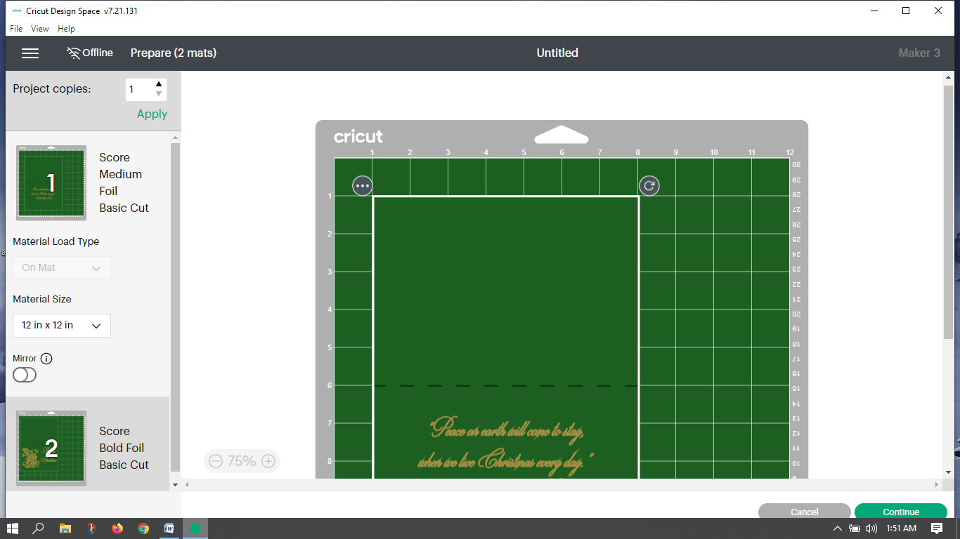

- On Set Base Material, choose light cardstock – 65 lb. If you don’t see it, click on Browse All Materials.

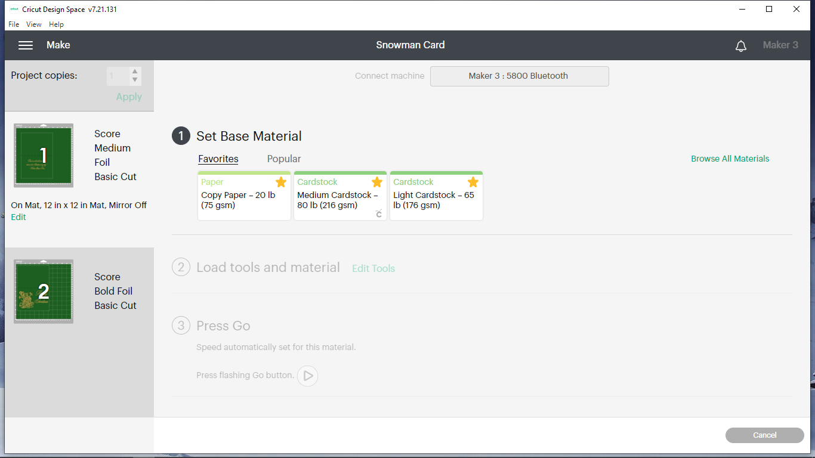
If you clicked on Browse All Materials, your screen looks like the one below. In the search box, type cardstock and click on the magnifying glass. As seen on the second screen choose light cardstock and click on Done.
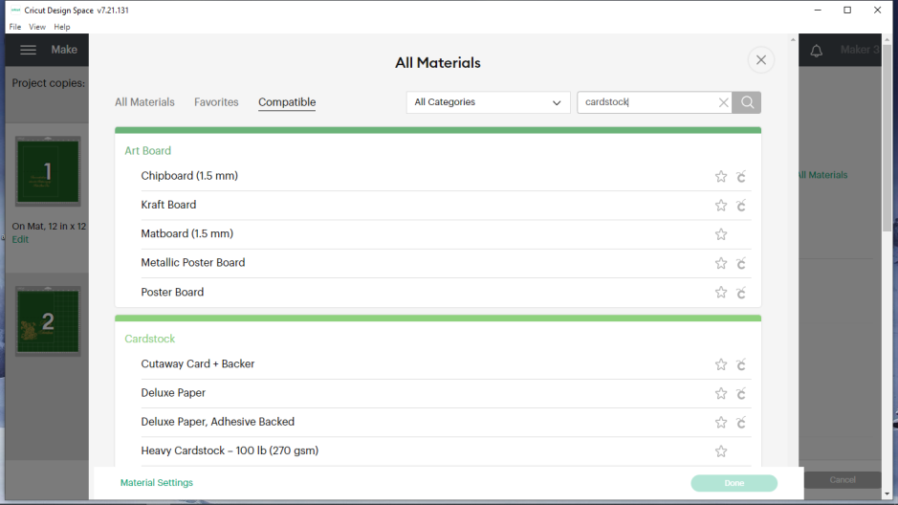

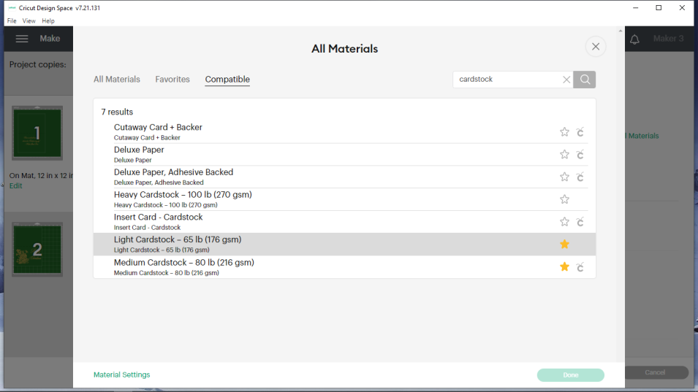

39. On the next screen, as seen below, you will have the chance to change pressure or tools. We will not do any of that in this project. You will also see that this screen shows you which tool the machine will be using next. Load the scoring tool.
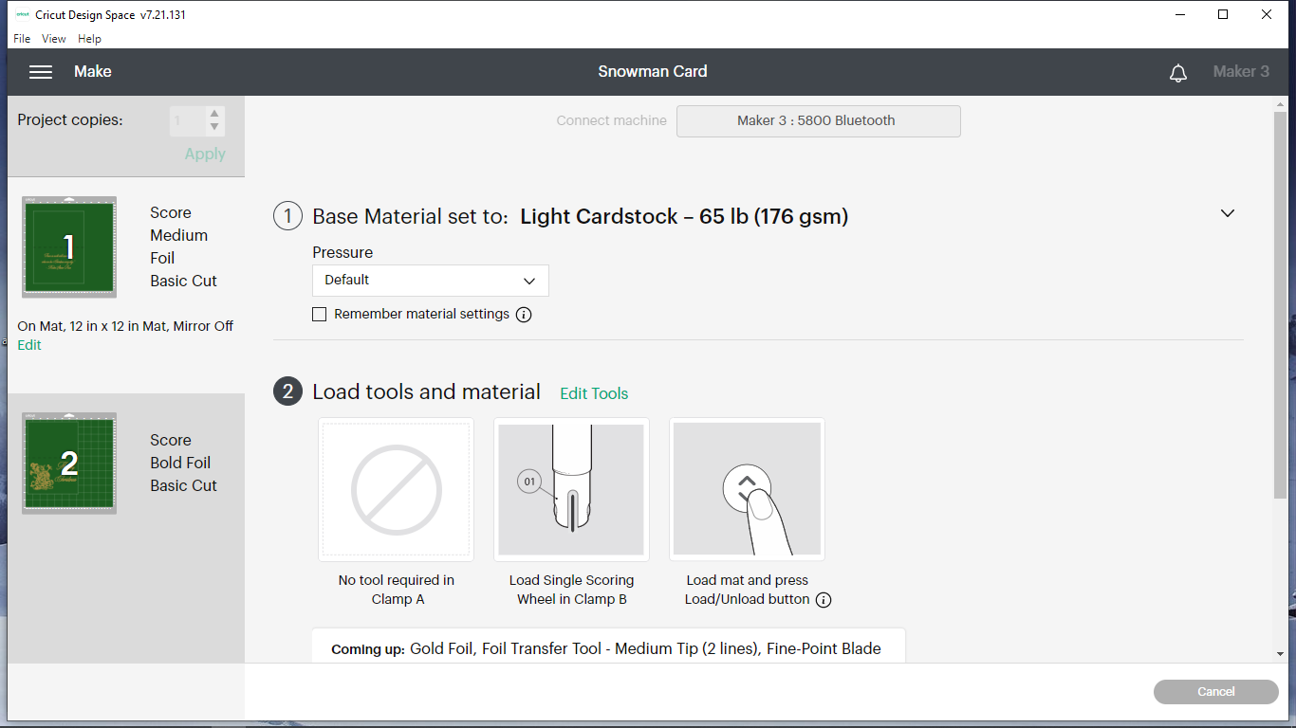

Follow the instructions on the screen and on this paper carefully from now to the end! For your project to be successful, you must read these instructions as you go.

- Put the color of paper you chose that is similar to the color that is shown in box 1 on a 12x12 light grip mat (or a well used standard grip mat). Put the top left corner of the paper at the top left corner of the grid. See the picture below.

- Place your ~5 x 7 piece of foil over the area as described in the highlighted area on #37. Securely tape down all sides with foil or painter’s tape, getting the foil mostly smooth (doesn’t have to be perfect!).

- Push the Cricut rollers all the way to the sides. Put your mat within the guides and push up to the rollers.

- Push the button on the Cricut that has up/down arrows. This will load the mat.

- Click Make It on the computer. Read the instructions on the screen and follow them. CAREFULLY REMOVE THE FOIL WHEN IT TELLS YOU TO.

- When it is finished with the first mat, it will tell you to press the up/down arrow button on the Cricut to unload the mat/paper. DO NOT UNLOAD. Carefully, only remove the card. Do not remove the paper that is around the card. (Sometimes Cricut updates make this trick (of not unloading the mat) not work and it will unload the mat anyway. If this happens, it will still turn out fine since absolute precision isn’t necessary. You may end up with a second score line, but it won’t affect the end result.)

- Tape a piece of paper (any kind) over the foiled area (doesn’t need a lot of tape). What is now the bottom covered foil area needs to be flipped so it becomes the top underside when put on the mat (if you don’t understand, ASK ME!). Place the card on the mat in the hole left from before.

- On the computer, click Cancel and then Yes to confirm that choice.

- Click on mat #2 (making sure it is the light highlighted area). Move the card exactly as you did in #37. Click on Continue.

- On Set Base Material, choose light cardstock – 65 lb. Click Edit Tools and choose Scoring Stylus (instead of scoring wheel – important!).

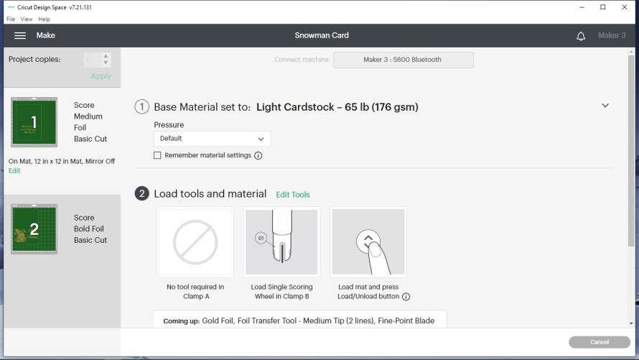

- Place your ~5 x 7 piece of foil over the area as described in the highlighted area on #37 (bottom ½ of the card – easy to see now).

- Do this only if the mat unloaded earlier. Put your mat within the guides and push up to the rollers. Push the button on the Cricut that has up/down arrows. This will load the mat.

- It will ask for the scoring tool. Do not put the scoring stylus in!!! If we had left the default as scoring wheel, you would have to put it in. The Cricut will refuse to go if you don’t put any geared tool in because of a sensor. Now the Cricut will act like it is scoring, but it’s not doing anything. Next, it will foil. Remove the foil carefully. Finally it will ask for the fine point blade. DO NOT PUT IN THE FINE POINT BLADE (cut earlier). Instead, unload the mat, remove the card, and take off the paper covering the other side.

- Now that everything has been done by the Cricut, fold the main card body in half using the score line. (Note: If using cardstock that is not solid core, you may end up seeing a little white after you fold it.) You are done! Your card should look similar to the one below (pic is of tree instead of snowman).

This class from the Discovering How Art Can Affect Our Lives program was made possible in part by a Peggy Barber Tribute Grant from the American Library Association’s Public Programs Office.

