The IG Resource Posts (posted once weekly for the duration of the series on www.instagram.com/durantlibrary; listed here as print screen images with links):
Week 1, February 5, 2021 for Jacob Lawrence: https://www.instagram.com/p/CK4lIfaJ_pX/
(Note: If you wish to duplicate something similar, use this first image for J. Lawrence as a template for up to 2-8 resource images.)

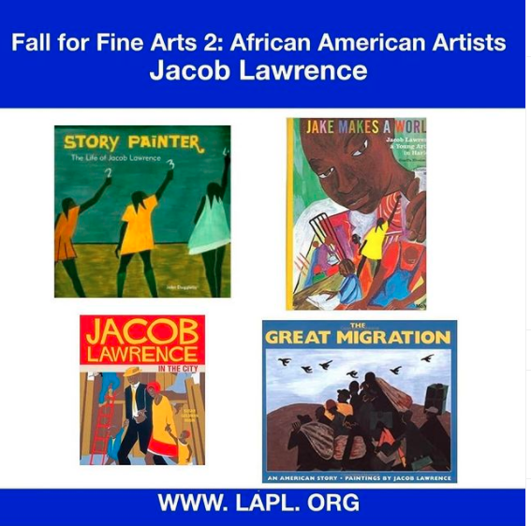

Week 2, February 12, 2021 for Clementine Hunter: https://www.instagram.com/p/CLHr_k_p9gq/
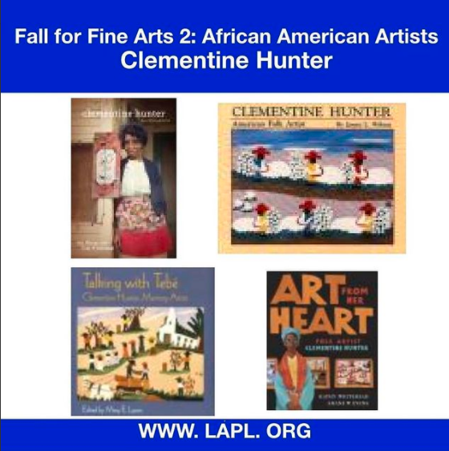

Week 3, February 19, 2021 for Alma W. Thomas: Not posted, only one resource at the time found in LAPL catalog.

Week 4, February 26, 2021 for Tom Feelings: https://www.instagram.com/p/CLrvlpMJkVq/ of template with this moving image video.


