Scrap Fabric Potholder

1. Open Cricut Design Space by double clicking on its icon (must have internet access for it to open).

2. Click on New Project.

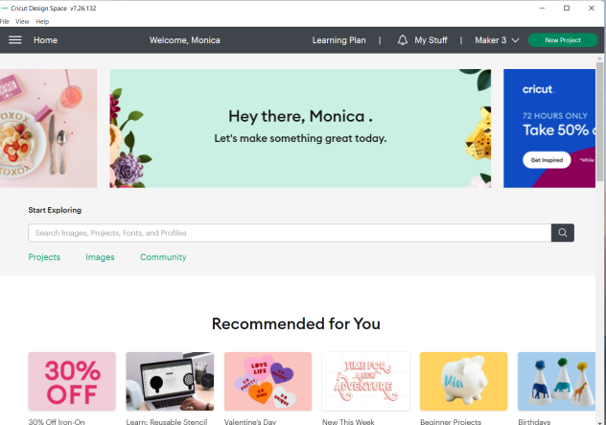

3. Click the square outline to maximize your screen and then click on Shapes.

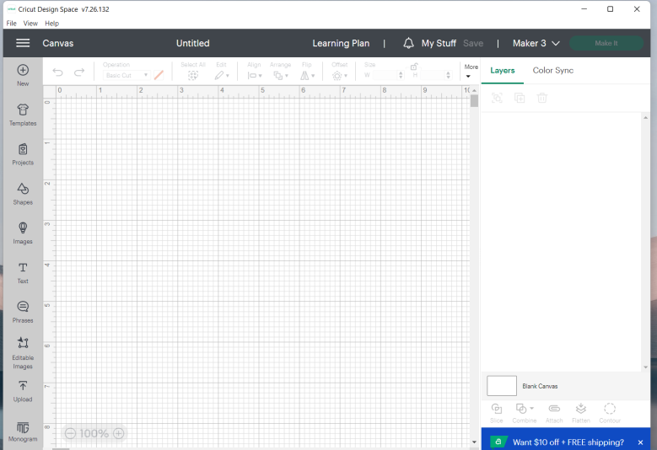

4. Choose the square shape (without rounded corners).

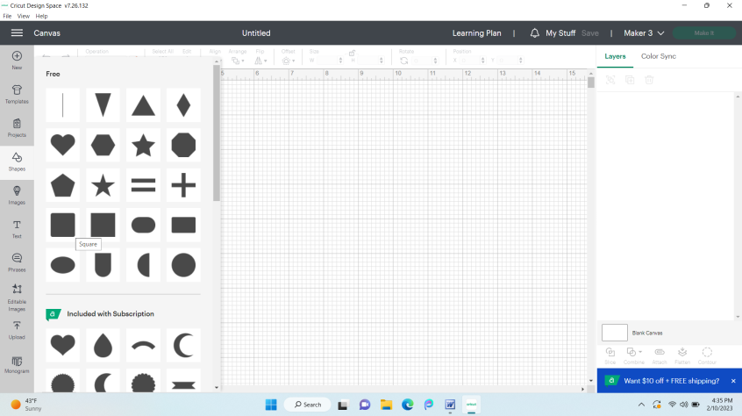

5. Change the size to 8 for w (width in inches) and the press the tab key on the keyboard to move from width to height (see arrow on 2nd pic). It will go from looking like the 1st pic to the 2nd pic. It should have automatically changed the height to 8 inches since the padlock should be in the locked position – meaning that if you adjust the height or the width, it keeps the proportions the same.

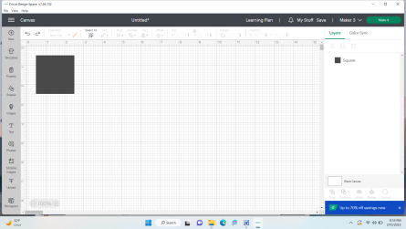

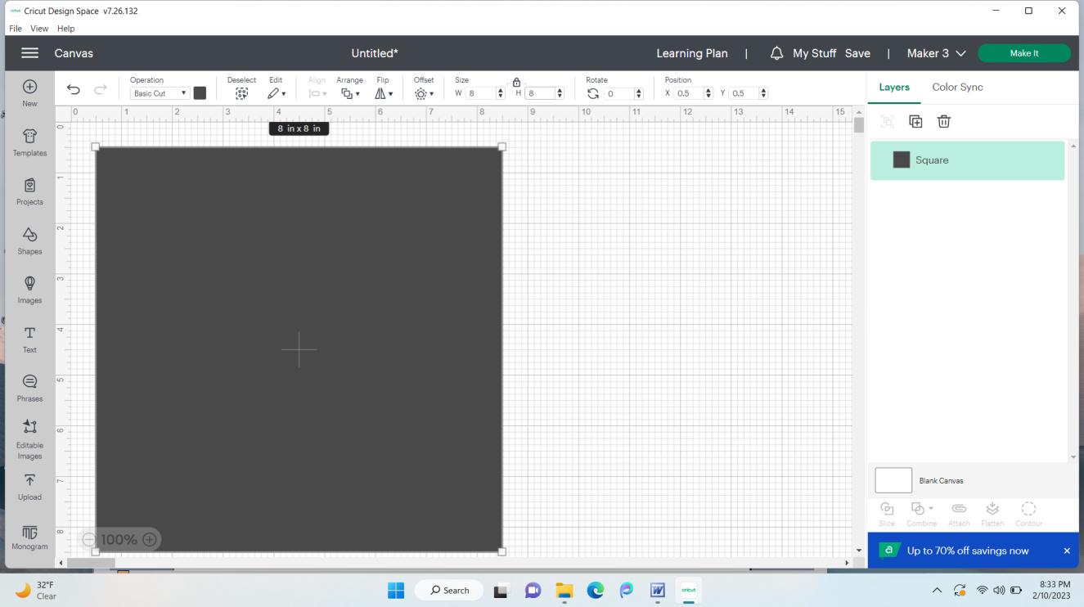

6. Click on the large black square shape and go up to the small black square just under and to the right of Operation. Click on it and change the color of the square to a light color. Click somewhere in the gridded area to exit the color selection box.

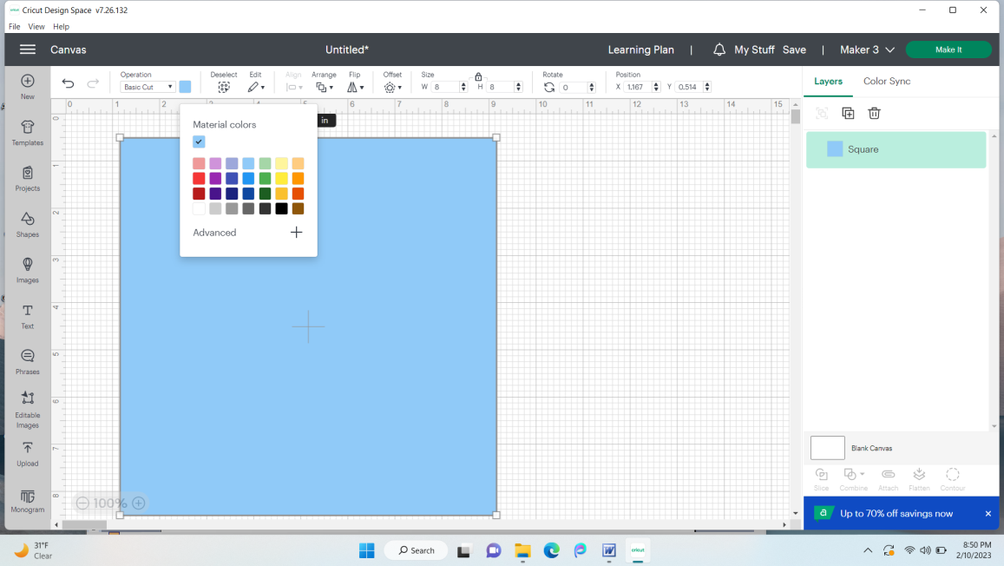

7. Go over to the left side and click on Shapes again. Choose the same square shape you did before. Now you have 2 squares.

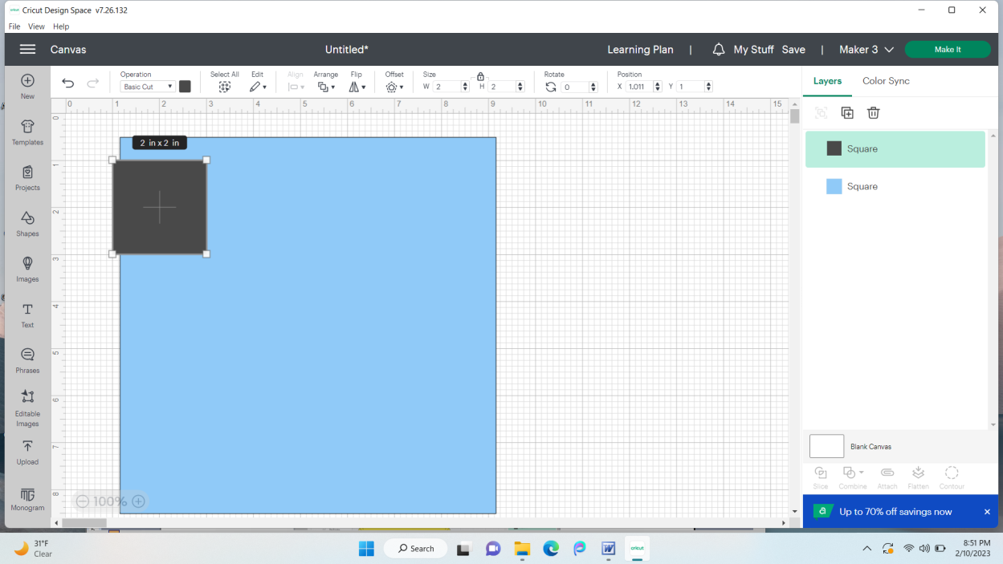

8. Change the Operation of this square to draw by clicking the triangle below and to the right of Operation and then going down to just under Draw and choosing Pen from the menu that pops up.
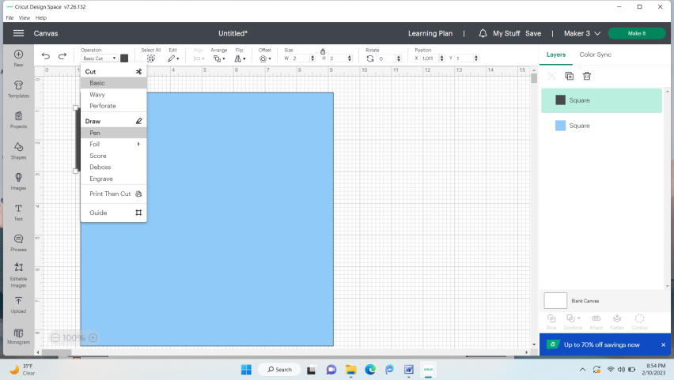

9. Go back up to the now outlined small square box just under and to the right of Operation. Click on it. Click on the small v to the right of Fine Point. Go down and click on Marker.

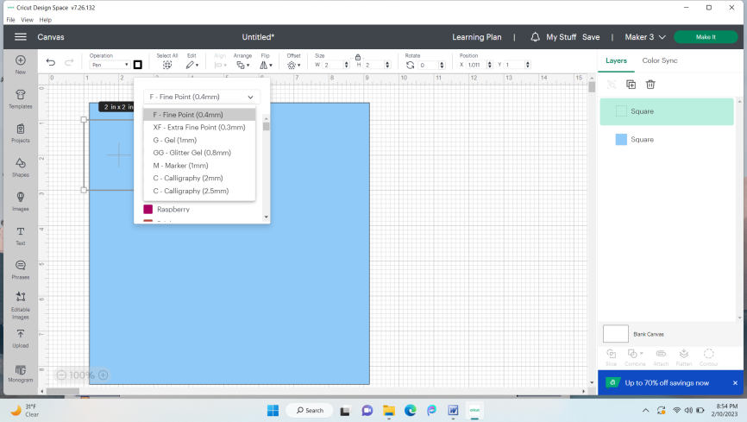

10. Choose black (or any color that you’ll be able to see) and click anywhere in the gridded area to exit the color selection screen.
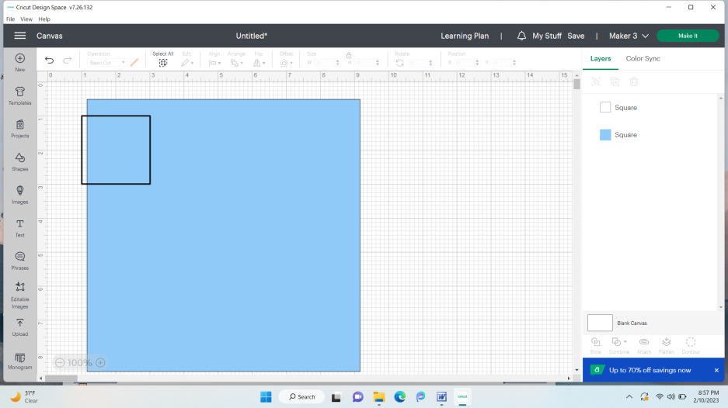

11. Click on the outlined square again. Change w (width) to 7 and press Enter on the keyboard. This should change your height to 7. Your screen now looks like this.

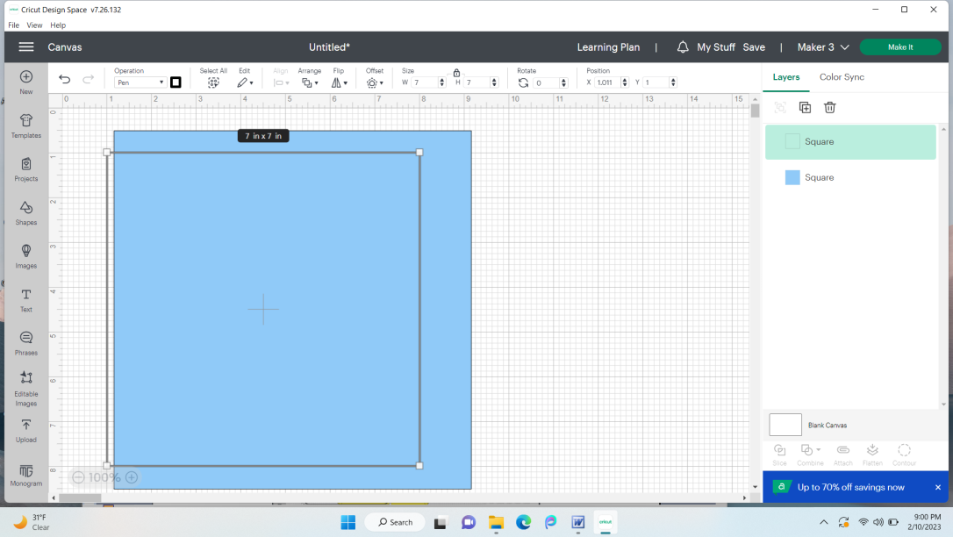

12. Double click just above and to the left of your solid and outlined squares. Without letting go, drag down and to the right until the outlined square and the solid square are highlighted. You should now see a very light colored rectangle surrounding both squares. The light colored rectangle around both shows that they are both selected and whatever you do to one will be done to the other. You can also see they are both selected because they are both highlighted on the right side of the screen.

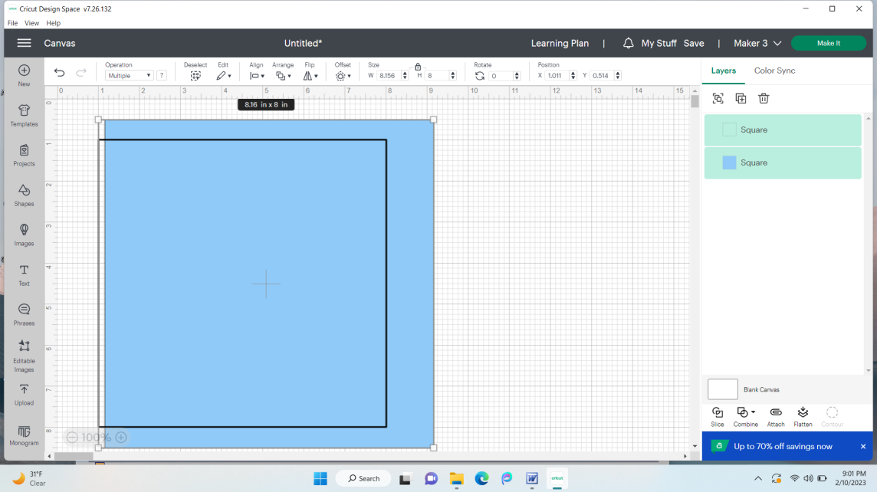

13. Click on the black triangle just under Align and from the menu, choose Center.

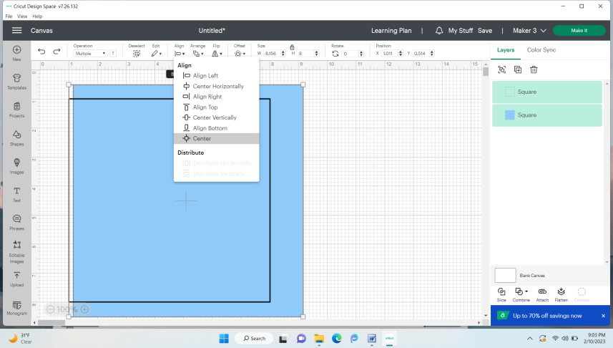

14. The squares should line up like in pic 1, below. While everything is still selected (everything highlighted on right side of screen), click on Attach. Next, click on the duplicate icon (see arrow on pic 1 toward top right – icon has 2 squares with a + on the closest one). This will make a second large square just like the first. Double click it and move it to the right so that it looks like the 2nd pic.

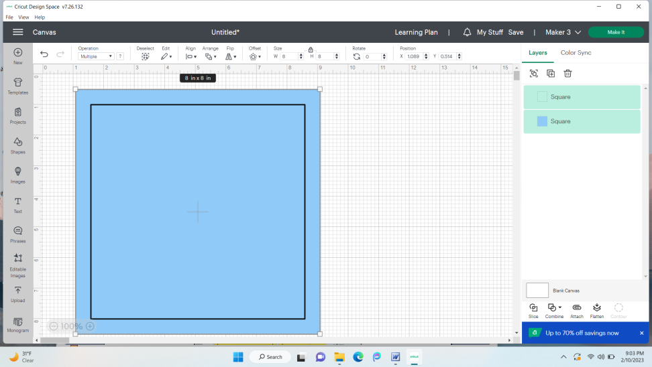

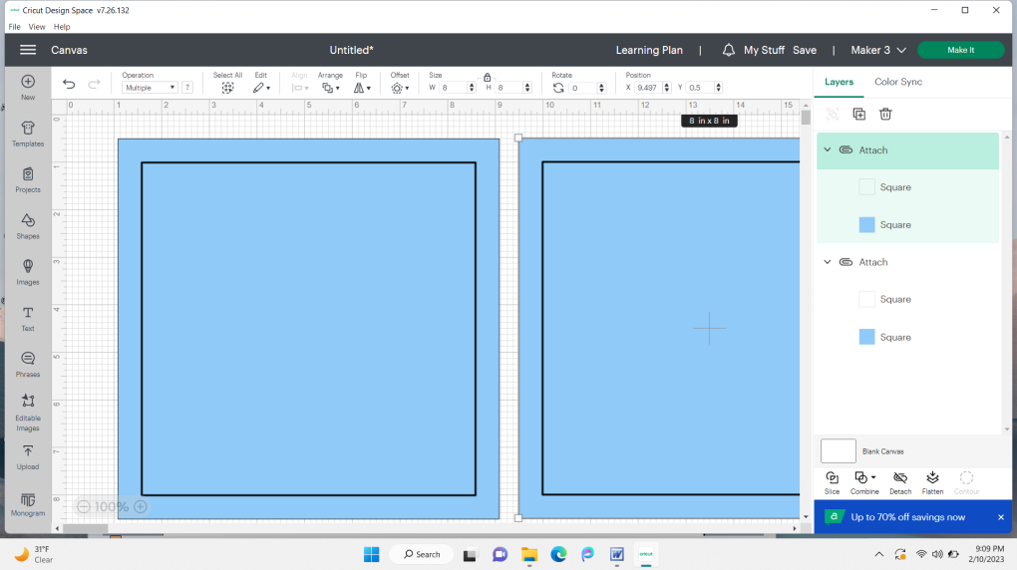

15. Change the w (width) to 7 and press enter on the computer keyboard. Now you have a slightly smaller square next to your larger square.
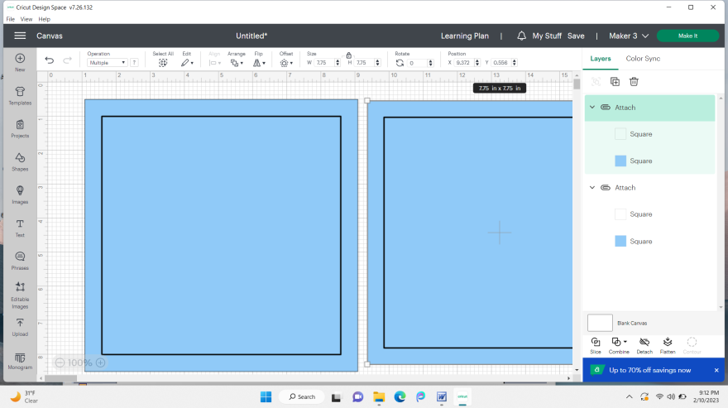

16. In the highlighted area on the right side of your screen, click on the top Square (has a blue square next to the word in the example below).
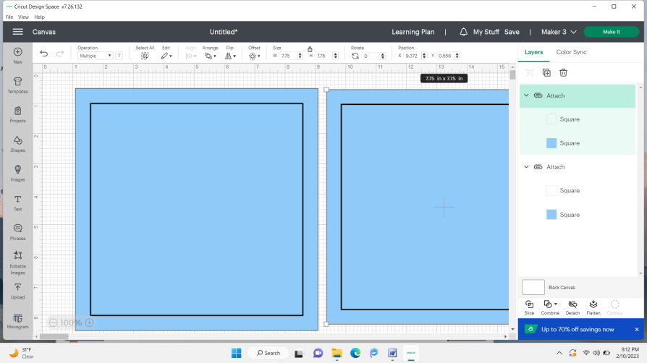

17. Go to the colored square just under and to the right of Operation. Change the color to a different one by clicking on it. Click in the gridded area to exit color selection menu.

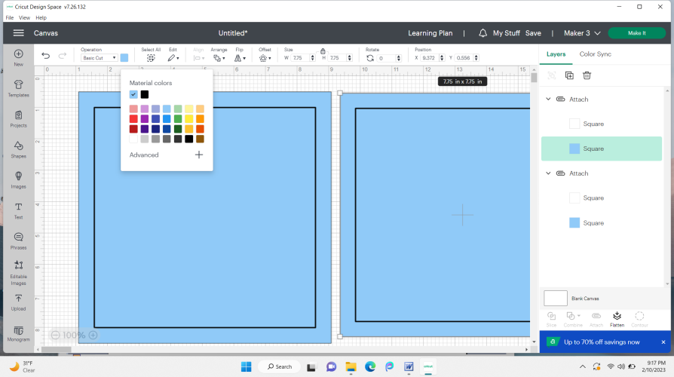

18. Your screen should look similar to the one below. My blue layer will be jeans material. My yellow (smaller) layer will be a decorative fabric.

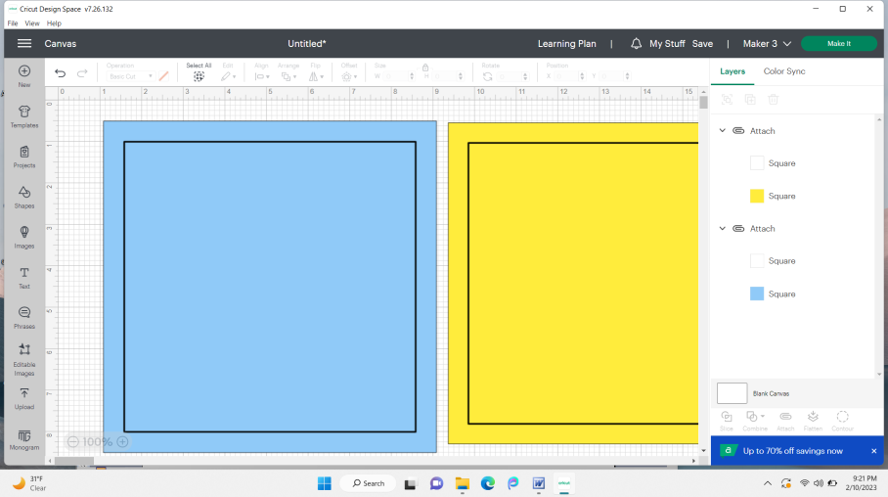

19. Go to shapes and pick the square again. Go up and change the new square’s width (w) to 6 and press enter. It should look like the 2nd picture below now.

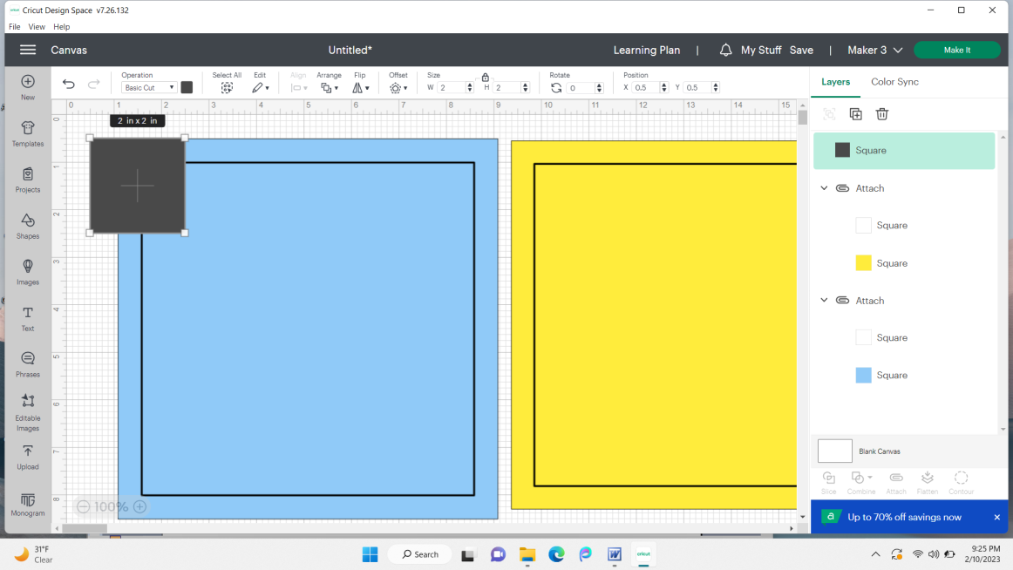

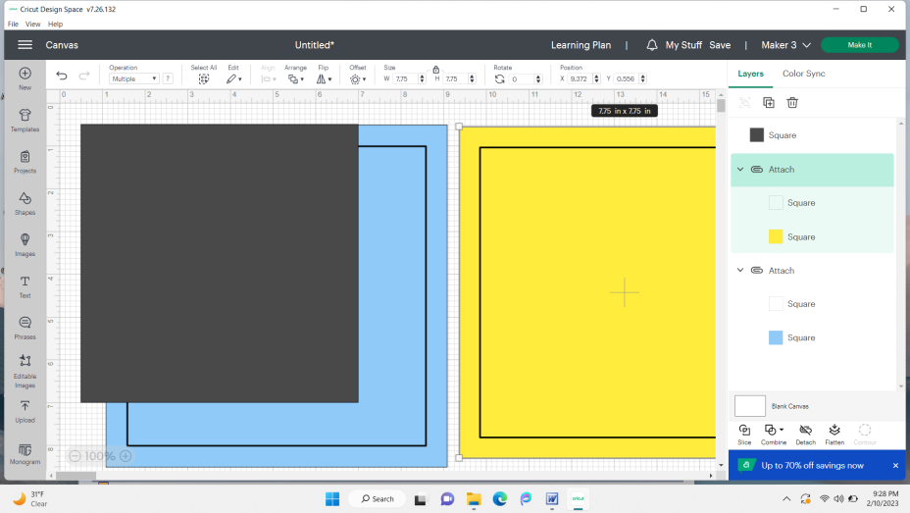

20. Change this square’s color to white by clicking on the small black square under Operation and choosing white. It will be the thermal material (shimmery). Click on the duplicate icon to add a second white square the same size. What you should see now is similar to the second picture. duplicate icon

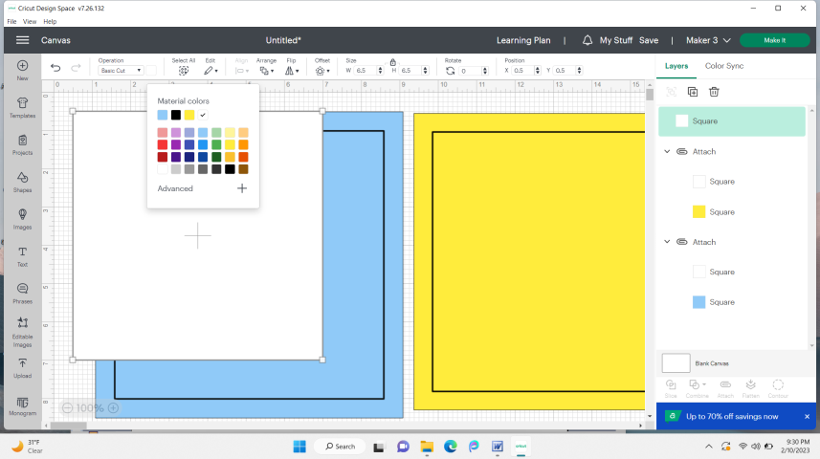
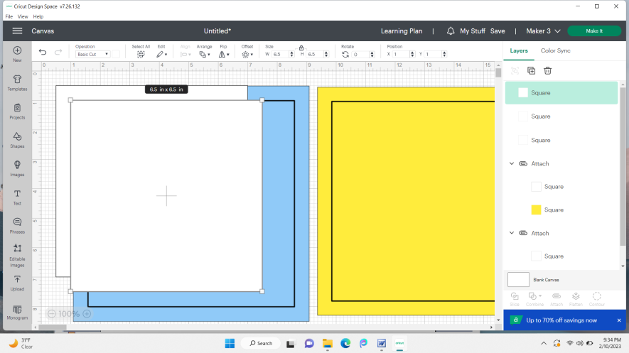

21. Change the color of the top square to light gray by clicking on the small square just below and to the right of Operation. The gray piece will be the cotton batting.
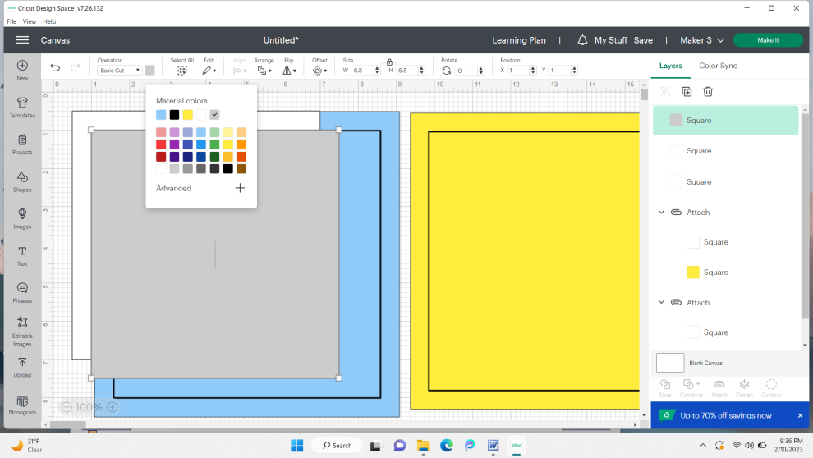
22. Check to make sure the correct machine is shown up toward the top right (see pic). If it isn’t click the v next to the machine name and select the right one. Click Make It. (the green button, just to the right of the machine’s name (Maker 3)).

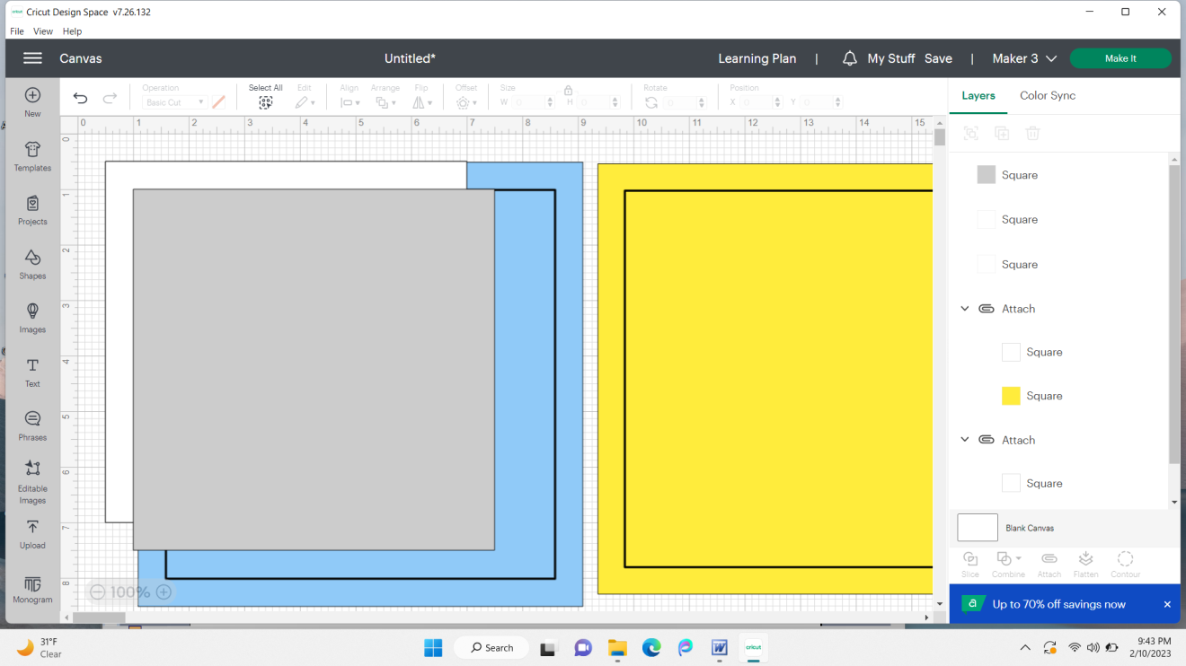

23. Click On Mat, then click Confirm.

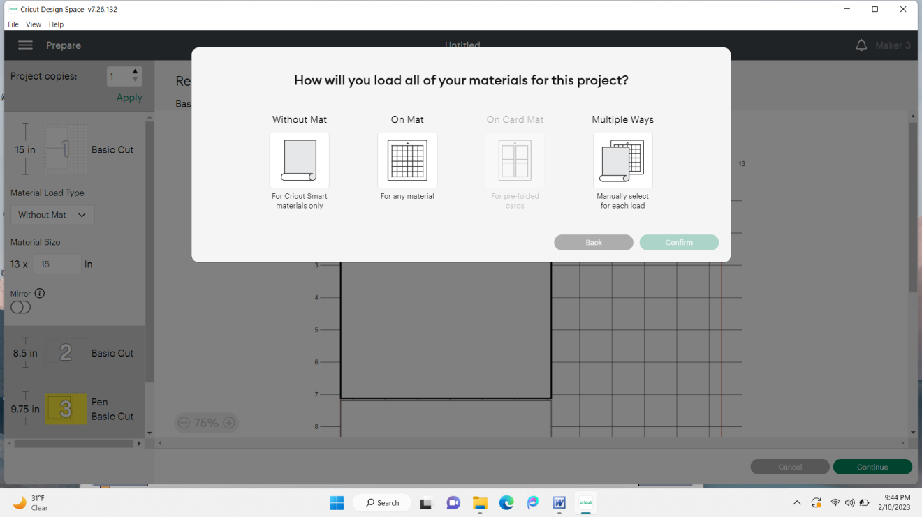

24. The screens below show a preview of your cuts (the 2nd picture is what you see when you scroll down (scroll bar shown by arrow). The first cut on my first picture (shown by the 1), is my thermal material. The mat with the 2 on it is the mat that will have the cotton batting. The mat with 3 on it is my decorative fabric (see 2nd pic). The mat with 4 on it is for my jean material. Mats 1 and 2 should show basic cut beside them. Mats 3 and 4 should show basic cut AND pen beside them. If everything looks correct, click on the green Continue button.

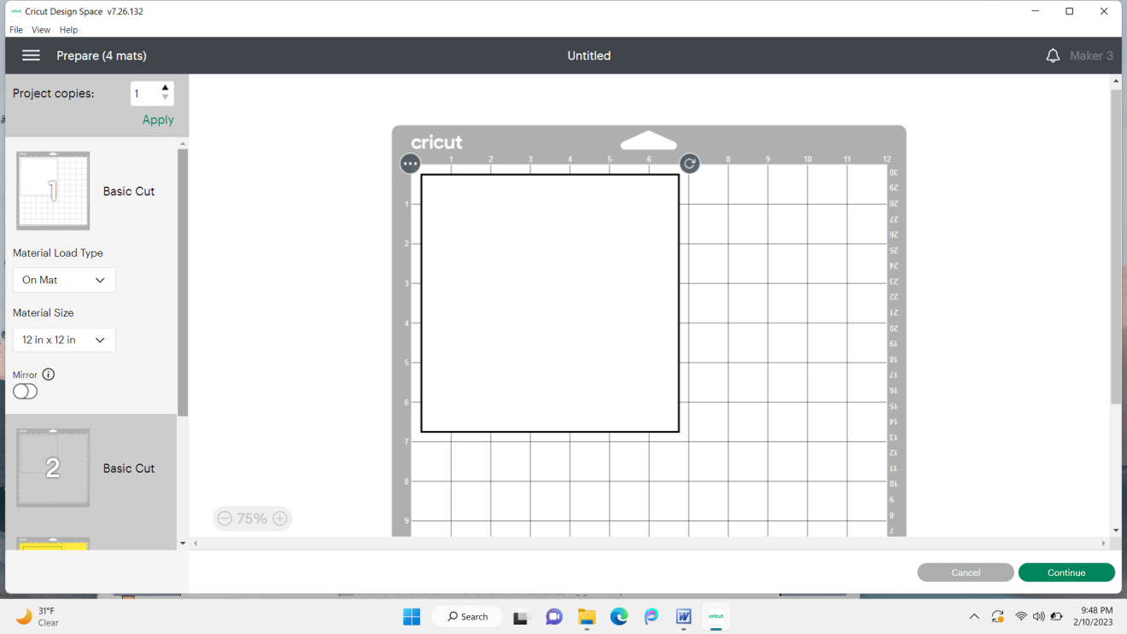

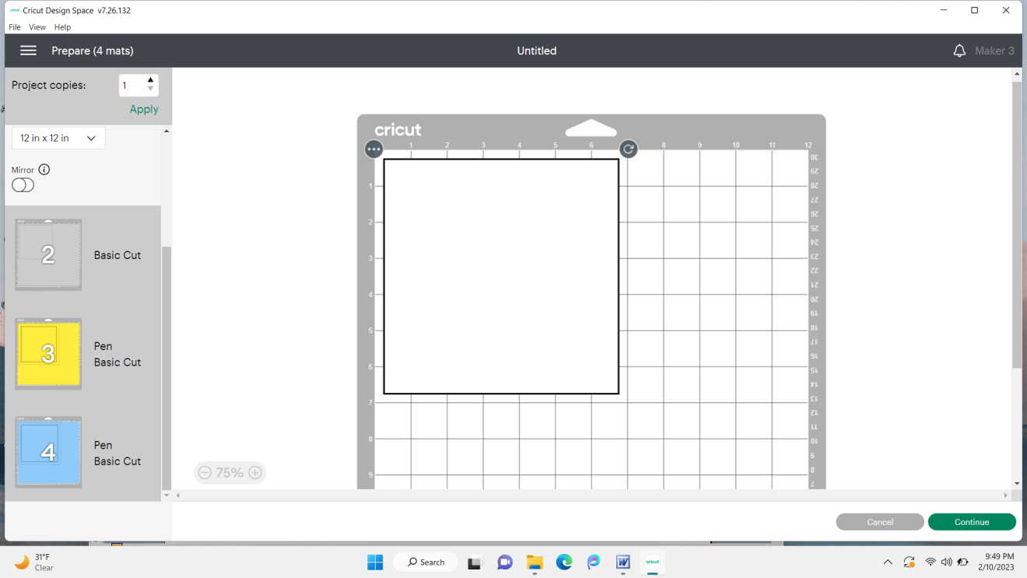

25. Place a piece of contact paper on your mat with the backing side up. Peel off backing. Now you should have a sticky surface on top of your mat to protect it from the fuzz that fabric leaves behind.

26. IMPORTANT – For all of the steps that you put any type of material onto the mat covered with contact paper, MAKE SURE that the material is adhered to the mat. If there is an area that is not sticking down, tape the edge down or change the contact paper. For each mat, you will click on Browse All Materials on the screen shown below. Notice on this screen, my mat is the white square, which is the thermal material (Insul-Brite).

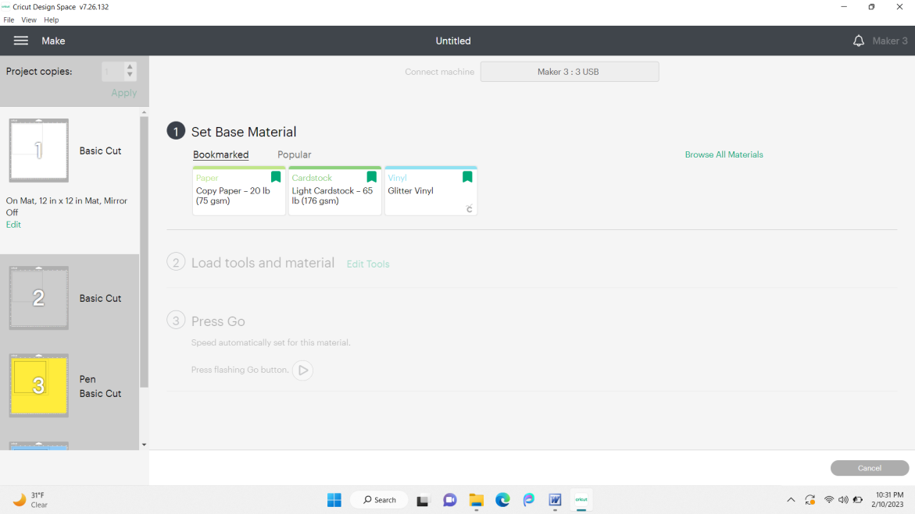

Type in Insulbrite in the search bar and click on the magnifying glass (or press Enter on the keyboard). Insulbrite Batting will show up. Click on it and then choose Done at the bottom right.

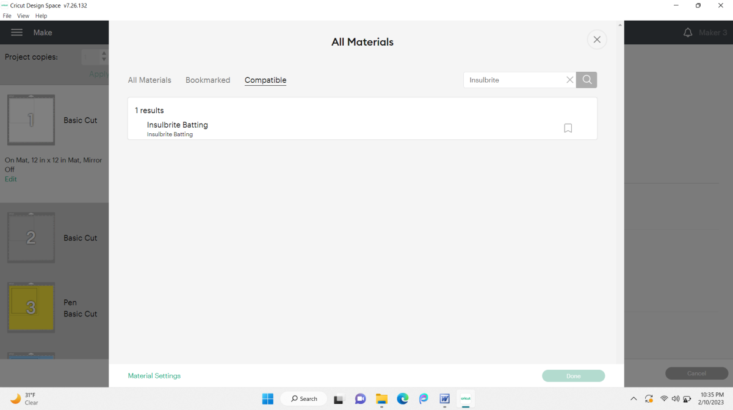

27. Change the pressure to Less (since using a new blade) by clicking the v to the right of Default under Pressure (see arrow). Read instructions in sec. 2 from left to right and do them. Here it says to put the rotary blade in B and then load the mat.

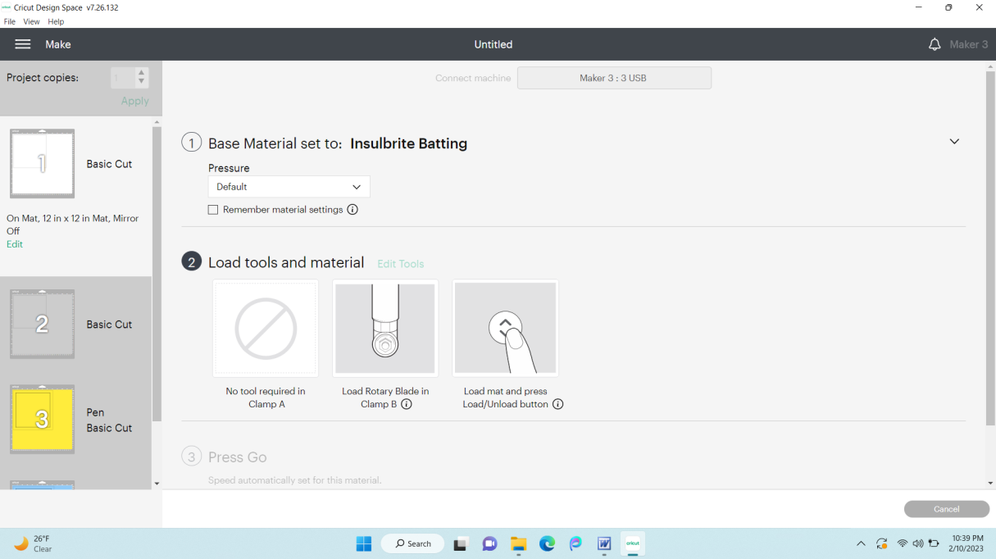

28. Put your thermal fabric (Insul-brite - at least 7”x7”, but not big enough that it goes past the gridded area of the mat – IMPORTANT!) on the mat starting at the top left corner of the gridded area (see pic). Make sure it is pressed down firmly. The one in the picture needs pressed down more! After it is done cutting, peel material off mat leaving the contact paper. If it cut the contact paper, that is ok, just push it back on the mat as you peel off the fabric.

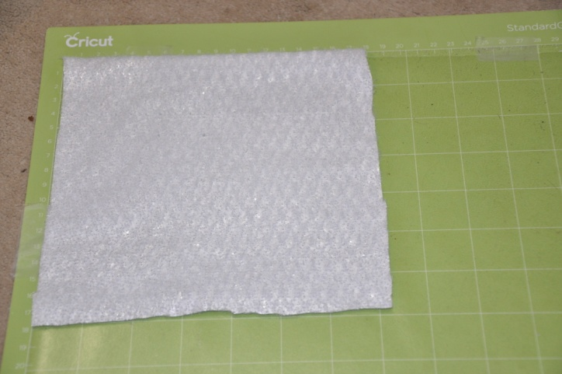

29. Notice on the screen below that mat 1 has a check mark to the left side of it showing it is done. Now mat 2 is lit up showing we are on it. The gray color was for my cotton batting. Click on Browse All Materials again. Type in Insulbrite again and click the magnifying glass. Choose Insulbrite Batting and click on Done. On the next screen, choose Less, then follow the directions. Put your cotton batting (at least 7”x7”) at the top corner of the gridded area again.

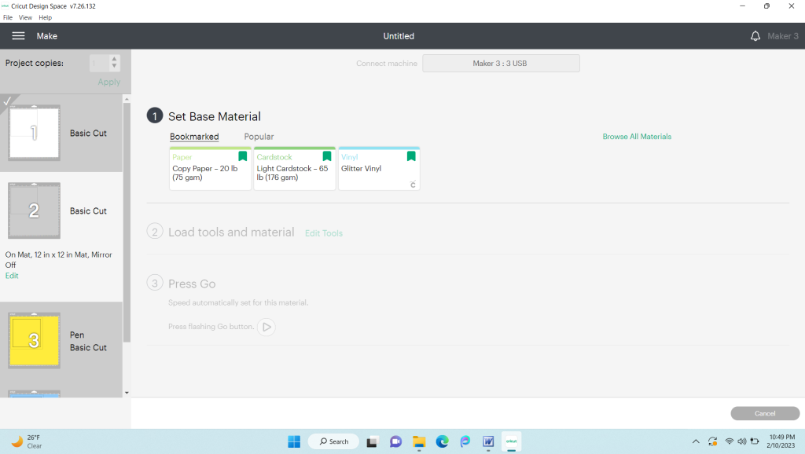

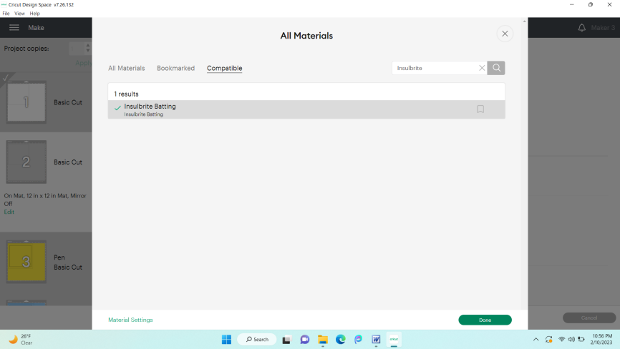

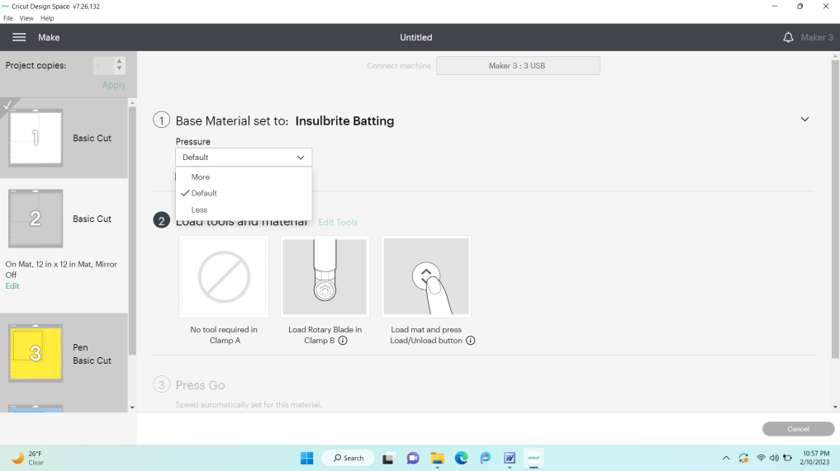

30. We are now on mat 3. Notice that yellow is the color I chose for my decorative fabric. It is a light cotton. (use the appropriate setting for your material – ask me if you are unsure!). Again, click on Browse All Materials and enter the type of fabric you are using into the search bar. When you find the correct material, click on it. In my case, I am putting light cotton in the search bar. I chose it (single layer) and clicked on done.

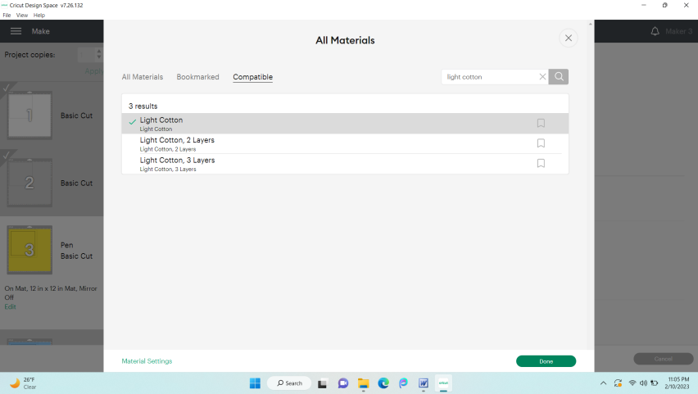

31. On the next screen, choose less pressure. NOTICE – in the directions section it has black pen 1.0 in clamp A. Our pen will be a washable fabric marker, so we will put that in clamp A leaving the Rotary Blade in clamp B. If your fabric is dark on the wrong side, you may wish to try a silver regular Cricut marker, if available (will not wash out, but you should be able to make folds so you can’t see it). The marker is used to show you where to fold the fabric when gluing it (since we aren’t sewing it). (The marker is generally used to show seam allowance lines to sew on.)

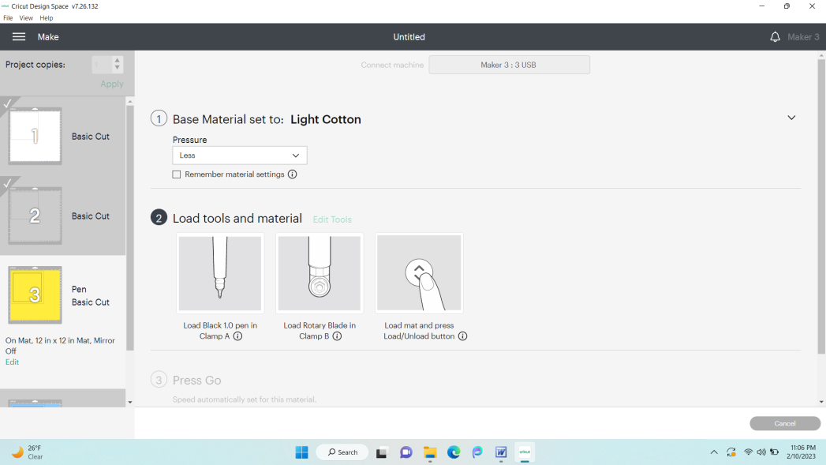

32. Put your material (at least 9” x 9”) on the mat with WRONG side up. Trim off any strings that might get caught in wheels on machine and do NOT use material wider than the gridded area. See pictures on #34 to see what is OK and what is NOT OK!

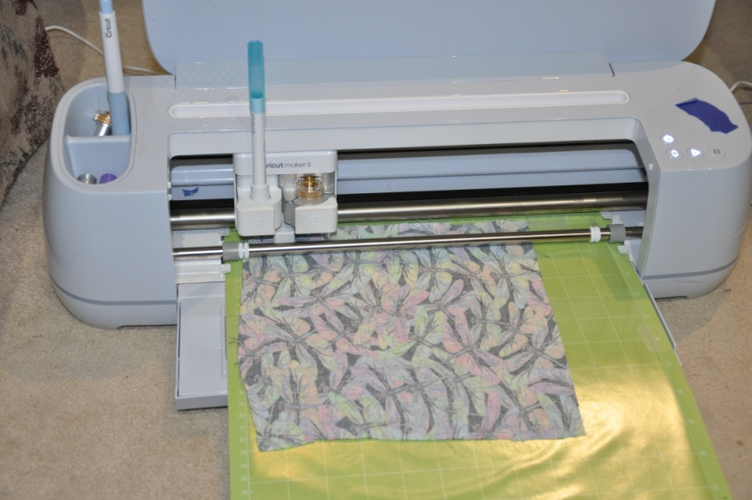

33. Now we are on mat 4. This is my denim mat. Make sure your denim piece has had all seams removed! Seams can be too thick for the machine and ruin it! Put your denim on the mat wrong side up (at least 9”x9”, but NOT larger than the gridded area of the mat!). Trim off strings that may get caught in wheels. If the top isn’t very straight and is not sticking down, trim it off once it’s on the contact paper. The bottom can be uneven as long as it sticks down. Again, make sure that no material goes past the gridded area of the mat and that all of it has adhered well. If not, tape edges down or put on new contact paper. Click on Browse All Materials. Choose “Denim” and click on Done. Put pressure on Less (unless rotary fabric blade is well used). Follow the directions on the screen under section #2 to have the machine cut the material.

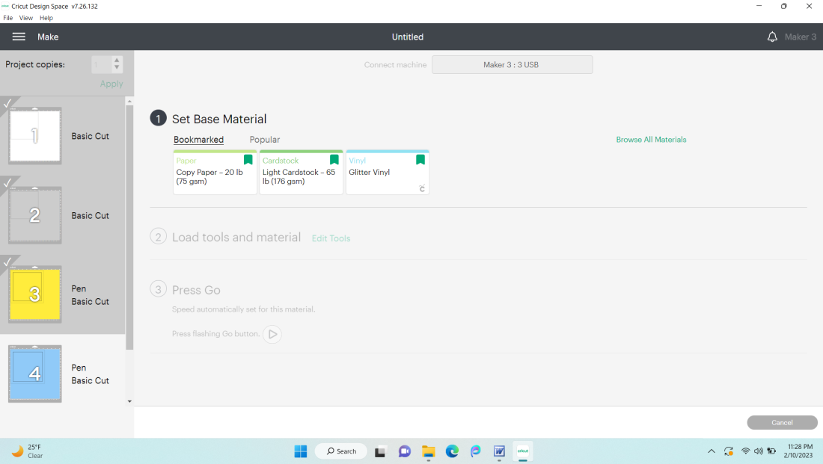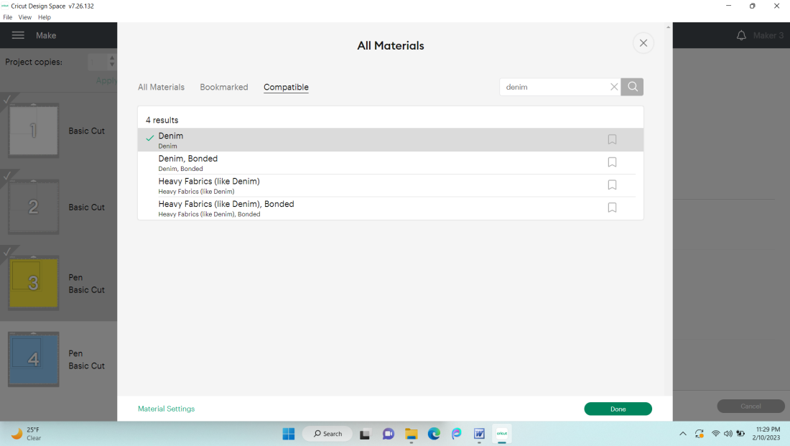

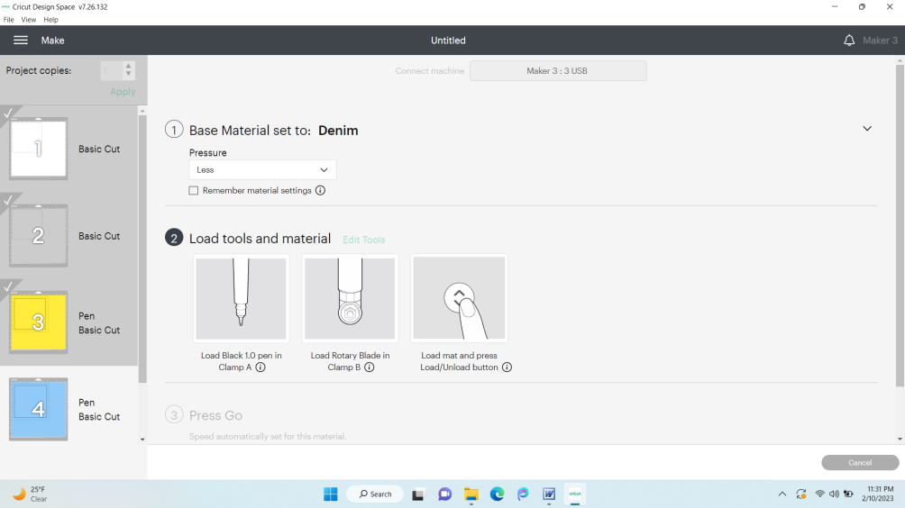
NOT OK!
Too Big and
Has Strings!
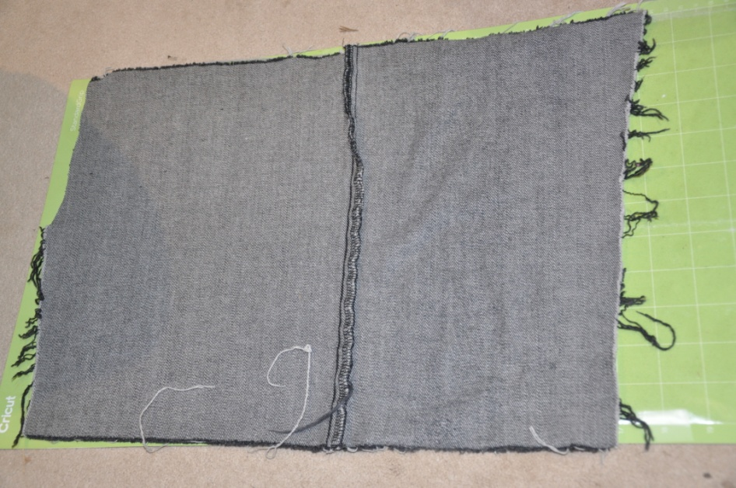
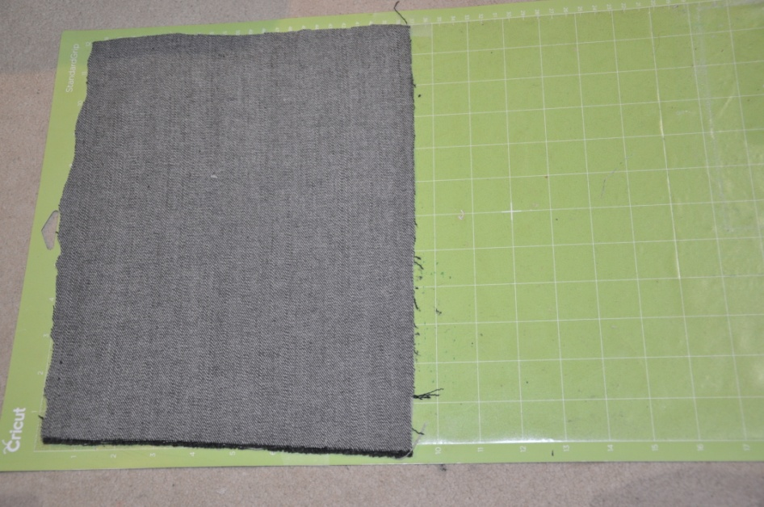
Much Better!

34. Unload the mat when the machine is done cutting. Remove the denim from the mat. Peel the contact paper off your mat and throw it away.

35. Next, you will glue your thermal batting to your light fabric layer. Gorilla Contact Adhesive Clear Grip works well (some fabric glues DO NOT work well). Whichever glue you choose to use, make sure it is waterproof and made for fabric (and works!). Center the thermal batting (white sparkly material) over your light fabric using the light blue lines drawn on the light fabric as a guide. Put a thin line of glue along 2 opposite edges of the light fabric (edge to edge). Press those edges down over the thermal material (fold at the batting) and make sure it is all adhered. Put a thin line of glue along the other 2 opposite edges of the light fabric. Press these edges over the thermal material. Make sure corners adhere well. Let dry while you work on the denim piece. It should look like the 3rd picture.

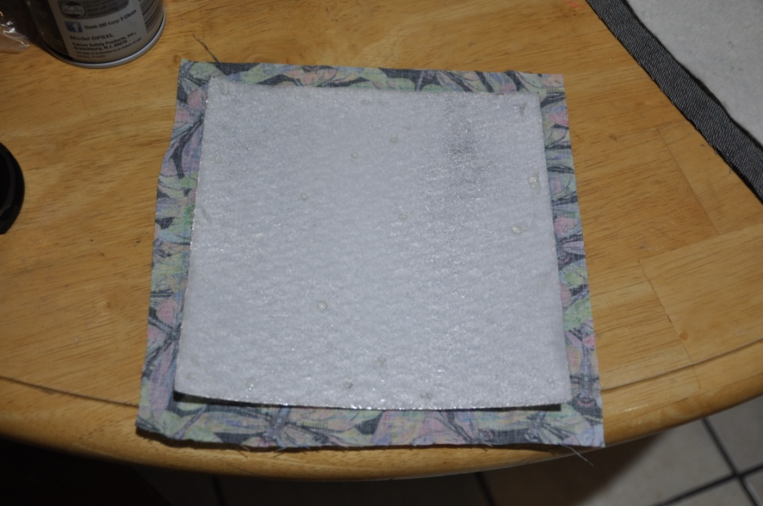

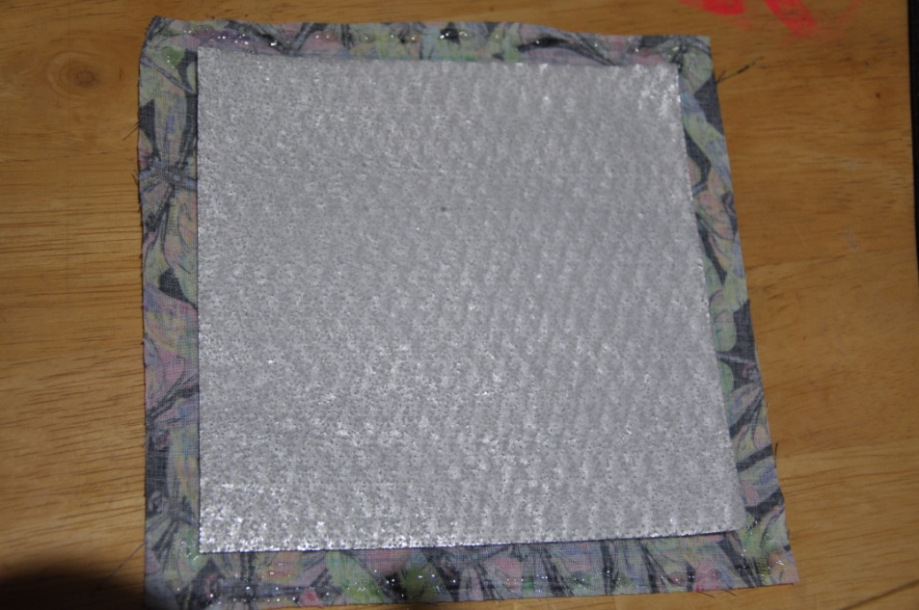

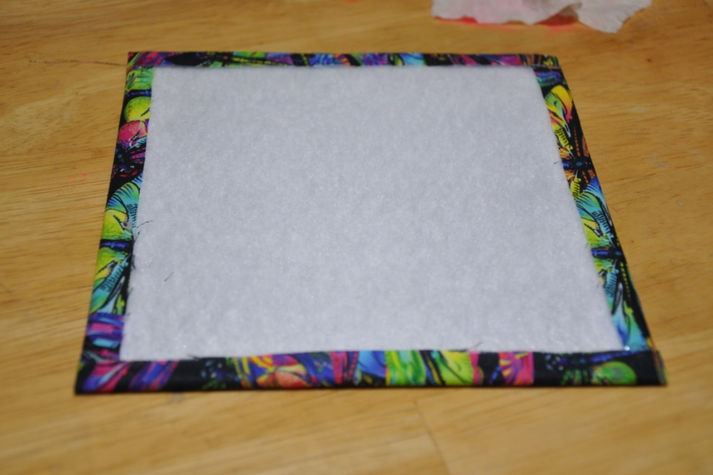

36. Center your plain batting between your blue lines on the denim. Put a line of glue along two opposite edges of the batting – continue the line of glue to the blue lines that were drawn on the denim (ask if unsure what this means). Fold the denim over on these 2 sides where the blue lines are. The denim should just barely cover the glue line on the batting. Make sure edges are adhered well.

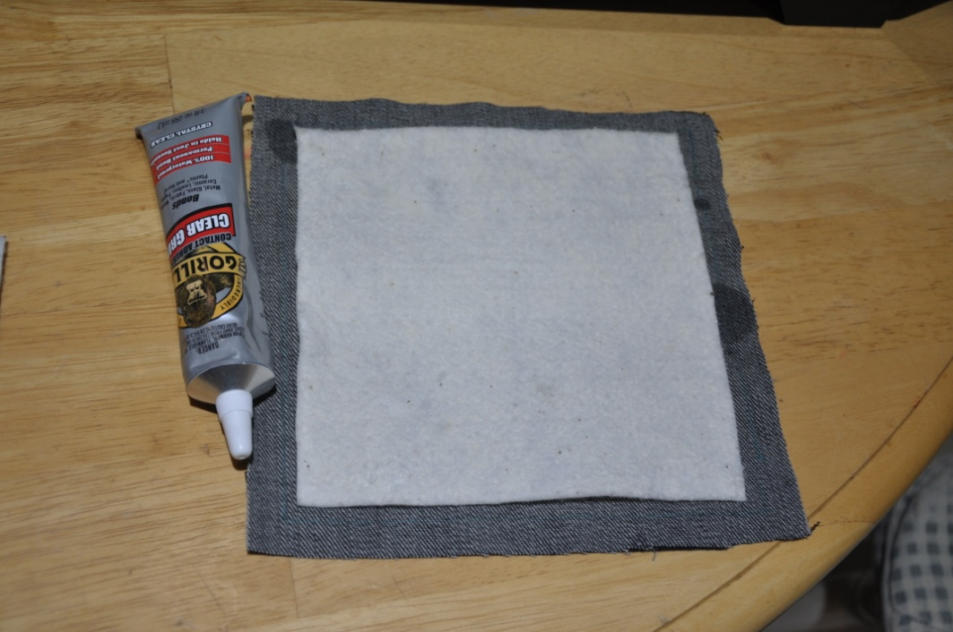

If you fold the denim over where the fold touches the batting, you will get a potholder that does not have the denim border (see last picture in these instructions. If you fold on the blue line, you will be attaching the denim just to the glued edge of the batting. That will give you the potholder (see picture again) that has a denim border around the decorative fabric.

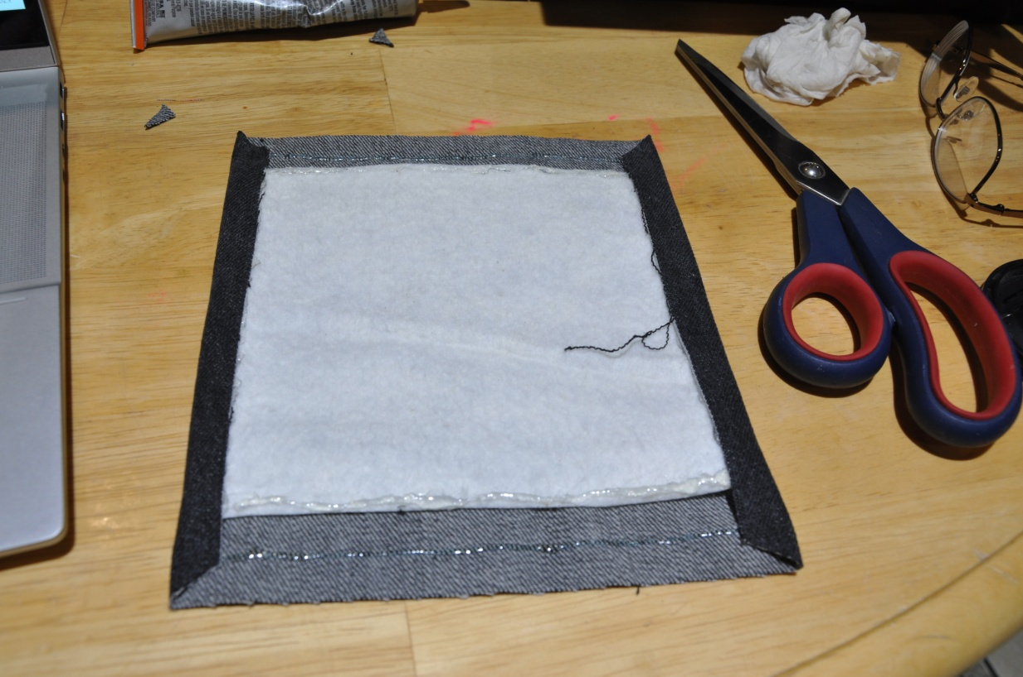

37. Cut the top layer of fabric’s corners at 45 degree angles (SEE PICTURE ABOVE!!) Glue these corners down so they are flat if they are puckered up. Put glue on the remaining two opposite edges of the batting, extending the line to the edge of the denim on both sides. (Don’t put glue were the symbol is in the pic above! – glue was accidentally put on the marker line). Fold the denim over at the blue line. The denim should just cover the glue line. Press down so the edges of the denim are adhered to the batting. Make sure your corners look square.

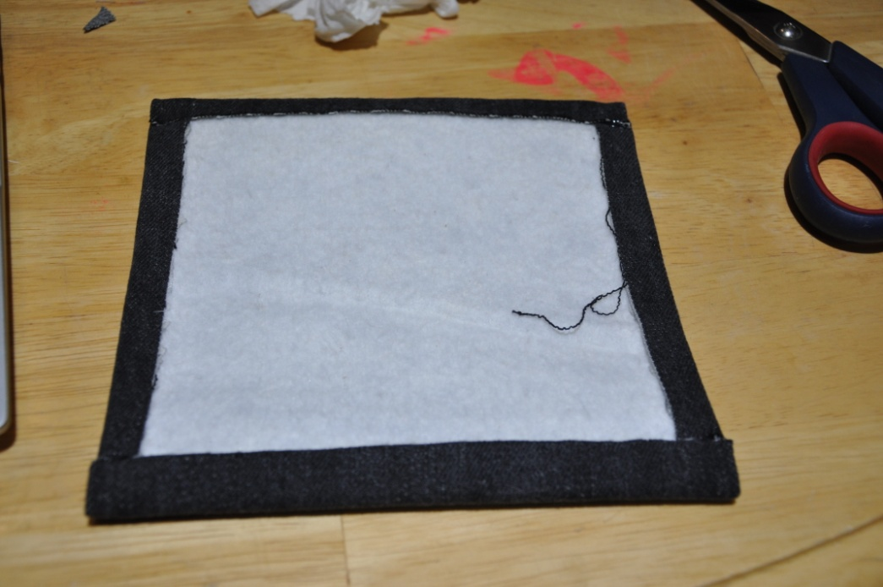
Put a little extra glue (clear) over the 4 parts where the denim crosses the denim at the 4 corners. Wipe the extra off with a slightly damp paper towel. This will help the corners from becoming frayed when washed. Let dry a few minutes.

38. Flip your decorative fabric layer over so that the thermal batting is showing, then put a line of glue all the way around the piece all along the outer edge of the decorative fabric (SEE PICTURE). Flip over, center over denim piece that has the batting side up, and press down until firmly attached. Make sure any cut parts of fabric that show on the denim have a little glue covering them so they will not fray later.

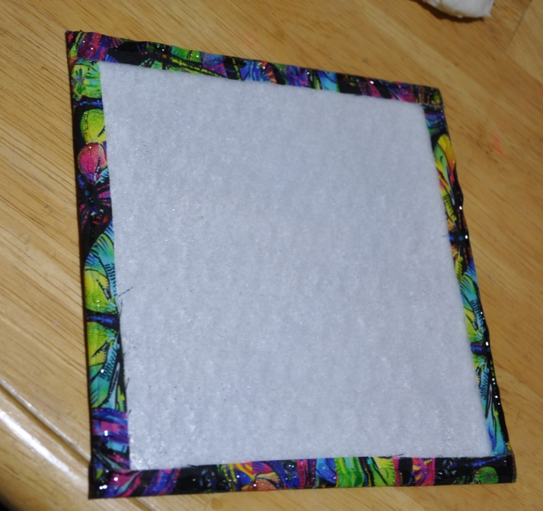
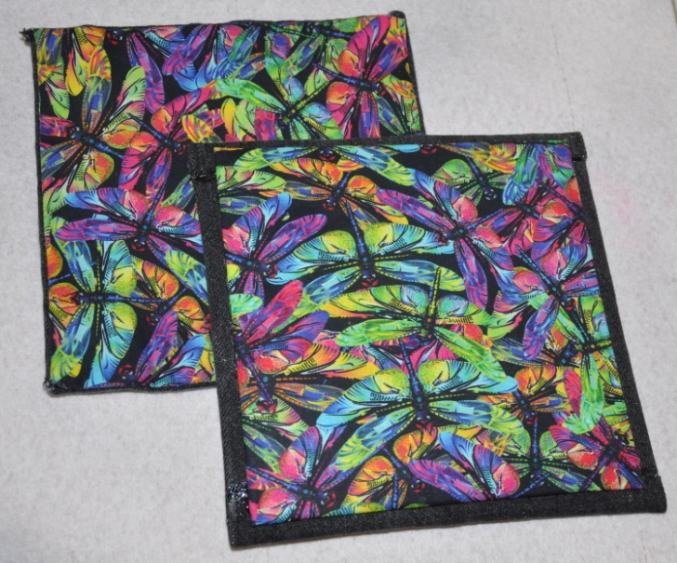

You are done!! Great job! Let your glue dry at least 24 hours. You can wash and dry the potholder as needed. Use for pulling things out of the oven or for setting hot things on, but DO NOT PUT IT IN THE MICROWAVE (thermal batting is not compatible with microwaves)!!!

